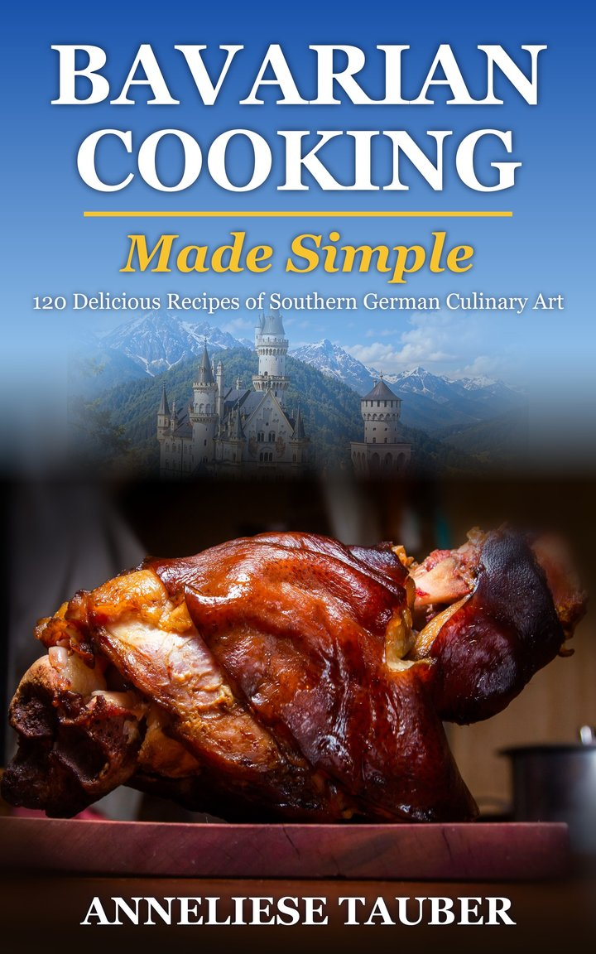
BAVARIAN
COOKING
Made Simple
* * *
Southern German Culinary Art
120 Delicious Recipes
Beyond the Oktoberfest
Anneliese Tauber
99 Luftballon Publishing
Passau, Germany
Copyright © 2025 by 99 Luftballon Publishing, Passau, Germany. All rights reserved.
No portion of this book may be reproduced in any form without written permission from the publisher or author, except as permitted by U.S. copyright law.
You may not make this e-book publicly available in any way.
1st Edition
Before You Cook
A word before you start. I cook for four children with strong opinions, which is good training for writing recipes: they have to be clear, they have to work, and nobody wants to wait. Nothing here needs special skills, only good ingredients, a little patience, and somebody willing to set the table.
Quantities and times. Every recipe is written for 4 people unless it says otherwise (cakes and bakes show their yield). Amounts are given in US and metric units; weigh ingredients with a kitchen scale for the most reliable results. Oven temperatures are for conventional ovens, so lower them by about 20 °C (25 °F) for fan ovens. Cooking times are guides: ovens, pans, and ingredients vary.
Meat, poultry, and fish. Cook poultry and ground meat until the center reaches 75 °C (165 °F) and pork until at least 70 °C (160 °F). Beef tartare, soft-cooked egg yolks, and mousse-style desserts use raw or lightly cooked eggs and meat: use the freshest ingredients from a trusted source, keep them cold, and avoid them for pregnant women, small children, older people, and anyone with a weakened immune system.
Hot oil and sugar. Frying and caramel reach very high temperatures. Never leave hot oil unattended, keep water away from it, and keep children out of the kitchen.
Alcohol. Mulled wine, Jägertee, grog, and some sauces and sorbets contain wine, beer, rum, or spirits. Boiling reduces but does not remove the alcohol, so keep this in mind when serving children or anyone who avoids alcohol.
Allergens. Many recipes contain gluten (wheat, rye, barley), milk, eggs, tree nuts (almonds, hazelnuts, walnuts, pistachios), celery, mustard, fish, shellfish (shrimp), sesame (tahini), poppy seeds, and sulphites (wine). Read the ingredient lists and the labels of any packaged products, and adapt recipes to your own dietary needs.
Guten Appetit! Enjoy the recipes, and feel free to adjust the seasoning to your own taste.

Contents

Soups
Beer Soup
Wine Soup
Bavarian Liver Dumpling Soup
Liver Spätzle Soup
Onion Soup with Bread and Cheese
Bavarian Creamy Potato Soup
Pancake Soup
German Split Pea Soup
German Lentil Soup
Bavarian Goulash Soup
Sausage Sauerkraut Soup
Beef Broth with Semolina Dumplings
Bavarian Wedding Soup
Bavarian Bread Soup
Appetizers
Bavarian Snack Platter
Goat Cheese with Beetroot and Pistachio Brittle
Leberkäse
Bavarian Cheese Spread
Bavarian Sausage Salad
Red and White Head Cheese
Radishes Salad
Deviled Eggs
Grilled and Braised Asparagus
Weißwurst with Sweet Mustard and Pretzel
Main Courses
Bavarian Braised Beef
Sauerkraut and Mashed Potatoes
Creamy Mushroom Dish
Roasted Duck (Ente) Stuffed with Apples
Tarte Flambée
Bavarian Beer Goulash
Jägerschnitzel
Bavarian-style Skewers
Gourmet Fish Fillets
Roasted Pork Knuckle
Bavarian Burger
Turkey Drumstick
Boiled Beef with Salted Potatoes and Horseradish
Rouladen
Bavarian Meatballs
Barley Risotto with Vegetables
Beef Tartare with Garlic Baguette
Crispy Duck with Red Cabbage, Walnut Crumble, and Dumpling Slices
Sour Pot Roast
Beef Fillet with Potato-Celery Puree
Bratwurst Supper
Bavarian Lentil Stew
Spaghetti with Beef Steak Strips and Parsnips
Char on a Bed of Vegetables
Fish Grilled on a Stick
Colorful Fish Skewers
Pork Chops with Saltimbocca
Pork Liver with Apple and Caramelized Onions
Spare Ribs with Potato Wedges
Bavarian Robber's Meat
Allgäuer Cordon Bleu
Stuffed Grilled Chicken
Paprika-Chicken with Shrimp
Bavarian Savoy Cabbage Lasagna
Bavarian Turkey Döner Kebab
Bavarian Potato Pancakes
Roast Pork with Crackling and Dark Beer Gravy
Oktoberfest Roast Chicken
Cheese Spätzle with Crispy Onions
Creamy Veal Strips with Mushrooms
Sirloin Steak with Fried Onions and Gravy
Pichelsteiner Meat and Vegetable Stew
Franconian Roast Pork Shoulder
Sour Sausages in Onion-Vinegar Broth
Boiled Pork with Sauerkraut
Crispy Chicken Schnitzel with Fried Potatoes
Sides
Potato Noodles
Egg Noodles
Potato Dumplings
Bavarian Cheese Dumplings
Bread Dumplings
Bavarian Braised Cabbage (Bayrisch Kraut)
Bavarian Yeast Dumplings
Blaukraut
Bavarian Warm Potato Salad
Spicy Bavarian Beer Mustard
Bavarian Pretzels
Sourdough Bread
Bavarian Green Bean Salad
Napkin Dumpling
Desserts
German Doughnuts
Bayerischer Scheiterhaufen
Marble Bundt Cake
Bavarian Plum Cake
Moist Apple Cake
Yeast Dumplings with Vanilla Sauce
Apple Fritters
Bavarian Cream
Almond-filled Stollen
All Saints' Braid
Apfel-Schneemus-Torte
Apfel-Zimt-Griessbrei
Hoiber Datschi
Lemon Sorbet and Tonic Dream
Oktoberfest Apple Strudel
Bavarian Gingerbread
Rhubarb Sour Cream Cake
Elisen Lebkuchen
Vanille Kipferl
Kirchweih Nudeln
Blackcurrant Ice Cream
Bavarian Lemon Sorbet
Bavarian Pancakes
Rice Pudding Cake with Cherry Compote
Apple Strudel
Shredded Pancake with Plum Compote
Quark Strudel
Prince Regent’s Torte
Poppy Seed Potato Noodles
Baked Apples with Almonds and Vanilla Sauce
Bee Sting Cake
Almnussen
Apple Cinnamon Rolls
Drinks
Grogg
Mulled Wine
Jägertee
Photo Credits
About the Author
About This Book

Soups
In Bavaria a proper meal starts with soup, and on a cold day it may never get further. These are the soups I make most often: some quick, some slow, all of them better with bread.

Beer Soup
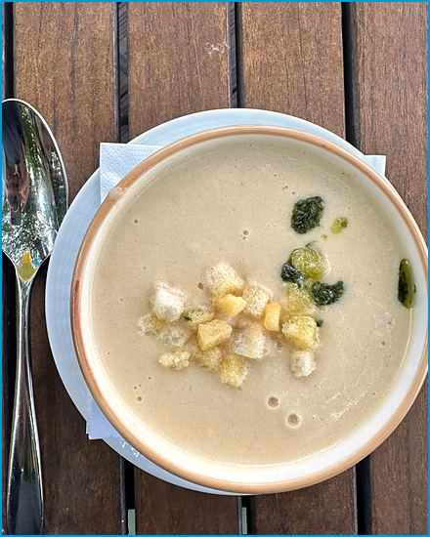
Serves 4
Biersuppe
A silky, golden soup that lets light beer, cream, and a hint of nutmeg do the talking. Croutons add the crunch. Yes, soup made with beer. My children were scandalized until they tasted it.
Ingredients

- 500 ml (2 cups) light beer (e.g. lager or wheat beer)
- 500 ml (2 cups) water
- 200 ml (¾ cup) heavy cream
- 2 Tbsp. butter
- 2 Tbsp. all-purpose flour
- 1 large onion, finely chopped
- 2 cloves garlic, minced
- 2 egg yolks
- Salt and pepper to taste
- A pinch of nutmeg
- Fresh chives or parsley, chopped (for garnish)
- Croutons (optional, for serving)
Method
Cook the Onion and Garlic:
- Melt the butter over medium heat in a large pot.
- Add the finely chopped onion and cook until it becomes soft and translucent.
- Add the minced garlic and cook for another minute.
Make the Roux:
- Sprinkle the flour over the onions and garlic, stirring constantly to form a roux.
- Cook 2 more minutes.
Add Beer and Water:
- Gradually whisk in the beer and water without lumps.
- Simmer for 15 minutes, stirring occasionally.
Add the Cream:
- Stir in the heavy cream and continue to simmer for another 5-10 minutes.
Temper the Egg Yolks:
- Whisk the egg yolks in a small bowl.
- Gradually ladle a little hot soup into it.
- Keep whisking to temper.
- Slowly pour the tempered egg yolk mixture back into the pot, whisking constantly.
Season and Serve:
- Season the soup with salt, pepper, and a pinch of nutmeg to taste.
- Heat gently, but do not let it boil, until the soup is slightly thickened.
- Ladle the soup into bowls and garnish with freshly chopped chives or parsley.
- Serve with croutons, if desired.

Wine Soup
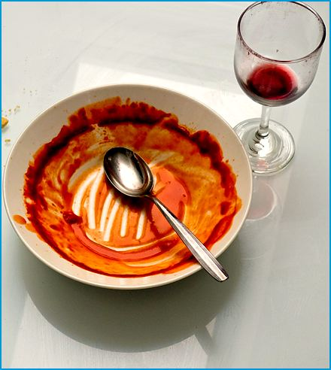
Serves 4
Weinsuppe
A gently sweet, wine-scented soup for festive meals, enriched with egg yolk and cream and lifted by lemon and cinnamon. It is served at festive meals, which in our house means any meal where nobody has spilled anything yet.
Ingredients

750 ml (3 cups) dry white wine
250 ml (1 cup) water
3 Tbsp. sugar
1 cinnamon stick
4 cloves
1 lemon, zest and juice
4 egg yolks
200 ml (¾ cup) heavy cream
A pinch of salt
Whipped cream (optional, for garnish)
Croutons (optional, for serving)
Method
Prepare the Wine Base:
- Combine the wine, water, sugar, cinnamon stick, cloves, lemon zest, and lemon juice in a large pot.
- Bring the mixture to a gentle simmer over medium heat.
- Let it simmer for about 10 minutes to allow the flavors to infuse.
Strain the Soup:
- Remove the cinnamon stick and cloves from the pot.
- Strain the soup through a fine sieve to remove the lemon and any solids.
- Return the soup to the pot.
Prepare the Egg Mixture:
- Whisk together the egg yolks, heavy cream, and a pinch of salt in a bowl until well combined.
Thicken the Soup:
- Slowly ladle a little of the hot wine base into the egg mixture, whisking constantly to temper the eggs.
- Slowly pour the egg mixture back into the pot with the remaining wine soup, whisking constantly.
Heat and Serve:
- Heat the soup gently over low heat, keep stirring until it thickens slightly.
- Do not boil to avoid curdling.
- Remove it from the heat once the soup has thickened to your desired consistency.
Garnish and Serve:
- Ladle the Weinsuppe into bowls. Optional: Garnish with a dollop of whipped cream and serve with croutons.

Bavarian Liver Dumpling Soup
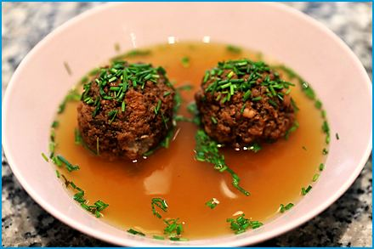
Serves 4
Bayerische Leberknödelsuppe
Dumplings of finely minced liver and marjoram simmered in strong beef broth: a Sunday classic that warms you through on a cold day. Children who say they hate liver have been known to ask for seconds, provided nobody tells them what is in it.
Ingredients

- 250 g (9 oz.) beef liver (finely chopped)
- 1 onion (finely chopped)
- 1 clove of garlic (finely chopped)
- 3 stale bread rolls (soaked in water and squeezed dry), plus 2-3 Tbsp. breadcrumbs if needed
- 2 eggs
- 1 Tbsp. parsley (chopped)
- Salt
- Pepper
- Nutmeg
- 1/2 tsp. marjoram
- 1 L (4¼ cups) beef broth
Method
Prepare the Liver Mixture:
- Finely chop the beef liver or pass it through a meat grinder.
- Finely chop the onion and garlic.
Combine Ingredients:
- Mix the chopped liver, onion, garlic, squeezed bread rolls, eggs, marjoram, and parsley in a bowl.
- Season with salt, pepper, and nutmeg to taste.
Form the Dumplings:
- Let the mixture rest for 15 minutes.
- Shape it into small dumplings (about 3 cm).
- Poach one test dumpling first, then if it falls apart, knead in a few more breadcrumbs.
Cook the Soup:
- Bring the beef broth to a boil.
- Add the liver dumplings and let them cook for about 15 minutes.
Serve:
- Serve the soup hot, garnished with parsley if desired.

Liver Spätzle Soup
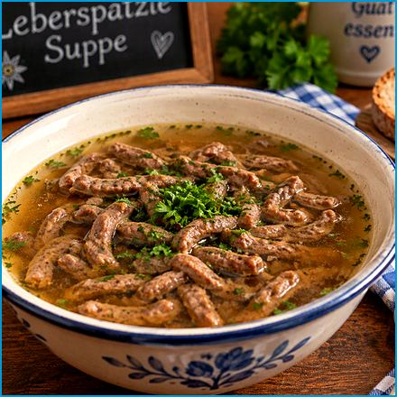
Serves 4
Leberspätzlesuppe
Small liver dumplings and a handful of vegetables in a rich beef broth, a rustic favorite in Bavarian inns.

Ingredients
For the Liver Spätzle:
- 9 oz. (260 g) beef liver
- 1 small onion, finely chopped
- 2 Tbsp. butter
- 1 clove garlic, minced
- 1 bread roll, soaked in milk and squeezed dry
- 1 egg
- 1 Tbsp. chopped fresh parsley
- Salt and pepper to taste
- 4 Tbsp. bread crumbs
For the Soup:
- 1.5 L (6¼ cups) beef broth
- 1 carrot, peeled and sliced
- 1 small leek, cleaned and sliced
- 1 celery stalk, sliced
- Salt and pepper to taste
- 7 oz. (200 g) cooked Spätzle (see the Spätzle recipe)
- Fresh chopped parsley for garnish
Method
Prepare the Liver Dumplings:
- Melt the butter over medium heat in a skillet.
- Add the finely chopped onion and cook until soft and translucent.
- Add the minced garlic and cook for another minute.
- Set aside to cool slightly.
- Blend the beef liver in a food processor until smooth.
- Combine the blended liver, cooked onion and garlic, soaked bread, egg, chopped parsley, salt, and pepper in a mixing bowl.
- Mix well.
- Add bread crumbs until the mixture holds together and can be shaped into dumplings.
- Form the mixture into small dumplings, about the size of a walnut.
Cook the Soup:
- Bring the beef broth to a boil in a large pot.
- Add the sliced carrot, leek, and celery to the broth and cook until tender, about 10-15 minutes.
- Reduce the heat to a gentle simmer.
Cook the Liver Dumplings:
- Gently add the liver dumplings to the simmering soup.
- Let them cook for about 15-20 minutes, or until they float to the surface and are cooked through.
Add the Spätzle:
- Add the cooked spätzle to the soup and heat through.
Serve:
- Taste the soup and adjust the seasoning with salt and pepper.
- Ladle the soup into bowls, making sure each serving has a few liver dumplings and spätzle.
- Garnish with fresh chopped parsley.

Onion Soup with Bread and Cheese
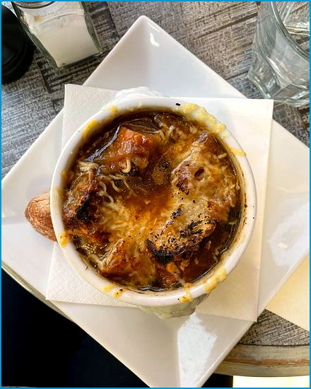
Serves 4
Zwiebelsuppe
Slowly caramelized onions in a savory broth, topped with toasted bread and bubbling Gruyère. The onions take forty minutes and cannot be rushed, which makes this the right soup for a day when everything else can wait.
Ingredients

- 4 large sweet onions, thinly sliced (about 6 cups (1.44 L))
- 2 Tbsp. butter
- 2 Tbsp. olive oil
- 1 Tbsp. flour
- 1 quart (about 1 L) chicken or vegetable broth
- 1 bay leaf
- 1 tsp. thyme
- 1/4 tsp. nutmeg
- Salt and freshly ground pepper to taste
- 4 very thin slices French bread, about 1/8 in., toasted
- 1 cup (240 ml) shredded Gruyère cheese
Method
Caramelize the Onions:
- Melt the butter and olive oil over medium heat in a large pot.
- Add the sliced onions and cook, stirring occasionally, until they are caramelized and golden brown, about 30-40 minutes.
- Be careful not to let them burn.
Make the Roux:
- Sprinkle the flour over them and stir to combine once the onions are caramelized.
- Cook for a few minutes to create a roux, which will thicken the soup.
Add the Broth and Seasonings:
- Pour in the chicken or vegetable broth, add the bay leaf, thyme, and nutmeg.
- Bring the soup to a simmer and let it cook for about 10 minutes to allow the flavors to meld.
- Season with salt and pepper to taste.
Prepare the Bread and Cheese:
- Preheat your oven to broil.
- Place the toasted French bread slices on top of the soup in oven-safe bowls.
- Sprinkle the grated Gruyère cheese over the bread.
Broil the Soup:
- Place the bowls under the broiler until the cheese is melted and bubbly, about 2-3 minutes.
Serve:
- Remove the bowls from the oven and let them cool slightly before serving.

Bavarian Creamy Potato Soup
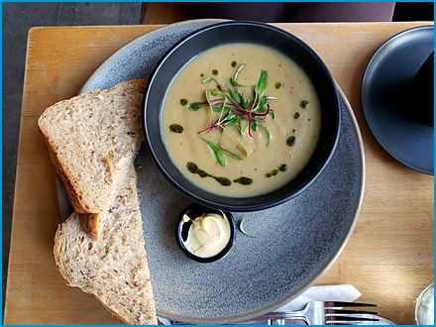
Serves 4
Kartoffelcremesuppe
A velvety purée of potatoes and leek, finished with a little cream and nutmeg. Plain, comforting, and quick. It has rescued more wet Tuesdays than I can count.
Ingredients

- 21 oz. (600 g) potatoes, peeled and diced
- 1 large onion, finely chopped
- 2 cloves garlic, minced
- 1 leek, cleaned and sliced
- 2 Tbsp. butter
- 1 L (4¼ cups) chicken or vegetable broth
- 200 ml (¾ cup) heavy cream
- Salt and pepper to taste
- A pinch of nutmeg
- Fresh chives, chopped (for garnish)
- Croutons (optional, for serving)
Method
Prepare the Vegetables:
- Peel and dice the potatoes.
- Finely chop the onion and mince the garlic.
- Clean and slice the leek.
Cook the Vegetables:
- Melt the butter over medium heat in a large pot.
- Add the chopped onion and leek, cooking until soft and translucent.
- Add the minced garlic and cook for another minute.
Add Potatoes and Broth:
- Add the diced potatoes to the pot and stir well.
- Pour in the chicken or vegetable broth and bring the mixture to a boil.
- Reduce the heat and let it simmer for about 20-25 minutes, or until the potatoes are tender.
Blend the Soup:
- Use an immersion blender to puree the soup until smooth. Alternatively, you can blend the soup in batches using a regular blender.
- Return it to the pot.
Add Cream and Season:
- Stir in the heavy cream and heat the soup gently without boiling.
- Season with salt, pepper, and a pinch of nutmeg to taste.
Serve:
- Ladle the creamy potato soup into bowls.
- Garnish with fresh chopped chives and croutons, if desired.

Pancake Soup
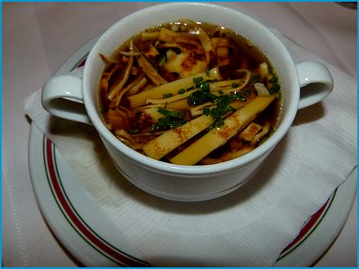
Serves 4
Pfannkuchensuppe (Flädlesuppe)
Thin, golden pancakes cut into ribbons and ladled over a clear vegetable broth, a humble Swabian-Bavarian soup that everyone remembers from childhood. It is also the most reliable way I know to get children to eat clear broth: hide pancakes in it.

Ingredients
For the Pancakes (Flädle):
- 4.5 oz. (130 g) all-purpose flour
- 250 ml (1 cup) milk
- 2 large eggs
- A pinch of salt
- 1 Tbsp. vegetable oil (for frying)
For the Broth:
- 1 L (4¼ cups) beef or chicken broth
- 1 carrot, peeled and thinly sliced
- 1 leek, thinly sliced
- 1 celery stalk, thinly sliced
- Fresh parsley, chopped (for garnish)
- Salt and pepper to taste
Method
Make the Pancake Batter:
- Whisk together the flour, milk, eggs, and salt in a mixing bowl until you have a smooth batter.
- Let the batter rest for about 15 minutes.
Cook the Pancakes:
- Heat a non-stick frying pan over medium heat and lightly grease it with vegetable oil.
- Pour a small amount of batter into the pan, just enough to coat the bottom thinly, and swirl the pan to spread the batter evenly.
- Cook the pancake until golden brown on both sides, about 1-2 minutes per side.
- Repeat with the remaining batter, stacking the cooked pancakes on a plate.
- Let them cool slightly.
Prepare the Broth:
- Bring the broth to a boil in a large pot.
- Add the sliced carrot, leek, and celery to the pot.
- Reduce the heat and let the broth simmer until the vegetables are tender, about 10-15 minutes.
- Season with salt and pepper to taste.
Slice the Pancakes:
- Roll up the cooled pancakes tightly and slice them into thin strips.
Serve the Soup:
- Divide the pancake strips among serving bowls.
- Ladle the broth and vegetables over the pancake strips.
- Garnish with freshly chopped parsley.

German Split Pea Soup
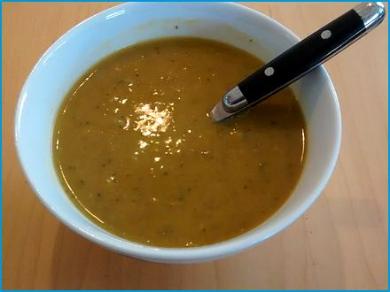
Serves 4
Erbsensuppe
A thick, filling soup of split peas, root vegetables, and marjoram, traditionally served with sausage or bacon. It tastes even better the next day, which is lucky, because this recipe does not know how to make a small pot.

Ingredients
For the Soup:
- 9 oz. (260 g) green split peas (soaking is optional)
- 1 large onion, chopped
- 2 carrots, chopped
- 1 leek, chopped
- 2 bay leaves
- 2 celery stalks, chopped
- 6 oz. (170 g) bacon, diced (optional)
- 1 tsp. marjoram (or sage)
- Salt and pepper to taste
- 6 cups (1.5 L) vegetable broth (or water)
- 2 medium potatoes, peeled and diced
For Serving:
- Fresh parsley, chopped (for garnish)
- European-style sausages (optional)
Method
Prepare the Ingredients:
- Rinse the split peas. (Soaking overnight is optional, then split peas also cook without it.)
- Chop the onion, carrots, leek, celery, and potatoes.
Cook the Soup:
- In a large pot, sauté the bacon (if using) until it starts to brown, then without bacon, heat 1 Tbsp. oil instead.
- Add the chopped onion, carrots, leek, and celery, and cook until the vegetables are softened.
- Add the rinsed split peas, bay leaves, marjoram, salt, pepper, and vegetable broth (or water).
- Bring the mixture to a boil.
- Reduce the heat and let it simmer for about 1 to 1½ hours, or until the split peas are tender.
Add the Potatoes:
- About 30 minutes before the soup is done, add the diced potatoes and cook until they are tender.
Finish and Serve:
- Remove the bay leaves and adjust the seasoning if needed.
- Slice them and add them to the soup during the last 15 minutes of cooking if using sausages.
- Serve the soup hot, garnished with fresh parsley.

German Lentil Soup
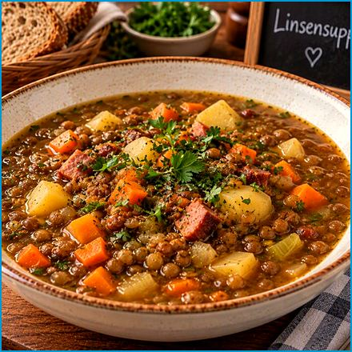
Serves 4
Linsensuppe
A hearty everyday soup of brown lentils, root vegetables, and smoky sausage, finished with a splash of vinegar at the table.
Ingredients

For the Lentils and Vegetables:
- 9 oz. (260 g) dried green or brown lentils
- 1 large onion, chopped
- 2 carrots, chopped
- 2 celery stalks, chopped
- 1 leek, chopped
- 2 cloves garlic, minced
- 1 bay leaf
- 7 oz. (200 g) potatoes, peeled and diced
For the Meat (optional):
- 6 oz. (170 g) bacon, diced (optional)
- 1-2 sausages, sliced (optional)
For the Broth and Seasoning:
- 1 tsp. dried marjoram (or thyme)
- 1.5 L (6¼ cups) vegetable or beef broth
- 2 Tbsp. olive oil
- Salt and pepper to taste
- Fresh parsley, chopped (for garnish)
Method
Prepare the Lentils:
- Rinse the lentils under cold water and drain.
Cook the Bacon and Vegetables:
- Heat the olive oil over medium heat in a large pot.
- Add the diced bacon (if using) and cook until crispy.
- Add the chopped onion, carrots, celery, leek, and minced garlic.
- Cook until the vegetables are softened, about 5-7 minutes.
Add the Lentils and Broth:
- Add the rinsed lentils, diced potatoes, bay leaf, and dried marjoram to the pot.
- Pour in the vegetable or beef broth and bring to a boil.
- Reduce the heat to a simmer, cover, and cook for about 30-40 minutes, or until the lentils and potatoes are tender.
Add the Sausages (Optional):
- Add them to the pot during the last 10-15 minutes of cooking if using sausages.
Season and Serve:
- Remove the bay leaf and adjust the seasoning with salt and pepper to taste.
- Serve hot, with a splash of vinegar at the table if you like.

Bavarian Goulash Soup
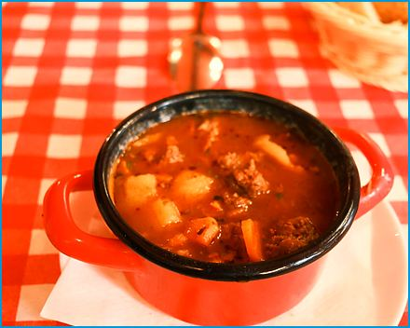
Serves 4
Gulaschsuppe
Tender beef, potatoes, and peppers in a paprika-red broth: a robust soup that is a meal in a bowl.
Ingredients
For the Goulash Base:
- 18 oz. (510 g) beef (stew meat or chuck), cut bite-sized
- 3 large onions, finely chopped
- 2 cloves garlic, minced
- 2 Tbsp. vegetable oil
- 2 Tbsp. sweet paprika powder
- 1 tsp. hot paprika powder (optional)
- 1 Tbsp. tomato paste
- 1 L (4¼ cups) beef broth
For the Vegetables:
- 2 large potatoes, peeled and diced
- 2 carrots, peeled and sliced
- 1 red bell pepper, diced
- 1 green bell pepper, diced
For the Seasoning and Garnish:
- 1 bay leaf
- 1 tsp. marjoram
- 1/2 tsp. caraway seeds (optional)
- Salt and pepper to taste
- Fresh parsley, chopped (for garnish)
- Sour cream (optional, for serving)
Method
Sear the Beef:
- Heat the vegetable oil over medium-high heat in a large pot.
- Add the beef pieces and sear them until browned on all sides.
- Remove the meat and set aside.
Cook the Onions and Garlic:
- Add the chopped onions and cook in the same pot until they become soft and translucent.
- Add the minced garlic and cook for another minute.
Add Spices and Tomato Paste:
- Stir in the sweet paprika powder, hot paprika powder (if using), and tomato paste.
- Cook for a few minutes to enhance the flavors.
Simmer the Soup:
- Return the seared beef to the pot.
- Pour in the beef broth and add the bay leaf, marjoram, and caraway seeds (if using).
- Bring the soup to a boil.
- Reduce the heat to low and let it simmer for about 1½ hours.
Add Vegetables:
- Add the diced potatoes, carrots, and bell peppers to the pot.
- Simmer the soup for another 30 minutes.
Season and Serve:
- Season the soup with salt and pepper to taste.
- Remove the bay leaf before serving.
- Ladle the Gulaschsuppe into bowls and garnish with fresh chopped parsley. For an extra touch, serve with a dollop of sour cream on top.

Sausage Sauerkraut Soup
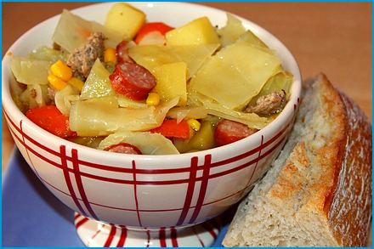
Serves 4
Sauerkrautsuppe
Tangy sauerkraut, smoked sausage, and potato in one pot, with a spoonful of sour cream on top.

Ingredients
- 1 lb. (450 g) sauerkraut, drained and rinsed
- 9 oz. (260 g) smoked sausages (such as kielbasa or bratwurst), sliced
- 1 large onion, finely chopped
- 2 cloves garlic, minced
- 1 bay leaf
- 2 Tbsp. butter or oil
- Salt and pepper to taste
- 1 large potato, peeled and diced
- 1 carrot, peeled and diced
- 1 L (4¼ cups) chicken or vegetable broth
- 1 tsp. caraway seeds (optional)
- Fresh parsley, chopped (for garnish)
- A dollop of sour cream (optional, for serving)
Method
Prepare the Ingredients:
- Drain and rinse the sauerkraut to reduce its acidity.
- Set aside.
- Slice the sausages and chop the onion, garlic, potato, and carrot.
Cook the Onions and Garlic:
- Melt the butter or heat the oil over medium heat in a large pot.
- Add the chopped onion and cook until soft and translucent.
- Add the minced garlic and cook for another minute.
Add Vegetables and Broth:
- Add the diced potato and carrot to the pot.
- Pour in the chicken or vegetable broth and bring to a boil.
Simmer the Soup:
- Add the drained sauerkraut, sliced sausages, bay leaf, and caraway seeds (if using) to the pot.
- Reduce the heat to low and let the soup simmer for 30-40 minutes, or until the vegetables are tender.
Season and Serve:
- Season the soup with salt and pepper to taste.
- Remove the bay leaf before serving.
- Ladle the soup into bowls and garnish with fresh chopped parsley. For an extra touch of richness, add a dollop of sour cream on top.

Beef Broth with Semolina Dumplings
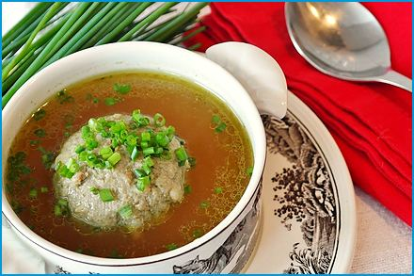
Serves 4
Rindssuppe mit Grießnockerl
The classic opener of a Bavarian Sunday lunch: a clear, golden beef broth with feather-light semolina dumplings.
Ingredients

For the Dumplings:
- 1.5 oz. (40 g) soft butter
- 1 large egg
- 3 oz. (80 g) semolina (Grieß, ideally durum)
- A pinch of salt
- A pinch of freshly grated nutmeg
- 1 Tbsp. finely chopped parsley
For the Broth:
- 1.5 L (6¼ cups) good beef broth (homemade, or clear store-bought)
- Salt to taste
- Fresh chives, finely chopped (for garnish)
Method
Make the Dumpling Dough:
- Beat the soft butter with a whisk until creamy.
- Beat in the egg.
- Stir in the semolina, salt, nutmeg, and parsley until smooth.
- Cover and let the dough rest in the refrigerator for 30 minutes so the semolina can swell.
Cook the Dumplings:
- Bring a wide pot of lightly salted water to a boil.
- Reduce the heat until it barely simmers. (Cooking the dumplings in water, not in the broth, keeps the broth clear.)
- Shape the dough into 8 small oval dumplings (Nockerl) and slide them into the water with two wet teaspoons.
- Cover and let them steep for 10-12 minutes, until they have puffed up and float.
- Do not let the water boil hard.
Serve:
- Heat the beef broth gently and season it with salt in the meantime.
- Lift the dumplings out with a slotted spoon and place 2 in each warm soup plate.
- Ladle the hot broth over them and sprinkle with chives.

Bavarian Wedding Soup
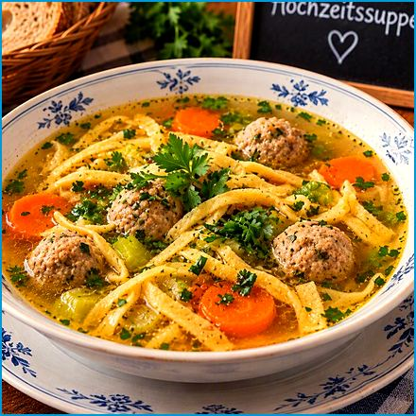
Serves 4
Hochzeitssuppe
A festive clear beef broth with tiny meatballs, golden egg-custard diamonds, and tender vegetables, traditionally served at weddings and family celebrations. You do not need a wedding. A Sunday with everyone home at once is celebration enough.
Ingredients

For the Broth:
- 1.5 L (6¼ cups) good beef broth
- 3.5 oz. (100 g) green asparagus tips or peas
- Salt and white pepper to taste
- Fresh chives or parsley, finely chopped (for garnish)
For the Egg Custard (Eierstich):
- 2 eggs
- 100 ml (3.5 fl oz.) milk
- A pinch of salt and a pinch of nutmeg
- Butter for greasing
For the Meatballs:
- 7 oz. (200 g) ground beef
- 1 egg yolk
- 2 Tbsp. breadcrumbs
- 1 Tbsp. finely chopped parsley
- Salt, pepper, and a pinch of nutmeg
Method
Make the Egg Custard:
- Preheat the oven to 160°C (320°F).
- Whisk the eggs with the milk, salt, and nutmeg.
- Pour the mixture into a small buttered ovenproof dish, cover with foil, and set it in a roasting pan filled with hot water to come halfway up the dish.
- Bake for 25-30 minutes, until set.
- Let it cool.
- Cut into small diamonds.
Make the Meatballs:
- Mix the beef, egg yolk, breadcrumbs, parsley, salt, pepper, and nutmeg and shape into marble-sized balls.
Cook the Soup:
- Bring the broth to a gentle simmer, add the meatballs, and cook for 8 minutes.
- Add the asparagus tips or peas and cook for 3-4 minutes more.
- Season with salt and pepper.
Serve:
- Place a few egg-custard diamonds in each warm soup plate, ladle over the hot broth with the meatballs and vegetables, and sprinkle with chives.

Bavarian Bread Soup
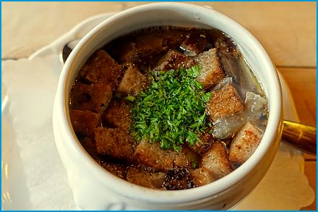
Serves 4
Brotsuppe
A thrifty farmhouse classic that turns stale bread, onions, and broth into a warm, caraway-scented soup. Bavarian grandmothers wasted nothing, and this soup is the proof.
Ingredients

- 7 oz. (200 g) stale rye or mixed bread, cut into small cubes
- 2 large onions, thinly sliced
- 2 Tbsp. butter
- 1 tsp. caraway seeds
- 1/2 tsp. dried marjoram
- 1.2 L (5 cups) beef or vegetable broth
- A pinch of freshly grated nutmeg
- 2 egg yolks
- 100 ml (3.5 fl oz.) heavy cream
- Salt and pepper to taste
- Fresh chives, chopped (for garnish)
Method
Cook the Onions:
- Melt the butter in a large pot over medium heat and cook the onions for 10-12 minutes, until deep golden.
- Stir in the caraway seeds and marjoram.
Simmer the Soup:
- Add the bread cubes and the broth and bring to a boil.
- Reduce the heat and simmer for 20 minutes, until the bread has fallen apart. For a smoother soup, stir vigorously with a whisk or blend briefly with an immersion blender.
Finish and Serve:
- Whisk the egg yolks with the cream, stir in a ladle of hot soup.
- Stir the mixture back into the pot.
- Heat gently without boiling.
- Season with nutmeg, salt, and pepper, and sprinkle with chives.

Appetizers
Bavarians call a snack a Brotzeit, "bread time", and take it as seriously as dinner. Here are the small plates, spreads, and salads that go with bread, beer, and good company.

Bavarian Snack Platter
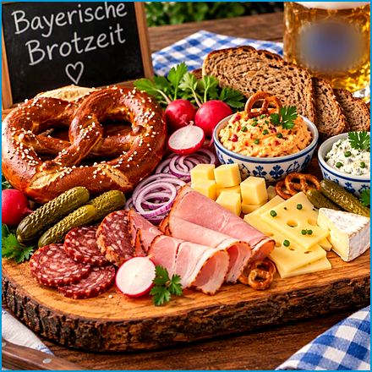
Serves 4
Bayerische Brotzeit
The Brotzeit is the Bavarian snack of choice: cold cuts, cheeses, spreads, pretzels, and crunchy radishes on one board, shared with a cold beer. There is no cooking involved, which is exactly its charm on a summer evening.
Ingredients
Meats:
- Cold cuts (salami, ham, smoked ham, liverwurst)
- Smoked sausage (e.g. Landjäger, salami sticks)
- Bavarian Leberkäse (meat loaf)
Cheeses:
- Slices of Emmental or Swiss and aged gouda
Bread:
- Fresh pretzels (Brezen)
- Sourdough or rye bread
- Crusty rolls (Semmeln) or Ciabatta
Extras:
- Obazda (see the Bavarian Cheese Spread recipe)
- Radishes
- Pickles
- Hard-boiled eggs
- Butter
- Griebenschmalz (lard with crisp cracklings and apple)
- Bavarian sweet mustard
Garnishes:
- Fresh chives and parsley, finely chopped
Method
Arrange the Platter:
- Place the cold cuts, smoked sausages, and Leberkäse on one side of the platter.
- Arrange the cheeses, including slices of Emmental, Obazda spread, and aged gouda, on the other side.
- Add the breads, such as pretzels, rye bread, and rolls, to the platter.
Add the Extras:
- Include radishes, both Radi (white radish) and Radieserl (red radishes), on the platter.
- Add pickles, hard-boiled eggs, Griebenschmalz, and a few dollops of butter.
Serve with Mustard:
- Place a small bowl of Bavarian mustard on the side for dipping.
Garnish and Serve:
- Garnish the platter with freshly chopped chives and parsley.
- Serve the Brotzeitplatte with a cold Bavarian beer for an authentic experience.

Goat Cheese with Beetroot and Pistachio Brittle
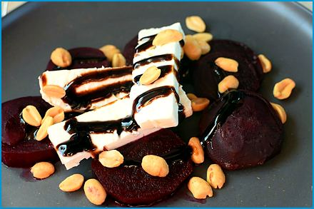
Serves 4
Ziegenkäse mit Rote Beete und Pistazienkrokant
Creamy goat cheese on sweet roasted beetroot, scattered with crunchy pistachio brittle: a modern starter with a Bavarian farm-shop feel.

Ingredients
For the Beetroot:
- 2-3 medium beetroots, peeled and thinly sliced
- 2 Tbsp. olive oil
- 1 Tbsp. balsamic vinegar
- Salt and pepper to taste
For the Goat Cheese:
- 7 oz. (200 g) goat cheese, sliced into rounds
For the Pistachio Brittle:
- 3.5 oz. (100 g) pistachios, shelled
- 2 oz. (55 g) sugar
- 1 Tbsp. water
For Garnish:
- Fresh arugula or mixed greens
- A drizzle of honey or balsamic glaze (optional)
Method
Prepare the Beetroot:
- Preheat your oven to 200°C (400°F).
- Toss the thinly sliced beetroots with olive oil, balsamic vinegar, salt, and pepper in a bowl.
- Arrange the beetroot slices on a baking sheet lined with parchment paper.
- Roast in a preheated oven for about 25 minutes, or until they are tender and slightly caramelized.
- Set aside to cool.
Prepare the Pistachio Brittle:
- Combine the sugar and water over medium heat in a small saucepan.
- Stir until the sugar dissolves.
- Let it cook without stirring until it turns a golden amber color.
- Quickly stir in the shelled pistachios and pour the mixture onto a parchment-lined baking sheet.
- Spread it out evenly and let it cool completely.
- Break it into small pieces once cooled.
Assemble the Dish:
- Arrange the roasted beetroot slices on a serving plate.
- Place the goat cheese rounds on top of the beetroot slices.
- Sprinkle the pistachio brittle pieces over the goat cheese.
- Garnish with fresh arugula or mixed greens.
Serve:
- Drizzle with honey or balsamic glaze for added sweetness and flavor (optional).
- Serve immediately and enjoy!

Leberkäse
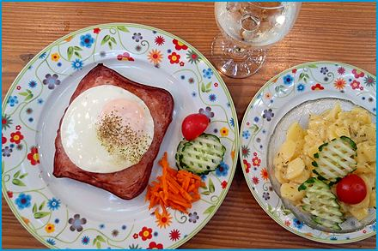
Serves 4
Despite its name, Leberkäse has no liver: it is a finely ground meat loaf with a crisp, dark crust, sliced thick and eaten warm in a roll. It contains neither liver nor cheese. Bavarians find this perfectly reasonable, and after one slice so will you.
Ingredients

- 1 lb. (450 g) fatty ground pork (about 30% fat, e.g. shoulder with belly), very cold
- 8 oz. (230 g) lean ground beef, very cold
- 1 small onion, finely chopped
- 2 tsp. dried marjoram
- 175 g (6 oz.) crushed ice
- 2 tsp. salt
- 1/2 tsp. white pepper
- 1/4 tsp. ground nutmeg
- 1/4 tsp. ground coriander
Method
Prepare the Meat Mixture:
- Combine the ground pork and ground beef in a large bowl.
- Add the finely chopped onion.
- Add the salt, white pepper, ground nutmeg, ground coriander, and marjoram.
- Chill the meat well, then process it in batches in a food processor together with the crushed ice until it forms a very fine, smooth paste (keep it below 12 °C / 54 °F).
Form the Leberkäs:
- Preheat your oven to 170°C (340°F).
- Grease a loaf pan or a baking dish.
- Press the meat mixture into the pan, smoothing the top with a wet spatula.
- Score the top of the meat mixture in a diamond pattern to help develop a good crust.
Bake the Leberkäs:
- Place the loaf pan in the preheated oven.
- Bake for about 45-60 minutes, or until the internal temperature reaches 72°C (160°F) and the top is golden brown and crispy.
Serve:
- Let the Leberkäs rest for a few minutes before slicing.
- Serve with traditional sides like potato salad, sauerkraut, or a pretzel.

Bavarian Cheese Spread
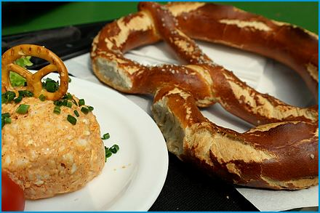
Serves 4
Obazda
Obatzda, the beer-garden spread: ripe Camembert mashed with butter, onion, and paprika, served with pretzels and radishes. It began as a way to rescue ripe cheese, and it has been improving beer gardens ever since.
Ingredients

- 8 oz. (230 g) Camembert or Brie cheese, ripened and soft
- 1.5 oz. (45 g) butter, softened
- 1-2 Tbsp. cream cheese (or sour cream)
- 1-2 Tbsp. wheat beer (optional)
- 1 small onion, finely chopped
- 2 tsp. mild paprika powder
- 1 tsp. caraway seeds (optional)
- Salt and pepper to taste
- Fresh chives or parsley chopped (for garnish)
- Radishes and pretzels (for serving)
Method
Prepare the Cheese:
- Cut the Camembert cheese into small pieces. If the cheese is too soft to cut, you can also mash it with a fork.
Mix Ingredients:
- Combine the Camembert cheese and softened butter, and cream cheese (or sour cream) in a mixing bowl.
- Add the finely chopped onion and paprika powder to the bowl.
- Add the caraway seeds if using.
- Mix everything together until you get a smooth, spreadable consistency. You can use a fork, a whisk, or even an immersion blender to achieve this.
Season:
- Season the mixture with salt and pepper to taste.
- Adjust the seasoning according to your preference. If you like it spicier, you can add more paprika or a pinch of cayenne pepper.
Chill:
- Cover the bowl with plastic wrap and refrigerate the Obazda for at least an hour to let the flavors meld together.
Serve:
- Let the Obazda come to room temperature before serving.
- Garnish with freshly chopped chives.
- Serve with radishes and pretzels for an authentic Bavarian snack.

Bavarian Sausage Salad
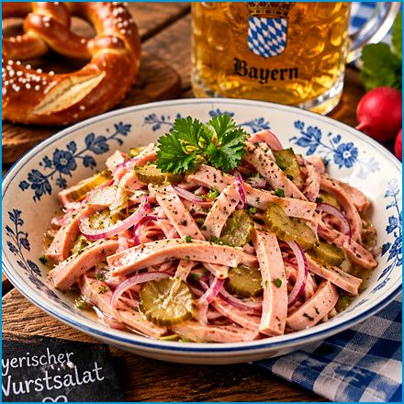
Serves 4
Bayerischer Wurstsalat
Thin strips of sausage and onion in a sharp vinegar dressing, a cool beer-garden snack eaten with rye bread.
Ingredients

- 18 oz. (510 g) sausage, thinly sliced into thin strips (Lyoner, Mortadella, or Bologna)
- 1 large onion, sliced
- 4 Tbsp. white wine vinegar
- 3 Tbsp. sunflower or canola oil
- 100 ml (3.5 fl oz.) beef broth or water
- 1 tsp. medium-hot mustard
- 3 small gherkins, sliced
- Salt and pepper to taste
- Fresh chives or parsley, chopped (for garnish)
Method
Prepare the Ingredients:
- Slice the sausage and onions into thin strips.
Make the Dressing:
- Whisk together the vinegar, broth, mustard, oil, salt, and pepper in a large bowl.
Combine and Toss:
- Add the sliced sausage, onion, and pickles to the bowl with the dressing.
- Toss everything together until well combined and the ingredients are evenly coated with the dressing.
Marinate:
- Let the salad marinate in the refrigerator for at least 1 hour before serving to allow the flavors to meld together.
Serve:
- Garnish with fresh chopped chives or parsley.
- Serve the Wurstsalat chilled, with some crusty bread or pretzels on the side.

Red and White Head Cheese
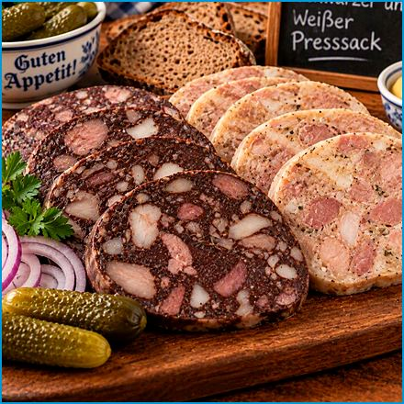
Serves 8 as a starter
Roter und Weisser Pressack
Two old-fashioned cold cuts from the butcher's counter: the dark one with blood, the pale one without. Served in slices with bread and pickles.
Ingredients
Roter Pressack (Blood Sausage)
- 18 oz. (510 g) pork head meat or pork belly
- 9 oz. (260 g) pork blood
- 3.5 oz. (100 g) pork rind
- 1 large onion, finely chopped
- Salt and pepper to taste
- A pinch of marjoram
- A pinch of ground allspice
- A pinch of ground cloves
Weisser Pressack (White Head Cheese)
- 18 oz. (510 g) pork head meat or pork belly
- 9 oz. (260 g) pork rind
- 1 large onion, finely chopped
- Salt and pepper to taste
- A pinch of marjoram
- A pinch of ground white pepper
Method
Prepare the Meat:
- Cook the pork head meat or pork belly until tender.
- Let it cool.
- Cut it into small pieces.
- Boil the pork rind until soft and cut it into small strips.
Cook the Onions:
- Cook the finely chopped onion in a large skillet until soft and translucent.
Combine Ingredients:
- Combine the cooked meat, pork rind, and cooked onions in a large bowl. For the red version, stir in the pork blood (fresh and chilled) once the mixture has cooled slightly.
- Season with salt, pepper, and marjoram.
- Add the ground allspice and cloves to the red version and the white pepper to the white version.
- Mix well.
Fill the Casings:
- Fill sausage casings with the mixture, making sure to tie off the ends securely.
Cook the Sausages:
- Poach the sausages in water at about 80 °C (176 °F) for about 30-40 minutes, making sure not to boil them to prevent bursting.
Cool and Serve:
- Let the sausages cool completely before slicing.
- Serve with bread and pickles.

Radishes Salad
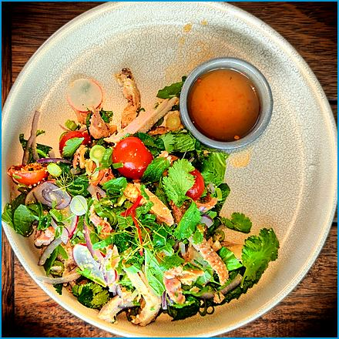
Serves 4
Radi und Radieserl Salat
Paper-thin slices of white and red radish with salt and a light dressing, the classic partner of a Maß of beer.
Ingredients

- 1 large white radish (Radi)
- 1 bunch of red radishes (Radieserl)
- 2 Tbsp. white wine vinegar
- 2 Tbsp. sunflower oil
- Salt and pepper to taste
- Fresh chives, finely chopped (optional)
- 1/2 cucumber (optional)
- Fresh sprouts (optional)
- Bread or pretzels (for serving)
Method
Prepare the Vegetables:
- Wash and peel the white radish.
- Slice it thinly, preferably using a mandoline or a sharp knife.
- Wash the radishes and slice them thinly as well.
- Wash the cucumber and slice it thinly if using.
Make the Dressing:
- Whisk together the white wine vinegar, sunflower oil, salt, and pepper in a small bowl.
Assemble the Salad:
- Combine the sliced white radish, radishes, and cucumber in a large bowl.
- Pour the dressing over the vegetables and toss to coat evenly.
Serve:
- Garnish the salad with freshly chopped chives.
- Let the salad sit for a few minutes to allow the flavors to meld before serving.

Deviled Eggs
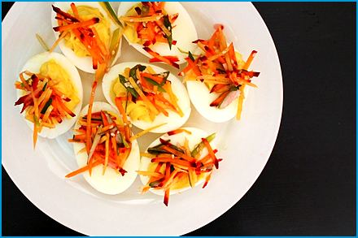
Serves 4
Gefüllte Eier
Halved eggs with a creamy mustard-yolk filling, ideal for a party platter.
Ingredients
- 6 large eggs
- 3 Tbsp. mayonnaise
- 1 tsp. Dijon mustard
- 1 tsp. white vinegar
- Salt and pepper to taste
- Paprika (for garnish)
- Fresh chives or parsley (optional, for garnish)
Method
Boil the Eggs:
- Place the eggs in a single layer in a saucepan and cover with water.
- Bring the water to a boil over medium-high heat.
- Remove the saucepan from heat and cover once boiling.
- Let the eggs sit in the hot water for about 12 minutes.
- Drain the hot water and cool the eggs under cold running water or in an ice bath.
Prepare the Eggs:
- Peel them and cut them in half lengthwise once the eggs are cool.
- Carefully remove the yolks and place them in a bowl.
- Set the egg whites aside.
Make the Filling:
- Mash the egg yolks with a fork until they are crumbly.
- Add the mayonnaise, Dijon mustard, white vinegar, salt, and pepper to the yolks.
- Mix until smooth and creamy.
Fill the Eggs:
- Spoon or pipe the yolk mixture back into the egg white halves.
- Sprinkle with paprika for a touch of color and flavor.
- Garnish with fresh chives or parsley if desired.
Serve:
- Arrange the deviled eggs on a platter and serve chilled.

Grilled and Braised Asparagus
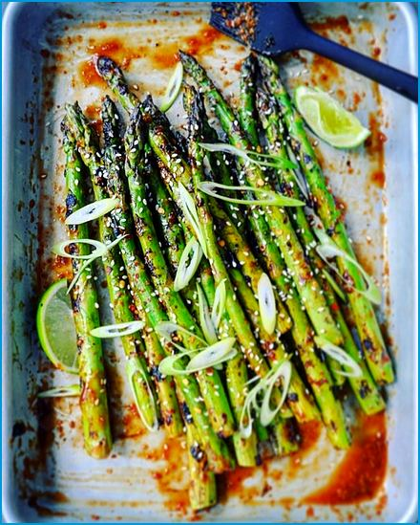
Serves 4
Geschmorter Spargel vom Grill
Asparagus charred on the grill, then finished in a garlicky butter broth until tender and smoky.
Ingredients

- 18 oz. (510 g) asparagus, trimmed
- 2 Tbsp. olive oil
- Salt and pepper to taste
- 2 cloves garlic, minced
- 1 lemon, sliced
- 1 Tbsp. butter
- 200 ml (¾ cup) vegetable broth
- Fresh herbs like parsley or dill, chopped (for garnish)
Method
Prepare the Asparagus:
- Preheat your grill to medium-high heat.
- Toss the asparagus with olive oil, salt, and pepper.
Grill the Asparagus:
- Place the asparagus directly on the grill grates.
- Grill for about 5-7 minutes, turning occasionally, until the asparagus is lightly charred and tender.
Braise the Asparagus:
- Melt the butter over medium heat in a large skillet.
- Add the minced garlic and sauté for about 1 minute, until fragrant.
- Add the grilled asparagus to the skillet and pour in the vegetable broth.
- Bring to a simmer and cook for another 5-7 minutes, until the asparagus is fully tender and the broth has reduced slightly.
Serve:
- Transfer the asparagus to a serving platter.
- Garnish with fresh lemon slices and chopped herbs.

Weißwurst with Sweet Mustard and Pretzel
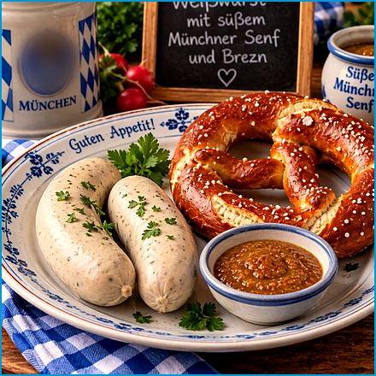
Serves 4
Weißwurst mit süßem Senf und Brezn
Munich’s white veal sausage is the heart of the Bavarian second breakfast (Weißwurstfrühstück). Tradition says it should be eaten before the noon bells ring. Tradition says a Weißwurst should never hear the noon bells. In our kitchen it rarely sees ten o'clock.
Ingredients

For the Sausages:
- 8 fresh Weißwürste (2 per person)
- 4 soft pretzels (Brezn)
- 1 wheat beer (Weißbier) per person, for serving
For the Sweet Mustard:
- 5 Tbsp. mild yellow mustard
- 1 Tbsp. honey
- 1 Tbsp. light brown sugar
- 1 tsp. apple cider vinegar
Method
Heat the Water:
- Bring about 2 L (8¼ cups) of water to a boil in a large pot.
- Take it off the heat and let it cool to about 80 °C (175 °F): hot and steaming, but no bubbles.
Steep the Sausages:
- Add the Weißwürste without piercing them and cover the pot.
- Let them steep for 10-15 minutes.
- Never boil them, or their delicate skins will burst.
Make the Sweet Mustard:
- Stir the mustard, honey, brown sugar, and vinegar until smooth and let it stand for 10 minutes.
Serve:
- Serve the sausages in a warmed bowl with a little of the hot water, with the sweet mustard, pretzels, and a wheat beer. To eat them the traditional way, cut the sausage lengthwise and peel the skin away, or suck the filling out of the skin (zuzeln). The skin is not eaten.

Main Courses
This is the heart of the book: roasts, schnitzels, stews, and the Sunday dishes that bring a family to the table on time without anyone being called twice.

Bavarian Braised Beef
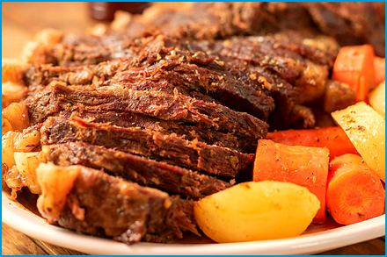
Serves 4
Bayerischer Rinderschmorbraten
A beef roast braised for hours in red wine and vegetables until it falls apart under the fork, with plenty of gravy.
Ingredients

- 2.2 lbs. (1 kg) beef roast (chuck or round)
- 2 Tbsp. vegetable oil
- Salt and pepper
- 1 large onion, finely chopped
- 2 cloves garlic, minced and 2 carrots, chopped
- 1 celery stalk, chopped
- 2 Tbsp. tomato paste
- 500 ml (2 cups) beef broth
- 125 ml (1/2 cup) red wine
- 2 bay leaves
- 1 tsp. dried thyme
- 1 tsp. dried marjoram
- 1 Tbsp. flour (optional, for thickening)
- Fresh parsley, chopped (for garnish)
Method
Preparation:
- Season the beef roast generously with salt and pepper.
- Preheat your oven to 160°C (320°F).
Sear the Beef:
- Heat the vegetable oil over medium-high heat in a large oven-safe pot or Dutch oven.
- Sear the beef roast on all sides until it is well browned.
- Remove the beef from the pot and set it aside.
Cook Vegetables:
- Add chopped onions, garlic, carrots, and celery.
- Cook until the vegetables are softened and starting to brown.
- Stir in the tomato paste and cook for another minute.
Deglaze:
- Pour in the red wine and beef broth, scraping up any browned bits from the bottom of the pot.
- Add the bay leaves, thyme, and marjoram.
- Stir well to combine.
Braise the Beef:
- Return the beef roast to the pot, cover it with a lid, and transfer the pot to the preheated oven.
- Braise the beef for about 2½ hours, or until the meat is tender and easily pulls apart with a fork.
Thicken the Sauce (Optional):
- Remove the beef from the pot and keep it warm if you prefer a thicker sauce.
- Mix the flour with a small amount of cold water to make a slurry, and gradually stir it into the sauce.
- Cook the sauce over medium heat until it thickens to your desired consistency.
Serve:
- Slice the beef and serve it with the braising sauce.
- Garnish with fresh parsley.
- Serve with traditional sides like bread dumplings (Semmelknödel), mashed potatoes, or red cabbage.

Sauerkraut and Mashed Potatoes
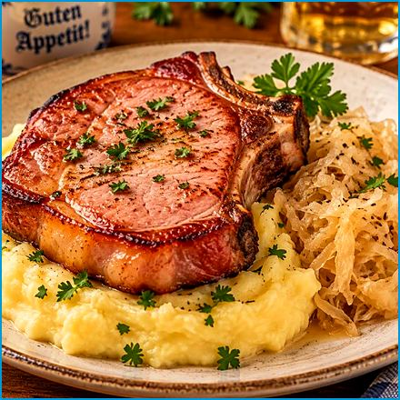
Serves 4
Kassler Rippchen mit Sauerkraut und Kartoffelpüree
Smoked pork chops, tangy sauerkraut, and buttery mashed potatoes: simple Bavarian comfort food on one plate.
Ingredients

For the Kassler Rippchen:
- 4 smoked pork chops, salt and pepper
- 1 Tbsp. vegetable oil
- 1 bay leaf
- 1 tsp. caraway seeds (optional)
- 1 onion, finely chopped
- 1 clove garlic, minced
- 1 lb. (450 g) sauerkraut
- 250 ml (1 cup) vegetable broth
For the Mashed Potatoes:
- 2 lbs. (910 g) potatoes, peeled and cut into chunks, salt and pepper to taste
- 1.5 oz. (45 g) butter
- 200 ml (¾ cup) milk, warmed
- Nutmeg (optional)
Method
Prepare the Sauerkraut:
- Heat the vegetable oil over medium heat in a large pot.
- Add the chopped onion and minced garlic, and sauté until they are soft and translucent.
- Add the sauerkraut, vegetable broth, bay leaf, and caraway seeds (if using).
- Season with salt and pepper to taste.
- Bring to a simmer, cover, and cook on low heat for about 30 minutes, stirring occasionally.
Cook the Kassler Rippchen:
- Heat a separate pan over medium-high heat while the sauerkraut is simmering.
- Add the Kassler Rippchen and sear on both sides about 2-3 minutes until they are golden brown.
- Reduce the heat to low and cover the pan.
- Let the Kassler Rippchen cook for another 10-15 minutes until they are heated through.
Prepare the Mashed Potatoes:
- Place the potato chunks in a large pot and cover with cold water while the sauerkraut and Kassler Rippchen are cooking.
- Bring to a boil and cook until the potatoes are tender, about 15-20 minutes.
- Drain the potatoes and return them to the pot.
- Add the butter and warmed milk, and mash until smooth and creamy.
- Season with salt, pepper, and a pinch of nutmeg (if using).
Serve:
- Arrange the Kassler Rippchen on plates.
- Serve with a generous helping of sauerkraut and a scoop of mashed potatoes on the side.

Creamy Mushroom Dish
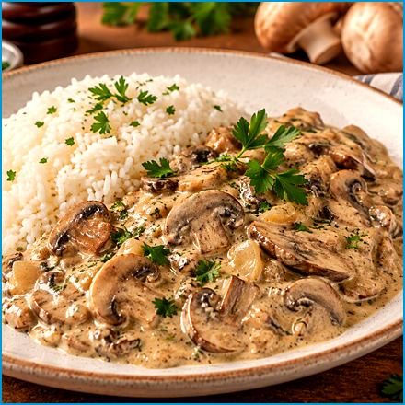
Serves 4
Rahmschwammerl
Mushrooms in a cream sauce, the Bavarian answer to a vegetarian main course. Perfect over bread dumplings.
Ingredients

- 18 oz. (510 g) sliced mushrooms (such as cremini or button mushrooms)
- 1 large onion, finely chopped
- 2 Tbsp. butter
- 200 ml (¾ cup) heavy cream
- 100 ml (3.5 fl oz.) vegetable broth
- 1 Tbsp. flour
- 1 tsp. lemon juice
- Salt and pepper to taste
- Fresh parsley, chopped (for garnish)
Method
Prepare Mushrooms:
- Clean the mushrooms by wiping them with a damp cloth, brushing off any dirt.
- Slice them evenly.
Sauté Onions:
- Melt butter over medium heat in a large skillet.
- Add chopped onion, sauté until they are soft.
Cook Mushrooms:
- Add the sliced mushrooms to the skillet.
- Cook 12 minutes to release moisture.
Thicken Sauce:
- Sprinkle flour over the mushrooms and stir well.
- Cook for another minute to eliminate raw flour taste.
Add Liquid:
- Slowly add the vegetable broth, stirring constantly to avoid lumps.
- Bring the mixture to a simmer.
Add Cream:
- Pour in the heavy cream and mix well.
- Simmer gently until it thickens to desired consistency, about 8 minutes.
Season and Finish:
- Add the lemon juice, salt, and pepper to taste.
- Stir in the chopped parsley just before serving.
Serve:
- Serve hot over bread dumplings or with a side of meat. It’s a versatile and comforting dish that’s sure to be a hit!

Roasted Duck (Ente) Stuffed with Apples
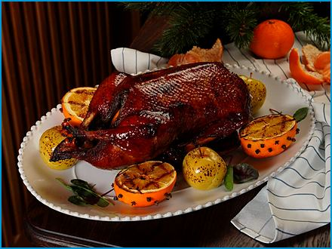
Serves 4
A whole roast duck with crisp skin, filled with apples and herbs, for festive occasions.
Ingredients

- 1 whole duck (about 5 lbs. (2.3 kg))
- Salt and pepper to taste
- 2-3 apples, cored and quartered
- 1 onion, quartered
- 2-3 sprigs fresh thyme
- 1 Tbsp. dried marjoram
- 1 lemon, quartered
- 2-3 cloves garlic, smashed
- 1 cup (240 ml) chicken broth or water
- 1 Tbsp. honey
- 1 Tbsp. soy sauce (optional)
Method
Prepare the Duck:
- Preheat your oven to 180°C (350°F).
- Rinse the duck thoroughly under cold water and pat it dry with paper towels.
- Season the duck generously with salt and pepper, both inside and out.
Stuff the Duck:
- Stuff the cavity of the duck with the apple quarters, onion quarters, lemon quarters, thyme sprigs, marjoram, and smashed garlic cloves.
- Tie the legs together with kitchen twine to keep the stuffing in place.
Roast the Duck:
- Place the duck on a rack in a roasting pan.
- Pour the chicken broth or water into the bottom of the roasting pan to keep the duck moist.
- Roast the duck in the preheated oven for about 2 to 2.5 hours, or until the skin is crispy and golden brown, and the internal temperature reaches 74°C (165°F).
Glaze the Duck (Optional):
- In the last 30 minutes of roasting, you can brush it with honey and soy sauce for added flavor and color.
Rest and Serve:
- Remove the duck from the oven and let it rest for about 10-15 minutes before carving.
- Serve the roasted duck with the apples and onions from the stuffing, along with your favorite sides such as red cabbage, potato dumplings, or a fresh salad.

Tarte Flambée
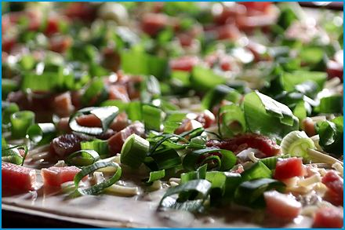
Serves 4
Flammkuchen
A paper-thin crust topped with crème fraîche, bacon, and onion, baked until the edges blister. It comes from Alsace but is loved across southern Germany.
Ingredients

For the Dough:
- 8 oz. (230 g) all-purpose flour
- 1/2 tsp. salt
- 2 Tbsp. olive oil
- 125 ml (½ cup) water
For the Toppings:
- 7 oz. (200 g) crème fraîche and / or sour cream)
- 1 large onion, thinly sliced
- 7 oz. (200 g) diced smoked bacon (or cured ham)
- Salt and pepper to taste
- Fresh chives or parsley, chopped (optional, for garnish)
Method
Prepare the Dough:
- Combine the flour and salt in a large mixing bowl.
- Add the olive oil and water, and mix until a dough forms.
- Knead the dough on a lightly floured surface until smooth and elastic, about 5 minutes.
- Cover the dough with a clean towel and let it rest for about 30 minutes.
Preheat the Oven:
- Preheat your oven to its highest setting (250°C / 480°F) and place a baking sheet to heat up.
Prepare the Toppings:
- Cook the diced bacon at medium heat in a skillet until crispy.
- Remove from the pan and set aside.
- Cook the sliced onions in the same skillet until they are soft and slightly caramelized.
Assemble the Flammkuchen:
- Divide the dough into two equal portions.
- Roll out each portion very thinly on parchment paper until about the size of the baking sheets.
- Spread a generous layer of crème fraîche over each rolled-out dough. Evenly distribute the cooked bacon and onions over the top.
- Season with salt and pepper to taste.
Bake the Flammkuchen:
- Carefully transfer the Flammkuchen on the parchment paper to the hot baking sheet.
- Bake for about 10-12 minutes, or until the edges are crisp and golden brown.
Serve:
- Garnish with fresh chives or parsley if desired.

Bavarian Beer Goulash
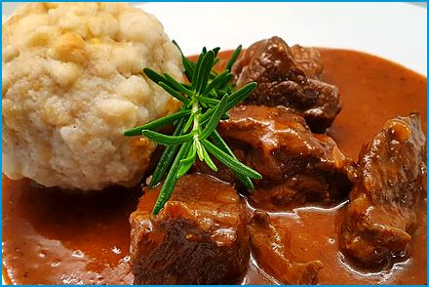
Serves 4
Bayerisches Biergulasch
Beef slowly simmered in dark beer and paprika until the sauce turns deep and glossy.

Ingredients
- 1.5 lbs. (680 g) beef stew meat, cut into bite-sized pieces
- 2 large onions, finely chopped
- 3-4 cloves garlic, minced
- 3 Tbsp. vegetable oil
- 2 Tbsp. tomato paste
- 1 bottle dark beer (Dunkel or Stout)
- 500 ml (2 cups) beef broth
- 2 Tbsp. sweet paprika powder
- 1 tsp. caraway seeds
- 1 bay leaf
- Salt and pepper to taste
- 2-3 Tbsp. flour (optional, for thickening)
- Fresh parsley, chopped (for garnish)
Method
Prepare the Meat:
- Season the beef with salt and pepper.
- Heat the oil over medium-high heat and brown the beef on all sides in a large pot.
Cook Onions and Garlic:
- Remove the browned meat from the pot and set aside.
  - Cook the chopped onions until they are soft and golden.
  - Add the garlic and cook for another 2 minutes.
Add Tomato Paste and Spices:
- Stir in the tomato paste, paprika, and caraway seeds.
- Cook for a few mins until the paste darkens.
Deglaze and Simmer:
- Add the beer and beef broth, scraping up any browned bits from the bottom of the pot.
- Return the browned beef.
- Add the bay leaf.
- Bring the mixture to a boil.
- Reduce the heat and let it simmer gently for 2 hours.
- Mix the flour with a small amount of cold water to make a slurry if you prefer a thicker sauce.
- Gradually stir the slurry into the goulash and let it simmer until the sauce thickens.
Serve:
- Remove the bay leaf and adjust the seasoning with salt and pepper if needed.
- Garnish with fresh parsley.
- Serve this Biergulasch hot with traditional sides like bread dumplings (Semmelknödel), potatoes, or spätzle.

Jägerschnitzel
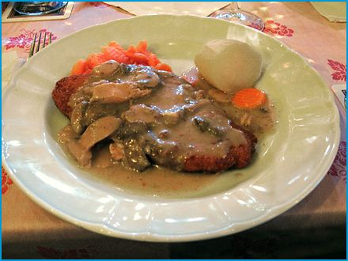
Serves 4
Crispy breaded pork cutlets with a creamy mushroom sauce, the German "hunter's style". No hunting is required; the mushrooms come quietly.
Ingredients

For the Schnitzel:
- 4 boneless pork chops
- 1 cup (240 ml) all-purpose flour, salt and pepper
- 2 large eggs, beaten
- 1 cup (240 ml) breadcrumbs
- about 1/2 cup (120 ml) vegetable oil or clarified butter (Butterschmalz), for shallow frying
For the Jäger Sauce:
- 9 oz. (260 g) sliced mushrooms (button or cremini)
- 1 onion, chopped and 3 cloves garlic, minced
- 2 Tbsp. butter and 1 Tbsp. all-purpose flour
- 200 ml (¾ cup) beef broth and 100 ml (3.5 fl oz.) heavy cream
- 1 tsp. paprika powder, salt and pepper to taste
- Fresh parsley, chopped (for garnish)
Method
Prepare the Schnitzel:
- Pound the pork chops to about 1/4 inch thickness using a meat mallet or rolling pin.
  - Season the pork chops with salt and pepper.
Bread the Schnitzel:
- Set up three shallow dishes: one with flour, one with beaten eggs, and one with breadcrumbs.
- Dredge each pork chop in flour, shaking off any excess.
- Dip in the beaten eggs, and finally coat with breadcrumbs.
Press the breadcrumbs firmly onto the meat to ensure an even coating.
Fry the Schnitzel:
- Heat the vegetable oil or clarified butter in a large skillet over medium-high heat.
- Fry the breaded pork chops until golden brown and cooked through, about 3-4 minutes per side.
- Transfer the cooked schnitzels to a plate lined with paper towels to drain any excess oil.
- Keep warm.
Prepare the Jäger Sauce:
- Melt the butter over medium heat in the same skillet.
- Add the chopped onions and garlic, and sauté until they are soft and translucent.
- Add the sliced mushrooms and cook until they release their moisture and start to brown.
- Sprinkle the flour over the mushrooms and stir well to combine.
- Cook for another minute.
- Gradually add the beef or vegetable broth, stirring constantly to avoid lumps.
- Add the heavy cream.
- Stir well.
- Season with paprika, salt, and pepper.
- Let the sauce simmer for about 5-10 minutes until it thickens.
Serve:
- Place the schnitzels on serving plates and spoon the Jäger sauce generously over the top.
- Garnish with freshly chopped parsley.
- Serve with traditional sides like Spätzle, potato dumplings, or a fresh salad.

Bavarian-style Skewers
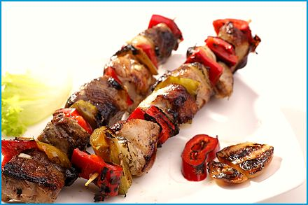
Serves 4
Bayerische Schaschlik Spiesse
Marinated pork, bacon, and colorful vegetables threaded on skewers and grilled until lightly charred.

Ingredients
For the Skewers:
- 18 oz. (510 g) pork shoulder or neck, cut into bite-sized pieces
- 7 oz. (200 g) button mushrooms
- 1 sliced zucchini
- 1 red bell pepper, cut into chunks
- 1 yellow bell pepper, cut into chunks
- 1 large onion, cut into chunks
- 7 oz. (200 g) smoked bacon, cut into pieces
- Wooden or metal skewers
For the Marinade:
- 3 cloves garlic, minced
- 1 Tbsp. paprika
- 1 tsp. ground cumin
- 1 tsp. dried oregano
- 1 tsp. dried thyme
- 1 tsp. salt
- 1/2 tsp. black pepper
- 2 Tbsp. olive oil
- 1/4 cup (60 ml) white wine or apple cider vinegar
- 2 Tbsp. honey, brown sugar or sweetener
Method
Prepare the Marinade:
- Combine the garlic, paprika, ground cumin, dried oregano, dried thyme, salt, black pepper, olive oil, white wine or apple cider vinegar, and honey, sweetener or brown sugar in a large bowl.
- Mix well.
Marinate the Meat:
- Add the pork pieces to the marinade and toss to coat evenly.
- Cover the bowl with plastic wrap and refrigerate for at least 2 hours, preferably overnight.
Assemble the Skewers:
- Soak them in water for at least 30 minutes to prevent burning if using wooden skewers.
- Thread the marinated pork pieces, bell peppers, onion chunks, bacon pieces, mushrooms, and zucchini slices alternately onto the skewers.
Grill the Skewers:
- Preheat your grill to medium-high heat.
- Place the skewers on the grill and cook for about 10-15 minutes, turning occasionally, until the meat is cooked through and the vegetables are tender and slightly charred.
Serve:
- Transfer the Bayern Schaschlik to a serving platter.
- Serve hot with your favorite dipping sauces, bread, or a side salad.

Gourmet Fish Fillets
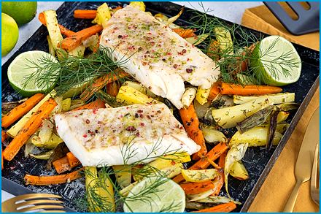
Serves 4
Schlemmerfilet
White fish fillets under a crisp garlic-parsley crumb, baked until golden. Quick and family-friendly.
Ingredients

- 4 white fish fillets (such as cod or pollock)
- Salt and pepper to taste
- 2 Tbsp. lemon juice
- 3-4 cloves garlic, minced
- 3.5 oz. (100 g) breadcrumbs
- 1.7 oz. (50 g) grated Parmesan cheese
- 3 Tbsp. chopped fresh parsley
- 3 Tbsp. melted butter
- 1 Tbsp. olive oil
- Lemon wedges (for serving)
Method
Prepare the Fish:
- Preheat your oven to 180°C (350°F).
- Season the fish fillets with salt, pepper, and lemon juice.
- Place them in a baking dish.
Make the Topping:
- Combine the minced garlic, breadcrumbs, grated Parmesan cheese, and chopped parsley in a bowl.
- Add the melted butter and olive oil to the mixture and stir until well combined.
Top the Fish:
- Spread the garlic breadcrumb mixture evenly over the fish fillets, pressing it down gently to adhere.
Bake the Fish:
- Bake in the preheated oven for about 20-25 minutes, or until the fish is cooked through and the topping is golden and crispy.
Serve:
- Serve the Schlemmerfilet with lemon wedges on the side.

Roasted Pork Knuckle
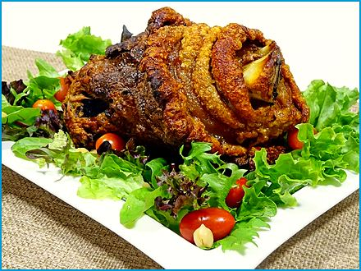
Serves 4
Schweinshaxen
The beer-hall king: a pork knuckle roasted in beer and caraway until the skin crackles and the meat is tender. One knuckle feeds two people, or one Bavarian on a Sunday.
Ingredients

- 2 pork knuckles (about 1.5-2 lbs. (680-910 g) each)
- Salt
- Pepper
- Caraway seeds
- 1-2 onions, quartered
- 2-3 garlic cloves, crushed
- 1-2 carrots, chopped
- 1-2 celery stalks, chopped
- 1-2 bay leaves
- 1-2 cups (240-480 ml) beer (dark beer is preferable)
Method
Preparation:
- Preheat your oven to 350°F (175°C).
- Rinse the pork knuckles under cold water and pat them dry with paper towels.
- Score the skin of the knuckles in a crisscross pattern to help the fat render for crispiness.
Seasoning:
- Rub the pork knuckles generously with salt, pepper, and caraway seeds.
Roasting:
- Place the pork knuckles in a roasting pan.
- Surround them with the onions, crushed garlic, chopped carrots, celery and bay leaves.
- Pour the beer over the pork knuckles and vegetables.
Baking:
- Place the roasting pan in the preheated oven and roast for about 2 to 3 hours.
- Baste the pork knuckles occasionally with the pan juices to keep them moist.
- Cover the knuckles with aluminum foil if they start browning too quickly after the first hour.
- Continue roasting until the meat is tender.
- Raise the oven to 220°C (430°F) for the last 15-20 minutes so the skin turns blistered and crackling-crisp.
Serving:
- Remove the pork knuckles from the oven and let them rest for a few minutes.
- Serve with roasted vegetables and side dishes like sauerkraut, potatoes or dumplings.
- Enjoy with a cold beer for an authentic Bavarian experience!

Bavarian Burger

Serves 4
with Horseradish-Cranberry Dip
A juicy beef patty seasoned with marjoram and mustard, melted Swiss cheese, and a sharp horseradish-cranberry dip.
Ingredients

For the Burger Patties:
- 18 oz. (510 g) ground beef
- 1 egg
- 1 small onion, finely chopped
- 2 Tbsp. breadcrumbs
- 1 tsp. mustard
- 1 tsp. dried marjoram
- Salt and pepper to taste
- 1 tsp. paprika
For the Dip:
- 7 oz. (200 g) cream cheese
- Salt and pepper to taste
- 2 Tbsp. prepared horseradish
- 3 Tbsp. cranberry sauce or lingonberry jam
For Assembly:
- 4 burger buns
- Lettuce leaves
- Sliced tomatoes
- Sliced pickles
- Sliced red onion
- Slices of Swiss cheese or Emmental cheese
Method
Prepare the Burger Patties:
- Combine the ground beef, finely chopped onion, egg, breadcrumbs, and mustard in a large bowl.
- Add salt, pepper, paprika, and marjoram.
- Mix well until all ingredients are thoroughly combined.
- Form the mixture into 4 equal-sized patties.
Cook the Burger Patties:
- Preheat your grill or skillet over medium-high heat.
- Cook the burger patties for about 4 minutes per side, or until they reach your desired level of doneness.
- Place a slice on each patty during the last minute of cooking and cover to melt if using cheese.
Prepare the Dip:
- Mix the cream cheese, horseradish, and cranberry sauce in a bowl until smooth and well combined.
- Salt and pepper to taste.
Assemble the Burgers:
- Toast the burger buns if desired.
- Spread a generous amount of the Dip on the bottom half of each bun.
- Add lettuce, a burger patty with melted cheese, sliced tomatoes, sliced pickles, and sliced red onion.
- Spread more dip on the top half of each bun and place it on top of the assembled burgers.
Serve:
- Serve the Bayerischer Burger with a side of fries, potato salad, or your favorite side dish.

Turkey Drumstick
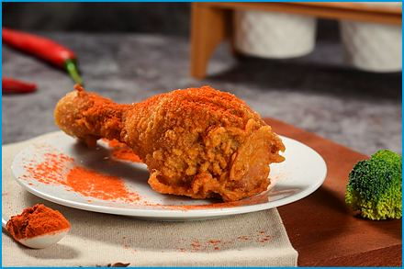
Serves 4
Putenkeule
Oven-roasted turkey legs with garlic, rosemary, and vegetables, served with their own pan juices.

Ingredients
- 2 turkey drumsticks
- 2 Tbsp. olive oil
- 3 cloves garlic, minced
- 1 Tbsp. fresh rosemary, chopped
- 1 Tbsp. fresh thyme, chopped
- 1 tsp. paprika
- Salt and pepper to taste
- 1 lemon, sliced
- 1 onion, sliced
- 2 carrots, chopped
- 2 celery stalks, chopped
- 1 cup (240 ml) chicken broth
Method
Preheat the Oven:
- Preheat your oven to 180°C (350°F).
Prepare the Marinade:
- Mix the olive oil, minced garlic, chopped rosemary, chopped thyme, paprika, salt, and pepper in a small bowl.
Marinate the Turkey:
- Rub the turkey drumsticks with the marinade, making sure to coat them evenly.
- Let the drumsticks marinate for at least 30 minutes, or overnight in the refrigerator for more flavor.
Prepare the Vegetables:
- Arrange the sliced lemon, onion, carrots, and celery in a roasting pan.
Roast the Turkey:
- Place the marinated turkey drumsticks on top of the vegetables in the roasting pan.
- Pour the chicken broth into the pan.
- Cover the pan with aluminum foil and roast in the preheated oven for about 1.5 to 2 hours, or until the turkey is cooked through and the internal temperature reaches 75°C (165°F).
- Remove the foil during the last 30 minutes of cooking to allow the skin to become crispy and brown.
Serve:
- Let the turkey drumsticks rest for a few minutes before serving.
- Serve the roasted Putenkeule with the roasted vegetables and your favorite side dishes.

Boiled Beef with Salted Potatoes and Horseradish
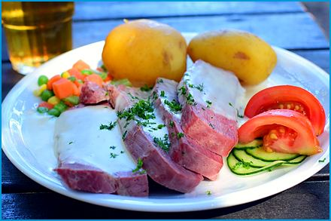
Serves 4
Tellerfleisch mit Salzkartoffeln und Meerrettich
Beef simmered gently in broth, sliced, and served with boiled potatoes and a creamy horseradish sauce.
Ingredients

For the Tellerfleisch:
- 2 lbs. (910 g) beef brisket or chuck roast
- 1 large onion, peeled and halved
- 2 carrots, peeled and cut into chunks
- 2 celery stalks, cut into chunks
- 2 cloves garlic, peeled
- 1 bay leaf
- 6-8 black peppercorns
- Salt to taste
- Water
For the Salzkartoffeln:
- 2 lbs. (910 g) potatoes, peeled and cut into chunks
- Salt
- Fresh parsley, chopped (for garnish)
For the Meerrettich (Horseradish Sauce):
- 2 oz. (50-60 g) fresh horseradish root, peeled and finely grated (or 2-3 Tbsp. from a jar), plus a squeeze of lemon juice
- 2 Tbsp. white vinegar
- 200 ml (¾ cup) heavy cream
- 1/2 Tbsp. sugar
- 1/2 tsp. salt
Method
Prepare the Beef:
- Place the beef brisket or chuck roast in a large pot.
- Add the onion, carrots, celery, garlic, bay leaf, peppercorns, and enough water to cover the beef.
- Bring to a boil.
- Reduce the heat to a simmer.
- Cover and cook for about 2-3 hours, or until the beef is tender and easily pulls apart with a fork.
- Remove the beef from the pot and let it rest before slicing.
Prepare the Potatoes:
- Place the potato chunks in a large pot while the beef is cooking.
- Add enough cold water to cover the potatoes and season with salt.
- Bring to a boil.
- Reduce the heat and simmer until the potatoes are tender, about 15-20 minutes.
- Drain the potatoes and keep warm.
Prepare the Horseradish Sauce:
- Combine the grated horseradish, white vinegar, sugar, and salt in a bowl.
- Mix well.
- Whip the heavy cream in a separate bowl until stiff peaks form.
- Gently fold the whipped cream into the horseradish mixture until well combined.
Serve:
- Slice the cooked beef and arrange it on serving plates.
- Serve with the salted potatoes and horseradish sauce on the side.
- Garnish the potatoes with freshly chopped parsley.

Rouladen
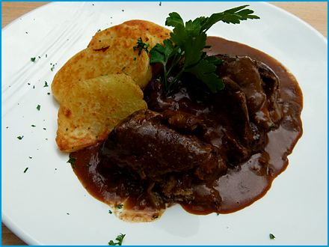
Serves 4
Beef slices rolled around bacon, onion, mustard, and pickle, then braised in rich gravy until tender. Rolling them is fiddly the first time and oddly calming by the fourth.
Ingredients

- 4 large thin beef slices, about 1/4 inch thick
- Salt and pepper to taste
- 2 Tbsp. mustard
- 4 slices bacon
- 1 large onion, finely chopped
- 2-3 pickles, sliced lengthwise
- 2 Tbsp. flour
- 2-3 Tbsp. vegetable oil
- 2 cups (480 ml) beef broth
- 1 bay leaf
- 1 tsp. dried thyme
- Fresh parsley, chopped (for garnish)
Method
Prepare the Beef:
- Lay the beef slices on a cutting board.
- Season with salt and pepper.
- Spread mustard over each slice.
Add Fillings:
- Place a slice of bacon, some chopped onions, and a few pickle slices on each beef slice.
- Roll up the beef tightly around the fillings and secure with toothpicks or kitchen twine.
Sear the Rouladen:
- Heat the oil over medium-high heat in a large pot.
- Dredge the beef rolls in flour to coat lightly.
- Add the beef rolls to the pot and sear on all sides until browned.
- Remove the rolls and set them aside.
Cook the Onions:
- Add any remaining chopped onions and sauté in the same pot until they are soft and golden brown.
Deglaze and Braise:
- Add the beef broth to the pot, scraping up any browned bits from the bottom.
- Add the bay leaf and dried thyme.
- Return the beef rolls to the pot and bring the liquid to a boil.
- Reduce the heat, cover the pot, and let simmer for about 1.5 hours, or until the beef is tender.
Thicken the Sauce:
- Remove the beef rolls and keep them warm if you prefer a thicker sauce.
- Mix 2 Tbsp. of flour with a little water.
- Gradually stir it into the pot and cook until the sauce thickens.
Serve:
- Remove the toothpicks or twine from the Rouladen.
- Serve with the sauce and fresh parsley. This dish is traditionally accompanied by sides like red cabbage and potato dumplings or spätzle.

Bavarian Meatballs
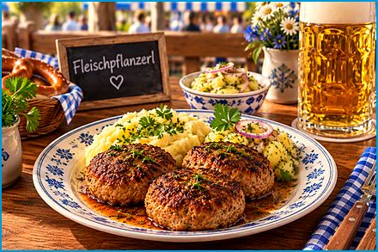
Serves 4
Fleischpflanzerl
Pan-fried minced-meat patties, golden outside and juicy inside. Delicious with potato salad or mashed potatoes.

Ingredients
- 18 oz. (510 g) ground beef and pork mix
- 1 onion, finely chopped
- 2 cloves garlic, minced
- 1 bread roll (or 2 slices of white bread) soaked in water and squeezed out
- 1 egg
- Salt and pepper to taste
- 1 tsp. mustard (optional)
- Fresh parsley, chopped
- 1 tsp. paprika powder
- 2-3 Tbsp. breadcrumbs (optional, if the mixture is too wet)
- Vegetable oil or butter for frying
Method
Prepare the Ingredients:
- Combine the ground meat, chopped onion, minced garlic, soaked bread roll, egg, salt, pepper, mustard (if using), and chopped parsley in a large bowl.
Mix and Season:
- Mix everything together thoroughly until you have a homogeneous mixture. If the mixture is too wet, you can add a bit of breadcrumbs to help bind it.
Form the Patties:
- Form the meat mixture into patties about the size of your palm with wet hands. They should be about 1-2 cm thick.
Fry the Fleischpflanzerl:
- Heat the vegetable oil or butter in a large skillet over medium heat.
- Add the patties to the skillet and fry them for about 4-5 minutes on each side, or until they are cooked through and nicely browned.
Serve:
- Remove the Fleischpflanzerl from the skillet and let them drain on paper towels.
- Serve hot with your favorite sides such as potato salad, mashed potatoes, or a fresh salad.

Barley Risotto with Vegetables
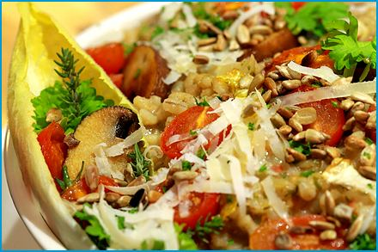
Serves 4
Graupenrisotto mit Gemüse
Pearl barley cooked like risotto, creamy yet pleasantly chewy, with spring asparagus and a hint of lemon.
Ingredients

- 7 oz. (200 g) pearl barley (Graupen)
- 1 large onion, finely chopped
- 1 carrot, finely diced
- 2 cloves garlic, minced
- 7 oz. (200 g) green asparagus, cut into bite-sized pieces
- 1 Tbsp. butter plus 1 Tbsp. vegetable oil
- 100 ml (3.5 fl oz.) dry white wine (optional)
- 700 ml (3 cups) hot vegetable or chicken broth
- 100 ml (3.5 fl oz.) heavy cream
- 1.7 oz. (50 g) grated Parmesan or mountain cheese
- Zest of 1/2 lemon
- Salt and pepper to taste
- Fresh parsley, chopped (for garnish)
- Optional: 10 oz. (280 g) pork tenderloin, cut into thin strips
Method
Cook the Base:
- Heat the butter and oil in a large, wide pot over medium heat.
- Cook the onion and carrot for 5 minutes, until soft.
- Add the garlic and the barley and stir for 1 minute until the grains are coated.
Cook the Barley:
- Pour in the wine, if using, and let it evaporate.
- Add the hot broth a ladle at a time, stirring often and letting each addition be absorbed before adding the next.
- Add the asparagus after 25 minutes.
- Continue for another 10-15 minutes, until the barley is tender but still pleasantly chewy.
Add the Pork (Optional):
- Meanwhile, season the pork strips with salt and pepper and sear them in a hot skillet for 3-4 minutes, until just cooked through.
Finish and Serve:
- Stir in the cream, cheese, and lemon zest and season with salt and pepper.
- Fold in the pork, if using, and garnish with parsley.

Beef Tartare with Garlic Baguette
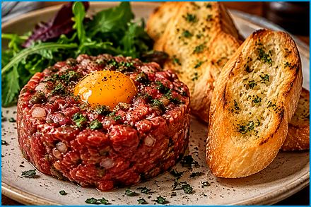
Serves 4
Rindertatar
Finely chopped raw beef with capers, shallot, and egg yolk, served with crisp garlic toasts. For special occasions; use the freshest meat.
Ingredients
- 1 lb. (450 g) beef tenderloin or filet, very finely chopped
- 1 small shallot, finely chopped
- 2 Tbsp. capers, chopped
- 1 Tbsp. Dijon mustard
- 1 Tbsp. Worcestershire sauce
- 1 egg yolk
- 1 tsp. hot sauce (optional)
- Salt and pepper to taste
- 1 Tbsp. fresh parsley, finely chopped
- 1 Tbsp. chives, finely chopped
- 1 baguette, sliced
- 2 Tbsp. olive oil, for the toasts
- 2 cloves garlic, halved, for rubbing the toasts
- Lemon wedges (for serving)
Method
Prepare the Beef Tartare:
- Combine the finely chopped beef, shallot, capers, Dijon mustard, Worcestershire sauce, egg yolk, and chopped parsley in a bowl.
- Mix well until all the ingredients are evenly distributed.
- Season with salt, pepper, and a few dashes of hot sauce if desired.
- Add a squeeze of lemon juice for extra freshness if you like.
Prepare the Garlic Baguette:
- Preheat your oven to 180°C (350°F).
- Arrange the baguette slices on a baking sheet.
- Drizzle the slices with olive oil and toast them in the oven until they are golden and crispy.
- Remove the toasted baguette slices from the oven and rub each with the cut side of the garlic cloves.
Serve:
- Arrange the beef tartare on a serving plate, for an elegant presentation.
- Serve the garlic baguette slices alongside the beef tartare.
- Use only the freshest beef from a trusted butcher, keep it cold, and serve at once. Raw meat is not recommended for pregnant women, small children, or anyone with a weakened immune system.

Crispy Chicken Schnitzel with Fried Potatoes
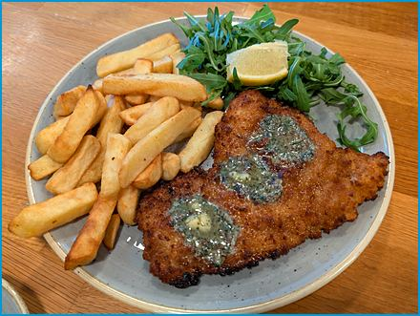
Serves 4
Knusprige Hähnchenschnitzel mit Bratkartoffeln
Golden breaded chicken cutlets with crisp fried potatoes: a family dinner that needs little introduction.
Ingredients
For the Hähnchenschnitzel:
- 4 chicken breasts, pounded thin
- 1 cup (240 ml) all-purpose flour
- 2 large eggs, beaten
- 2 cups (480 ml) breadcrumbs
- Salt and pepper to taste
- 1 tsp. paprika
- Vegetable oil for frying
- Lemon wedges (for serving)
For the Bratkartoffeln:
- 2 lbs. (910 g) potatoes, preferably waxy (like Yukon Gold)
- 1 large onion, finely chopped
- 2-3 Tbsp. vegetable oil
- Salt and pepper to taste
- Fresh parsley, chopped (for garnish)
Method
Prepare the Potatoes:
- Peel and slice the potatoes into 1/4 inch thick rounds.
- Boil the potatoes in salted water until just tender, about 10 minutes.
- Drain and let them cool slightly.
Prepare the Chicken Schnitzel:
- Season the chicken breasts with salt, pepper, and paprika on both sides.
- Set up a breading station with 3 plates: one for flour, one for beaten eggs, and one for breadcrumbs.
- Dredge each chicken breast in the flour.
- Dip in the beaten eggs, and coat with breadcrumbs.
Cook the Bratkartoffeln:
- Heat the vegetable oil over medium-high heat in a large skillet.
- Add the potato slices to the skillet and cook until golden and crispy, turning occasionally.
- Add the chopped onion and cook until soft and translucent.
- Season with salt and pepper to taste.
- Keep the potatoes warm while you cook the schnitzel.
Cook the Chicken Schnitzel:
- Heat enough vegetable oil to cover the bottom of the pan over medium-high heat in a large skillet.
- Fry the breaded chicken breasts until golden brown and cooked through, about 4-5 minutes per side.
- Remove from the skillet and drain on paper towels.
Serve:
- Serve the crispy chicken schnitzel with the fried potatoes.
- Garnish with fresh parsley and lemon wedges.

Crispy Duck with Red Cabbage, Walnut Crumble, and Dumpling Slices
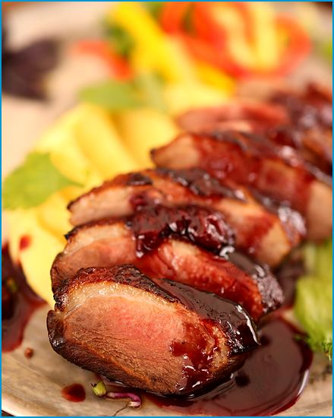
Serves 4
Knusprige Ente mit Blaukraut, Walnuss-Crumble and Knödeltaler
Pink duck breast with a crisp skin, braised red cabbage, a crunchy walnut crumble, and fried dumpling slices: restaurant style at home.

Ingredients
For the Duck:
- 4 duck breasts, skin scored
- Salt and pepper to taste
For the Blaukraut (Red Cabbage):
- 1 small red cabbage, finely sliced
- 1 large onion, chopped, 2 apples, peeled, cored, and grated
- 2 Tbsp. vegetable oil
- 100 ml (3.5 fl oz.) red wine
- 200 ml (¾ cup) apple juice
- 3 Tbsp. apple cider vinegar
- 1 Tbsp. sugar
- Salt and pepper to taste
- 1 tsp. ground cinnamon
- 2 cloves
- 2 bay leaves
For the Walnut-Crumble:
- 3.5 oz. (100 g) walnuts, chopped
- 4 Spekulatius (spiced speculoos) cookies, crushed
- 1.7 oz. (50 g) butter, melted
For the Knödeltaler (Dumpling Slices):
- 4-6 Semmelknödel (see the Bread Dumplings recipe), cooked and cooled
- 1 Tbsp. butter, for frying
Method
Prepare the Blaukraut:
- Heat the oil over medium heat in a large pot.
- Add the chopped onion and cook until soft and translucent.
- Add the sliced red cabbage and grated apples, stirring to combine.
- Add the red wine, apple juice, apple cider vinegar, sugar, salt, pepper, cloves, cinnamon, and bay leaves.
- Bring the mixture to a boil, reduce the heat, and let it simmer for about 1 hour, stirring occasionally.
Prepare the Duck:
- Preheat your oven to 180°C (350°F).
- Season the duck breasts with salt and pepper.
- Place the duck breasts skin-side down and cook over medium heat in an ovenproof skillet for 8 minutes.
- Flip the duck breasts and transfer the skillet to the preheated oven.
- Cook for an additional 6-8 minutes for medium (up to 12 minutes for well done).
- Remove from the oven and let rest.
Prepare the Walnut-Crumble:
- Combine the walnuts, cookies, and melted butter in a bowl.
- Mix until well combined.
- Spread the mixture on a baking sheet and bake in the preheated oven at 180°C (350°F) for about 10 minutes, or until golden and crispy.
- Set aside to cool.
Prepare the Knödeltaler:
- Cut the dumplings into slices about 1 cm thick.
- Heat the butter over medium heat and fry the slices in a skillet until golden brown on both sides.
Assemble the Dish:
- Place a portion of the Blaukraut on each plate.
- Slice the duck breasts and arrange them on the Blaukraut.
- Sprinkle the Walnut-Spekulatius-Crumble over the duck.
- Add the Knödeltaler to the plate.

Sour Pot Roast
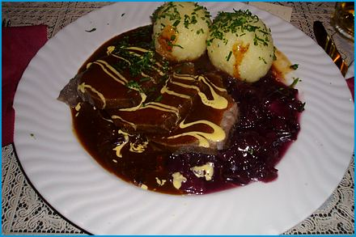
Serves 4
Sauerbraten
Beef marinated for days in vinegar and wine, then braised and served in a sweet-and-sour gravy. Bavaria's answer to a slow-cooked classic. It marinates for days, so it rewards the cooks who plan ahead and teaches patience to the rest of us.
Ingredients

For the Marinade:
- 1 cup (240 ml) red wine vinegar and 2 cups (480 ml) water
- 1 cup (240 ml) red wine
- Salt to taste
- 1 large onion, sliced and 3 cloves garlic, minced
- 2 bay leaves and 10 black peppercorns
- 6 cloves
- 1 tsp. mustard seeds
- 1 tsp. sugar
For the Roast:
- 2.2 lbs. (1 kg) beef roast
- Salt and pepper
- 2 Tbsp. vegetable oil and 2 cups (480 ml) beef broth
- 1 large carrot, chopped
- 1 large onion, chopped
- 1 Tbsp. juniper berries (optional)
- 4 gingersnaps (or 1 oz. (30 g) Lebkuchen)
- 1 oz. (30 g) raisins
- Fresh parsley, chopped (for garnish)
Method
Prepare the Marinade:
- Combine all the marinade ingredients in a large bowl or pot.
- Mix well.
- Place the beef roast in the marinade, ensuring it is fully submerged.
- Cover and refrigerate for at least 3 days, preferably 5-7 days.
- Turn the meat occasionally to ensure even marination.
Sear the Roast:
- Remove the beef from the marinade and pat it dry with paper towels.
- Reserve the marinade.
- Heat the oil over medium-high heat in a large pot or Dutch oven.
- Sear the beef on all sides until browned.
Cook the Roast:
- Add 2 cups (500 ml) of the strained marinade, the beef broth, chopped carrot, and onion to the pot.
- Bring to a boil.
- Reduce the heat to low.
- Cover and simmer gently for 2½ to 3 hours, until the meat is tender.
Thicken the Sauce:
- Remove the beef from the pot and keep warm.
- Strain the cooking liquid and return it to the pot.
- Stir in the crumbled gingersnaps and raisins and simmer for 10 minutes until smooth and slightly thickened.
- Add a little sugar if the sauce is too sharp.
- Season with salt and pepper to taste.
Serve:
- Slice the beef and serve with the sauce.
- Garnish with freshly chopped parsley. Sauerbraten is traditionally served with red cabbage, potato dumplings, or spätzle.

Beef Fillet with Potato-Celery Puree
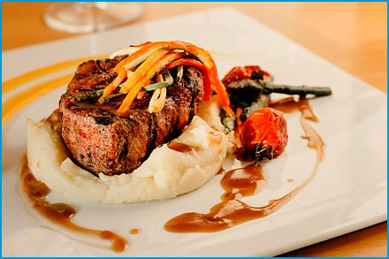
Serves 4
Rinderfilet mit Kartoffel-Selleriepüree
A tender fillet seared in butter with garlic and thyme, served on a silky potato and celeriac purée.
Ingredients

For the Beef Fillet:
- 4 beef fillets (about 5 oz. (140 g) each)
- Salt and pepper to taste
- 2 Tbsp. vegetable oil
- 2 Tbsp. unsalted butter
- 2 cloves garlic, smashed
- 2 sprigs fresh thyme
For the Potato-Celery Puree:
- 18 oz. (510 g) potatoes, peeled and cubed
- 9 oz. (260 g) celery root (celeriac), peeled and cubed
- 1.7 oz. (50 g) unsalted butter
- 100 ml (3.5 fl oz.) heavy cream
- Salt and pepper to taste
- Fresh chives or parsley, chopped (for garnish)
Method
Prepare the Potato-Celery Puree:
- Combine potatoes and celery root in a large pot.
- Cover with cold water and add a pinch of salt.
- Bring to a boil and cook until tender, about 15-20 minutes.
- Drain the potatoes and celery root.
- Return them to the pot.
- Add the butter and heavy cream.
- Mash until smooth.
- Season with salt and pepper to taste.
- Keep warm while preparing the beef.
Cook the Beef Fillet:
- Season the beef fillets generously with salt and pepper on both sides.
- Heat the vegetable oil over medium-high heat in a large skillet.
- Add the beef fillets and cook until browned on each side, about 4 minutes per side for medium-rare.
- Reduce the heat to medium and add the butter, smashed garlic, and thyme to the skillet.
- Baste the beef fillets with the melted butter and aromatics for an additional 2-3 minutes.
- Remove the beef fillets from the skillet and let them rest for a few minutes.
Serve:
- Spoon the potato-celery puree onto plates.
- Place the beef fillets on top of the puree.
- Garnish with freshly chopped chives or parsley.

Bratwurst Supper
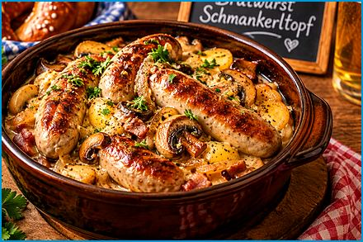
Serves 4
Bratwurst Schmankerltopf
Bratwurst browned with onions and simmered in beer, served with sauerkraut, mustard, and a pretzel. Beer-garden food at the stove.
Ingredients

- 4-6 Bratwursts (fresh or pre-cooked)
- 1-2 Tbsp. vegetable oil or butter
- 1 large onion, sliced
- 1-2 cloves garlic, minced
- 1 cup (240 ml) beer or chicken broth
- Salt and pepper to taste
- For the Side Dishes:
- Sauerkraut (store-bought or homemade)
- German-style mustard
- Pretzels or fresh bread rolls
- Potato salad or mashed potatoes
Method
Cook the Bratwursts:
- Heat the vegetable oil or butter over medium heat in a large skillet.
- Add the sliced onions and cook until they are soft and golden brown.
- Add the minced garlic and cook for another minute.
- Move the onions to the side of the skillet and add the Bratwursts.
- Brown the Bratwursts on all sides, which should take about 5-7 minutes.
Simmer with Beer:
- Pour in the beer or chicken broth once the Bratwursts are browned.
- Reduce the heat to low and let the Bratwursts simmer gently for about 15-20 minutes, or until they are cooked through.
Serve:
- Arrange the Bratwursts on a serving platter with the cooked onions.
- Serve with a side of warm sauerkraut, a dollop of German mustard, and some freshly baked pretzels or bread rolls.
- Add a side of potato salad or mashed potatoes to complete the meal.

Bavarian Lentil Stew
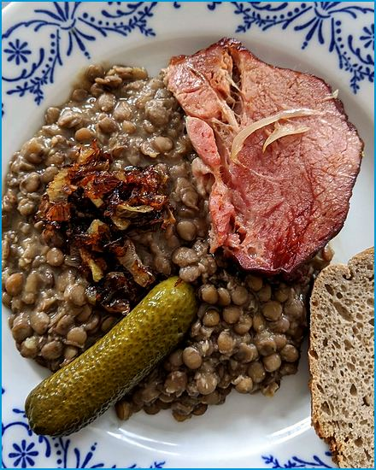
Serves 4
Linseneintopf
A thick vegetarian stew of lentils, root vegetables, and tomato that cooks almost on its own.
Ingredients
- 7 oz. (200 g) lentils
- 2 carrots, diced
- 1 leek, sliced
- 1 celery stalk, diced
- 1 large potato, diced
- 1 onion, chopped
- 2 cloves garlic, minced
- 1 L (4¼ cups) vegetable broth
- 2 Tbsp. tomato paste
- 1 bay leaf
- 1 tsp. thyme
- Salt and pepper to taste
- Fresh parsley for garnish
Method
Prepare the Lentils:
- Rinse the lentils under cold water and drain.
Sauté the Vegetables:
- Heat a bit of oil over medium heat in a large pot.
- Add the chopped onion and minced garlic, and sauté until they become translucent.
- Add the diced carrots, sliced leek, diced celery, and diced potato.
- Cook for a few minutes until the vegetables start to soften.
Add the Lentils and Broth:
- Add the rinsed lentils to the pot.
- Pour in the vegetable broth and add the tomato paste, bay leaf, and dried thyme.
- Stir everything together and bring to a boil.
Simmer the Stew:
- Reduce the heat to low, cover the pot, and let the stew simmer for about 30-40 minutes, or until the lentils and vegetables are tender.
Season and Serve:
- Season the stew with salt and pepper to taste.
- Remove the bay leaf before serving.
- Garnish with freshly chopped parsley.

Spaghetti with Beef Steak Strips and Parsnips
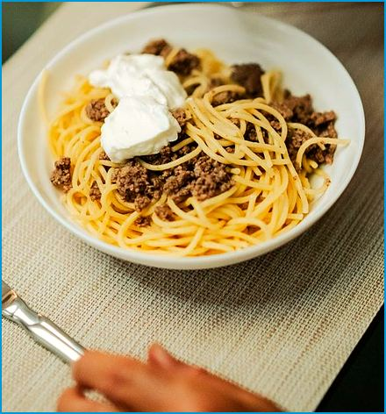
Serves 4
Spaghetti mit Rindersteakstreifen und Pastinaken
Strips of seared steak and sweet parsnip in a light cream sauce over spaghetti, a modern Bavarian pasta dish.
Ingredients
- 10 oz. (280 g) spaghetti
- 14 oz. (400 g) beef steak, thinly sliced into strips
- 2 large parsnips, peeled and cut into thin strips
- 1 large onion, finely chopped
- 2 cloves garlic, minced
- 200 ml (¾ cup) beef broth
- 100 ml (3.5 fl oz.) heavy cream
- 2 Tbsp. olive oil
- 1 tsp. paprika
- Salt and pepper to taste
- Fresh parsley, chopped (for garnish)
- Grated Parmesan (optional, for serving)
Method
Cook the Spaghetti:
- Bring a large pot of salted water to a boil.
- Add the spaghetti and cook according to package instructions until al dente.
- Reserve 1/2 cup (120 ml) of the pasta water.
- Drain and set aside.
Cook the Beef:
- Heat 1 Tbsp. of olive oil over medium-high heat in a large skillet.
- Add the beef strips and season with salt, pepper, and paprika.
- Cook the beef until browned, about 3-4 minutes.
- Remove the beef from the skillet and set aside.
Cook the Vegetables:
- Add the remaining Tbsp. of olive oil in the same skillet.
- Add the chopped onion and cook until it becomes soft and translucent.
- Add the minced garlic and cook for another minute.
- Add the parsnip strips and cook until they are tender and lightly caramelized, about 5-7 minutes.
Make the Sauce:
- Add the beef broth to the skillet and bring to a simmer.
- Stir in the heavy cream and let the sauce cook until it thickens slightly, about 5 minutes.
- Return the cooked beef strips to the skillet and toss to combine.
Combine and Serve:
- Add the cooked spaghetti to the skillet and toss to coat the pasta evenly with the sauce, adding a splash of pasta water if it seems dry.
- Adjust the seasoning with salt and pepper to taste.
- Garnish with freshly chopped parsley and grated Parmesan cheese, if desired.

Char on a Bed of Vegetables
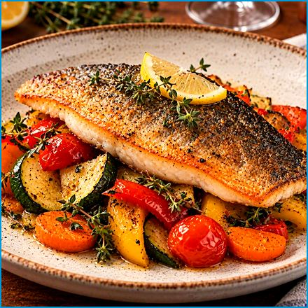
Serves 4
Saibling auf Gemüsebett
Crisp-skinned fillets of char, a trout-like fish from Bavaria's alpine lakes, on a tray of roasted vegetables with thyme.
Ingredients

For the Fish:
- 4 char fillets (Saibling), skin-on
- Salt and pepper
- 2 Tbsp. olive oil
- 1 lemon, sliced
For the Vegetable Bed:
- 1 large carrot, peeled and sliced
- 1 red and 1 yellow bell pepper, sliced
- 1 onion, sliced
- 2 cloves garlic, minced
- 7 oz. (200 g) cherry tomatoes, halved
- 1 large zucchini, sliced
- Salt and pepper to taste
- 2 Tbsp. olive oil
- 1 Tbsp. fresh thyme leaves
Method
Prepare the Vegetables:
- Preheat your oven to 200°C (400°F).
- Combine the sliced zucchini, carrot, red and yellow bell peppers, onion, cherry tomatoes, and minced garlic in a large baking dish.
- Drizzle with olive oil, sprinkle with thyme, and add salt and pepper.
- Toss to coat the vegetables evenly.
Roast the Vegetables:
- Spread the vegetables out in an even layer in the baking dish.
- Roast in the preheated oven for about 20 minutes, until the vegetables are tender and slightly caramelized.
Prepare the Fish:
- Season the char fillets with salt and pepper while the vegetables are roasting.
- Heat the olive oil over medium-high heat in a large skillet.
- Place the char skin-side down in the skillet.
- Cook until the skin is crispy and the fish is nearly cooked through, about 3-4 minutes.
- Turn the fillets and cook for an additional 1-2 minutes until the fish is fully cooked.
Serve:
- Remove the vegetables from the oven and arrange them on serving plates.
- Place the char fillets on top of the vegetable bed.
- Garnish with lemon slices.

Fish Grilled on a Stick
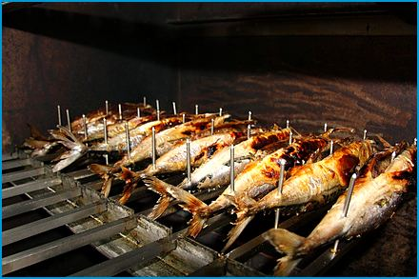
Serves 4
Steckerlfisch
Whole fish marinated with herbs, skewered, and grilled over an open flame: the smell of every Bavarian beer garden in summer.
Ingredients

For the Sticks:
- 4 whole fish (mackerel or trout), cleaned and gutted
- 4 long wooden skewers or metal rods
- 4 lemons, cut into wedges (for serving)
For the Marinade:
- 4 Tbsp. vegetable oil
- 2 Tbsp. lemon juice
- 1 Tbsp. white wine vinegar
- 3 cloves garlic, minced
- 2 tsp. salt
- 1 tsp. black pepper
- 1 tsp. paprika
- 1 tsp. dried thyme
- 1 tsp. dried rosemary
- 1 tsp. dried marjoram
Method
Prepare the Fish:
- Soak them in water for at least 30 minutes to prevent them from burning if using wooden skewers.
- Rinse the fish thoroughly and pat dry with paper towels.
Make the Marinade:
- Mix together the vegetable oil, lemon juice, white wine vinegar, minced garlic, salt, black pepper, paprika, thyme, rosemary, and marjoram in a small bowl.
Marinate the Fish:
- Rub the marinade all over the fish, both inside and out.
- Let the fish marinate for at least 30 minutes, or up to 2 hours, in the refrigerator.
Skewer the Fish:
- Thread each fish onto a skewer or metal rod, making sure to secure it well.
Grill the Fish:
- Preheat your grill to medium-high heat.
- Grill the fish over direct heat, turning occasionally, until the skin is crispy and the fish is cooked through, about 20 minutes (or 15-20 minutes in a 180 °C / 350 °F oven), until the flesh is opaque and flakes easily.
Serve:
- Serve the Steckerlfisch hot off the grill with lemon wedges for squeezing over the top.
- Pair it with a cold Bavarian beer for an authentic experience.

Colorful Fish Skewers
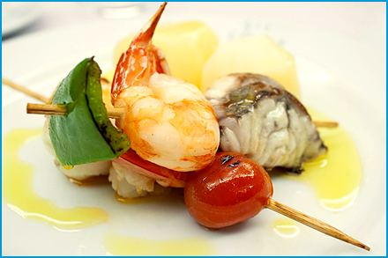
Serves 4
Bunte Fischspieße
Chunks of firm fish alternating with peppers, zucchini, and cherry tomatoes, marinated in lemon and herbs and grilled.
Ingredients

- 14 oz. (400 g) firm white fish fillets (such as cod, halibut, or salmon), cut into bite-sized pieces
- 1 red bell pepper, cut into chunks
- 1 yellow bell pepper, cut into chunks
- 1 zucchini, sliced into rounds
- 1 red onion, cut into chunks
- 7 oz. (200 g) cherry tomatoes
- 2 Tbsp. olive oil
- 2 Tbsp. lemon juice
- 2 cloves garlic, minced
- 1 tsp. dried oregano
- 1 tsp. dried thyme
- Salt and pepper to taste
- Fresh parsley, chopped (for garnish)
- Lemon wedges (for serving)
Method
Prepare the Marinade:
- Whisk together the olive oil, lemon juice, minced garlic, dried oregano, dried thyme, salt, and pepper in a large bowl.
- Add the fish pieces to the bowl and toss to coat.
- Cover and refrigerate for at least 30 minutes to marinate.
Assemble the Skewers:
- Soak them in water for at least 30 minutes to prevent them from burning if using wooden skewers.
- Thread the marinated fish pieces, bell pepper chunks, zucchini slices, red onion chunks, and cherry tomatoes onto the skewers, alternating between fish and vegetables.
Grill the Skewers:
- Preheat your grill to medium-high heat.
- Place the skewers on the grill and cook for about 8-10 minutes, turning occasionally, until the fish is cooked through and the vegetables are tender and lightly charred.
Serve:
- Transfer the skewers to a serving platter.
- Garnish with freshly chopped parsley and serve with lemon wedges on the side.

Pork Chops with Saltimbocca
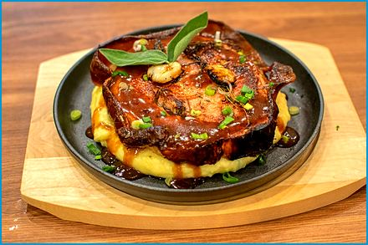
Serves 4
Kotelett mit Birnen-Saltimbocca
Pork chops wrapped with ham, pear, and sage, finished in a honeyed pan sauce.
Ingredients

For the Pork Chops:
- 4 pork chops (about 7 oz. (200 g) each)
- Salt and pepper to taste
- 2 Tbsp. olive oil
- 2 cloves garlic, minced
- 1 sprig fresh rosemary
For the Birnen-Saltimbocca:
- 2 ripe pears, sliced
- 8 thin slices of prosciutto
- Fresh sage leaves
- 2 Tbsp. butter
- 1/4 cup (60 ml) white wine (optional)
- 1/2 cup (120 ml) chicken broth
- 1 Tbsp. honey
Method
Prepare the Pork Chops:
- Season the pork chops with salt and pepper on both sides.
- Heat the olive oil over medium-high heat in a large skillet.
- Add the garlic and rosemary sprig to the skillet and cook for about 1 minutes to infuse the oil with flavor.
- Add the pork chops and sear until browned on both sides, about 3 minutes per side (they finish cooking later).
- Remove from the skillet and set aside.
Prepare the Birnen-Saltimbocca:
- Melt the butter over medium heat in the same skillet.
- Place a slice of pear on top of each pork chop and wrap them with a slice of prosciutto.
- Secure with toothpicks if needed.
- Add the wrapped pork chops back to the skillet along with fresh sage leaves.
- Cook for about 2-3 minutes per side until the prosciutto is crispy and the pears are slightly caramelized.
Make the Sauce:
- Remove the pork chops from the skillet and set aside.
- Add white wine (if using) and chicken broth to the skillet, scraping up browned bits from the bottom.
- Stir in the honey and let the sauce simmer until it thickens slightly, about 5 minutes.
Serve:
- Place the pork chops on serving plates.
- Spoon the sauce over the pork chops and pears.
- Garnish with additional sage leaves if desired.

Pork Liver with Apple and Caramelized Onions
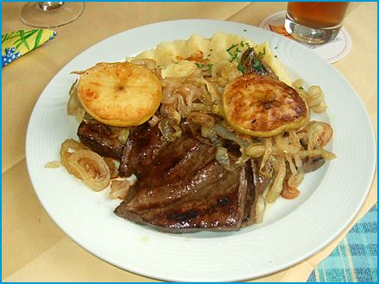
Serves 4
Schweineleber mit Apfel und Karamellisierten Zwiebeln
Quickly pan-fried liver with sweet caramelized onions and soft apples: a classic that proves liver can be tender.
Ingredients

- 18 oz. (510 g) pork liver, sliced
- 2 large onions, thinly sliced
- 2 apples, peeled, cored, and sliced
- 2 Tbsp. vegetable oil
- 2 Tbsp. butter
- 1 tsp. sugar
- Salt and pepper to taste
- 1 tsp. dried thyme (optional)
- 50 ml (3.5 Tbsp.) apple cider vinegar (optional)
- Fresh parsley, chopped (for garnish)
Method
Prepare the Onions:
- Heat 1 Tbsp. of vegetable oil over medium heat in a large skillet.
- Add the sliced onions and cook until they become soft and translucent.
- Add the sugar and continue to cook, stirring occasionally, until the onions are caramelized and golden brown, about 15-20 minutes.
- Remove the onions from the skillet and set aside.
Prepare the Apples:
- Add 1 Tbsp. of butter in the same skillet.
- Add the sliced apples and cook until they are soft and slightly caramelized, about 5-7 minutes.
- Remove the apples from the skillet and set aside with the caramelized onions.
Cook the Liver:
- Soak the liver slices in milk for 30 minutes (optional).
- Pat dry.
- Season the pork liver slices with salt, pepper, and dried thyme (if using).
- Heat 1 Tbsp. of vegetable oil and 1 Tbsp. of butter over medium-high heat in the same skillet.
- Add the liver slices and cook until browned on both sides, about 1½-2 minutes per side, until just pink in the center (do not overcook).
- Deglaze the skillet with apple cider vinegar, scraping up browned bits from the bottom if using.
Combine and Serve:
- Return the caramelized onions and apples to the skillet with the liver.
- Toss everything together and heat through for another 2-3 minutes.
- Transfer to a serving platter and garnish with freshly chopped parsley.

Spare Ribs with Potato Wedges
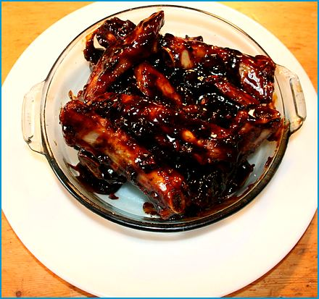
Serves 4
Spareribs mit Kartoffelspalten
Spare ribs baked low and slow with a smoky rub, glazed with barbecue sauce, and served with crisp potato wedges.
Ingredients

For the Spareribs:
- 3 lbs. (1.4 kg) pork spareribs
- 2 Tbsp. olive oil
- Salt and pepper to taste
- 2 Tbsp. paprika
- 1 tsp. garlic powder
- 1 tsp. onion powder
- 1 tsp. ground cumin
- 1 tsp. chili powder
- 1 cup (240 ml) barbecue sauce (your favorite brand)
For the Kartoffelspalten (Potato Wedges):
- 2 lbs. (910 g) potatoes, washed and cut into wedges
- 2 Tbsp. olive oil
- 1 tsp. garlic powder
- 1 tsp. paprika
- Salt and pepper to taste
- Fresh rosemary or thyme (optional, for garnish)
Method
Prepare the Spareribs:
- Preheat your oven to 150°C (300°F).
- Remove the thin membrane from the back of the ribs, if not already removed.
- Combine the salt, pepper, paprika, garlic powder, onion powder, ground cumin, and chili powder in a small bowl.
- Rub the spareribs with olive oil.
- Rub this spice mixture evenly over the spareribs.
- Place the spareribs on a baking sheet lined with aluminum foil.
- Cover tightly with another piece of aluminum foil.
- Bake in the preheated oven for 2.5 to 3 hours, or until the meat is tender and pulls away easily from the bones.
Prepare the Potato Wedges:
- Preheat your oven to 200°C (400°F) for the potato wedges while the ribs are baking.
- Toss the potato wedges with olive oil, garlic powder, paprika, salt, and pepper in a bowl until evenly coated.
- Spread the potato wedges on a baking sheet in a single layer.
- Bake for 30 minutes until the potatoes are golden brown and crispy, turning them halfway through the cooking time.
Finish the Spareribs:
- Remove the top layer of foil and brush the ribs generously with barbecue sauce once the ribs are tender.
- Increase the oven temperature to 200°C (400°F) and return the ribs to the oven.
- Bake uncovered for an additional 10-15 minutes, or until the barbecue sauce is caramelized and sticky.
Serve:
- Transfer the spareribs to a serving platter and cut into individual ribs.
- Serve with the crispy potato wedges.
- Garnish the potato wedges with fresh rosemary or thyme, if desired.

Bavarian Robber's Meat
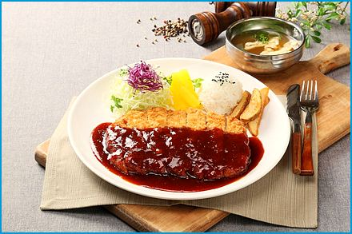
Serves 4
Bayerisches Räuberfleisch
Cutlets simmered with mushrooms, peppers, and bacon in a creamy paprika sauce, a hearty dish from the "robber's pan".
Ingredients
- 4 schnitzels (chicken or pork cutlets, about 5 oz. (140 g) each)
- 2 onions, finely chopped
- 2 cloves garlic, minced
- 7 oz. (200 g) mushrooms, sliced
- 2 red bell peppers, sliced
- 3.5 oz. (100 g) bacon bits (Speckwürfel)
- 250 ml (1 cup) beef broth
- 7 oz. (200 g) sour cream (Schmand)
- 2 Tbsp. tomato paste
- Salt, pepper, paprika, and cayenne pepper to taste
- Fresh parsley, for garnish
- 2 Tbsp. vegetable oil, for frying
Method
Prepare the Schnitzels:
- Season the schnitzels with salt, pepper, and paprika on both sides.
Cook the Vegetables:
- Heat the oil over medium heat in a large skillet.
- Add the chopped onions and cook until soft and translucent.
- Add the minced garlic and cook for another minute.
- Add the sliced mushrooms, bell peppers, and bacon bits, and cook until the vegetables are tender and the bacon is crispy.
Add Broth and Seasoning:
- Pour in the beef broth and bring to a simmer.
- Stir in the tomato paste and season with salt, pepper, paprika, and cayenne pepper to taste.
Cook the Schnitzels:
- Place the schnitzels on top of the simmering sauce in the skillet.
- Cover and let it cook for about 20-30 minutes, or until the schnitzels are cooked through and tender.
Add Sour Cream:
- Stir in the sour cream and mix well to combine with the sauce.
- Warm gently for another 5 minutes.
- Do not let it boil, or the sour cream may curdle.
Serve:
- Garnish with fresh parsley.
- Serve the Räuberfleisch with crusty bread, noodles, or rice.

Allgäuer Cordon Bleu
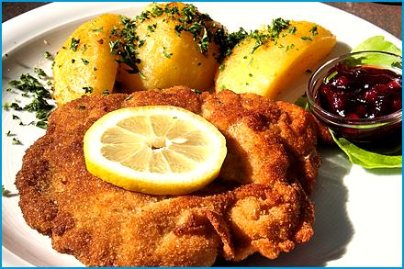
Serves 4
Pork or veal cutlets filled with ham and mountain cheese, breaded, and fried until golden.

Ingredients
- 4 pork or veal cutlets, pounded thin
- 4 slices of ham
- 4 slices of Allgäuer Bergkäse (or another good melting cheese like Emmental or Gruyère)
- 1 cup (240 ml) all-purpose flour
- 2 large eggs, beaten
- 2 cups (480 ml) breadcrumbs
- Salt and pepper to taste
- Vegetable oil for frying
- Lemon wedges (for serving)
- Fresh parsley, chopped (for garnish)
Method
Prepare the Cutlets:
- Lay out the cutlets and season them with salt and pepper on both sides.
Stuff the Cutlets:
- Place a slice of ham and a slice of cheese on one half of each cutlet.
- Fold the cutlet over to enclose the filling, securing the edges with toothpicks if needed to prevent the cheese from leaking out during cooking.
Bread the Cutlets:
- Set up a breading station with three shallow dishes: one with flour, one with beaten eggs, and one with breadcrumbs.
- Dredge each stuffed cutlet first in the flour, shaking off any excess.
- Dip it in the beaten eggs, and finally coat it thoroughly with breadcrumbs.
Fry the Cutlets:
- Heat about 1/2 inch of vegetable oil over medium-high heat in a large skillet.
- Fry the cutlets in batches, cooking each side until golden brown and crispy, about 3-4 minutes per side.
- Transfer the fried cutlets to a paper-towel-lined plate to drain any excess oil. Serve:.
- Serve the Allgäuer Cordon Bleu hot, with lemon wedges on the side for squeezing over the cutlets.
- Garnish with freshly chopped parsley.

Stuffed Grilled Chicken
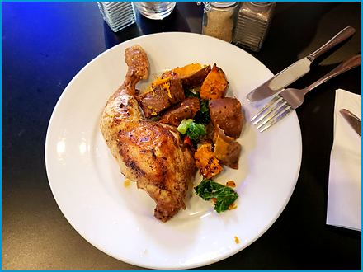
Serves 4
Gefülltes Grillhendl
A roast chicken with a herb and breadcrumb stuffing tucked under the skin, golden and juicy.
Ingredients

- 1 whole chicken (about 1.5 kg (3.5 lbs.))
- 2 Tbsp. cold butter
- 4 sprigs rosemary
- 1 tsp. salt
- 1 tsp. paprika
- 1 tsp. black pepper
- 1 Tbsp. olive oil (for brushing)
- 1/2 tsp. garlic powder
- 1/2 tsp. dried oregano
- 5.5 oz. (150 g) dry breadcrumbs, soaked in 150 ml (⅔ cup) warm milk
- 1 onion, finely chopped
- 2 eggs
- 200 g (7 oz.) chicken liver (optional, finely chopped)
- Fresh herbs for garnish (optional)
Method
Prepare the Chicken:
- Rinse the chicken under cold water and pat it dry with paper towels.
- Remove any giblets from the cavity.
Prepare the Filling:
- Mix together the breadcrumbs, chopped onion, eggs, chicken liver (if using), salt, paprika, black pepper, garlic powder, and oregano in a bowl.
Stuff the Chicken:
- Preheat your oven to 200°C (390°F).
- Loosely fill the cavity with the stuffing (it expands) and close it with kitchen twine or toothpicks.
- Loosen the skin over the breast and tuck the rosemary sprigs and small pieces of the cold butter under it.
Roast the Chicken:
- Place the chicken on a baking tray, breast side up.
- Drizzle with olive oil and season with salt and pepper.
- Roast in the preheated oven for about 1 hour, or until the internal temperature reaches 75°C (165°F).
Serve:
- Let the chicken rest for 10 minutes before carving.
- Garnish with fresh herbs if desired.

Paprika-Chicken with Shrimp

Serves 4
Chicken and shrimp in a creamy paprika sauce with peppers, served with rice or noodles.
Ingredients

For the Chicken and Shrimp:
- 4 chicken breasts or thighs, boneless and skinless
- 9 oz. (260 g) shrimp, peeled and deveined
For the Vegetables:
- 1 large onion, finely chopped
- 2 cloves garlic, minced
- 1 red bell pepper, sliced
- 1 yellow bell pepper, sliced
For the Sauce:
- 2 Tbsp. vegetable oil
- 2 Tbsp. sweet paprika powder
- 1 tsp. smoked paprika (optional, for extra flavor)
- 1 tsp. salt
- 1/2 tsp. black pepper
- 200 ml (¾ cup) chicken broth
- 200 ml (¾ cup) heavy cream
- 2 Tbsp. tomato paste
- Fresh parsley, chopped (for garnish)
Method
Prepare the Chicken and Shrimp:
- Season the chicken breasts or thighs with salt, black pepper, and half of the sweet paprika powder.
- Season the shrimp with a pinch of salt, pepper, and a little paprika powder.
Cook the Chicken:
- Heat the vegetable oil over medium-high heat in a large skillet.
- Add the chicken and cook until browned on both sides, about 7 minutes per side.
- Remove the chicken from the skillet and set aside.
Cook the Vegetables:
- Add the chopped onion and cook in the same skillet until it becomes soft and translucent.
- Add the minced garlic and cook for another minute.
- Add the sliced red and yellow bell peppers and cook until they are tender.
Add the Paprika and Tomato Paste:
- Stir in the remaining sweet paprika powder, smoked paprika (if using), and tomato paste.
- Cook for a few minutes to enhance the flavors.
Simmer with Broth and Cream:
- Pour in the chicken broth and bring to a simmer.
- Stir in the heavy cream and return the chicken to the skillet.
- Let the mixture simmer gently for about 10 minutes.
Cook the Shrimp:
- Add the seasoned shrimp to the skillet and cook for an additional 3-5 minutes, or until the shrimp are pink and cooked through.
Serve:
- Garnish with freshly chopped parsley.
- Serve the Paprika Chicken with Shrimp over rice, pasta, or with a side of crusty bread.

Bavarian Savoy Cabbage Lasagna
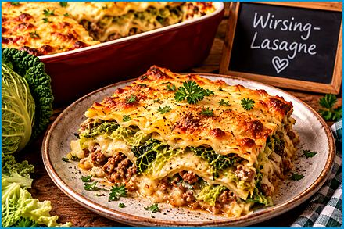
Serves 6
Wirsing-Lasagne
Layers of savoy cabbage, meat sauce, and béchamel baked under a golden cheese crust.
Ingredients

- 1 medium Wirsing (Savoy cabbage), chopped
- 12 lasagna sheets
- 18 oz. (510 g) ground beef or pork
- 1 large onion, finely chopped
- 1 can (14 oz. (400 g)) diced tomatoes
- 2 Tbsp. tomato paste
- 200 ml (¾ cup) beef or vegetable broth
- 2 cloves garlic, minced
- 7 oz. (200 g) grated cheese (such as Emmental or Gruyère)
- 2 Tbsp. vegetable oil
- 1 tsp. dried oregano
- 1 tsp. dried basil
- Salt and pepper to taste
- 1 tsp. paprika
- Fresh parsley, chopped (for garnish)
For the Béchamel Sauce:
- 1.7 oz. (50 g) butter
- 1.7 oz. (50 g) all-purpose flour
- 500 ml (2 cups) milk
- Salt and pepper to taste
- A pinch of nutmeg
Method
Prepare the Wirsing:
- In a large pot of boiling salted water, blanch the Wirsing for 5 minutes until tender.
- Drain and set aside.
Cook the Meat Sauce:
- Heat the vegetable oil over medium heat in a large skillet.
- Add the chopped onion and cook until it becomes soft and translucent.
- Add the minced garlic and cook for another minute.
- Add the ground beef or pork and cook until browned.
- Drain any excess fat.
- Stir in the diced tomatoes, tomato paste, beef or vegetable broth, paprika, dried oregano, and basil.
- Season with salt and pepper to taste.
- Let it simmer for about 15-20 minutes.
Prepare the Béchamel Sauce:
- Melt the butter over medium heat in a saucepan.
- Add the flour and whisk continuously for about 2 minutes until it forms a smooth paste.
- Gradually add the milk while continuing to whisk until the sauce thickens.
- Season with salt, pepper, and a pinch of nutmeg.
- Set aside.
Assemble the Lasagna:
- Preheat your oven to 350°F (175°C).
- Spread a layer of meat sauce on the bottom in a large baking dish.
- Place a layer of lasagna sheets on top.
- Add a layer of blanched Wirsing, then a layer of Béchamel sauce.
- Repeat the layers until all ingredients are used, finishing with a layer of Béchamel sauce on top.
- Sprinkle the grated cheese evenly over the top.
Bake:
- Cover the baking dish with aluminum foil and bake in the preheated oven for about 30 minutes.
- Remove the foil and bake for an additional 15-20 minutes, or until the cheese is golden brown and bubbly.
Serve:
- Let the lasagna cool slightly before slicing.
- Garnish with fresh chopped parsley.

Bavarian Turkey Döner Kebab
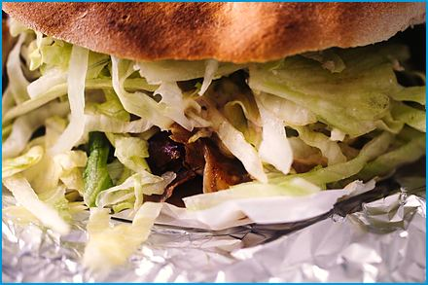
Serves 4
Puten Döner
Marinated turkey strips in warm flatbread with a garlic-tahini sauce and crisp vegetables, the beloved street food of every German city.

Ingredients
For the Turkey Marinade:
- 18 oz. (510 g) turkey breast, cut into thin strips
- Salt and pepper
- 2 cloves garlic, minced
- 1 lemon, juiced
- 2 Tbsp. olive oil
- 1 tsp. ground cumin
- 1 tsp. ground coriander
- 1 tsp. paprika
- 1/2 tsp. ground turmeric
- 1/2 tsp. ground cinnamon
For the Sauce:
- 7 oz. (200 g) Greek yogurt
- 1 clove garlic, minced
- 1 Tbsp. lemon juice
- 2 Tbsp. tahini
- Salt and pepper
For Assembly:
- Pita bread or flatbreads
- Lettuce leaves, shredded
- Sliced tomatoes
- Sliced cucumber
- Sliced red onion
- Fresh parsley, chopped
Method
Marinate the Turkey:
- Combine the turkey strips with minced garlic, lemon juice, olive oil, ground cumin, ground coriander, paprika, ground turmeric, ground cinnamon, salt, and pepper in a large bowl.
- Mix well to ensure the turkey is evenly coated with the marinade.
- Cover and let marinate in the refrigerator for at least 1 hour, preferably overnight.
Prepare the Sauce:
- Combine the Greek yogurt, tahini, minced garlic, lemon juice, salt, and pepper in a bowl.
- Mix well and refrigerate until ready to use.
Cook the Turkey:
- Heat a large skillet or grill pan over medium-high heat.
- Add the marinated turkey strips and cook until they are browned and cooked through, about 5-7 minutes.
Assemble the Döner:
- Warm the pita bread or flatbreads in a dry skillet or oven.
- Spread a generous amount of sauce on each pita.
- Add the cooked turkey strips, shredded lettuce, sliced tomatoes, sliced cucumber, sliced red onion, and chopped parsley.
Serve:
- Wrap the pita bread around the filling and enjoy your Puten Döner.

Bavarian Potato Pancakes
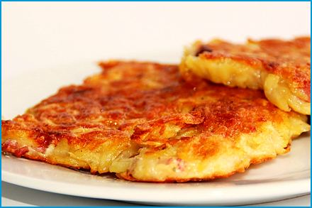
Serves 4
Reiberdatschi, also known as Kartoffelpuffer
Crisp fried pancakes of grated potato, served with applesauce or sour cream.
Ingredients

- 2 lbs. (910 g) potatoes
- 2 eggs
- 2-3 Tbsp. flour
- 1 small onion, grated (optional)
- Salt and pepper to taste
- Vegetable oil for frying
- Applesauce or sour cream for serving
Method
Prepare the Potatoes:
- Peel the potatoes.
- Grate the potatoes using a coarse grater or food processor.
- Place the grated potatoes in a clean kitchen towel or cheesecloth and squeeze out as much liquid as possible. This will help the pancakes become crispy.
Mix the Batter:
- Combine the grated potatoes with the eggs, flour, and grated onion (if using) in a large bowl.
- Mix well and season with salt and pepper to taste.
Fry the Pancakes:
- Heat a generous amount of vegetable oil in a large skillet over medium-high heat.
- Scoop a spoonful of the potato mixture into the skillet and flatten it with the back of the spoon to form a thin pancake.
- Fry the pancakes for about 3-4 minutes on each side, or until golden brown and crispy.
- Remove the pancakes from the skillet and place them on paper towels to drain excess oil.
Serve:
- Serve the Bavarian Potato Pancakes hot, with applesauce or sour cream.

Roast Pork with Crackling and Dark Beer Gravy
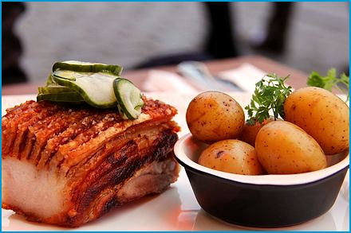
Serves 4
Bayerischer Schweinebraten (Krustenbraten) The crackling is the point. Guard it, because it has a habit of vanishing between the oven and the table.
Bavaria’s Sunday roast: juicy pork shoulder under a blistered, crackling crust, with a dark-beer gravy. Serve it with bread dumplings and red cabbage.
Ingredients

For the Roast:
- 2.2 lbs. (1 kg) pork shoulder or neck, with the rind (skin) on
- 1½ tsp. salt
- 1 tsp. freshly ground black pepper
- 1 tsp. caraway seeds, ground
- 1 tsp. dried marjoram
- 3 cloves garlic, crushed
- 250 ml (1 cup) water, for the pan
For the Vegetables and Gravy:
- 2 onions, quartered
- 2 carrots, cut into chunks
- 1/4 celeriac (or 2 celery stalks), cut into chunks
- 1 Tbsp. tomato paste
- 500 ml (2 cups) dark beer (Dunkel), divided
- 250 ml (1 cup) beef broth
- 1 Tbsp. cornstarch mixed with 2 Tbsp. cold water (optional)
- Salt and pepper to taste
Method
Prepare the Roast:
- Preheat the oven to 180°C (350°F).
- Pat the pork dry.
- Score the rind in a diamond pattern about 1 cm apart, cutting through the skin and fat but not into the meat with a sharp knife.
- Mix the pepper, caraway, marjoram, and garlic with 1 tsp. of the salt and rub it into the meat.
- Rub the remaining salt into the scored rind.
Roast:
- Scatter the onions, carrots, and celeriac in a roasting pan, stir in the tomato paste, and pour in the water.
- Set the roast on top, rind side up.
- Roast for 30 minutes.
- Pour 250 ml (1 cup) of the beer around (not over) the roast.
- Continue roasting for about 1 hour, basting the meat (not the rind) with the pan juices every 30 minutes and adding a little water if the pan dries out.
Crisp the Crackling:
- Raise the oven to 220°C (430°F).
- Brush the rind with a little of the remaining beer and roast for 15-20 minutes more, until the crust blisters and turns golden. The roast is done when the meat is very tender (about 85°C / 185°F inside).
- Let it rest for 15 minutes before carving.
Make the Gravy:
- Strain the pan juices through a sieve, pressing on the vegetables, into a saucepan and skim off the fat.
- Add the remaining 250 ml (1 cup) beer and the beef broth and simmer for 15 minutes, until reduced by about a third.
- Thicken with the cornstarch mixture if you like, and season with salt and pepper.
Serve:
- Carve the roast into thick slices, each with a piece of crackling, and serve with the gravy, Semmelknödel, and Blaukraut.

Oktoberfest Roast Chicken
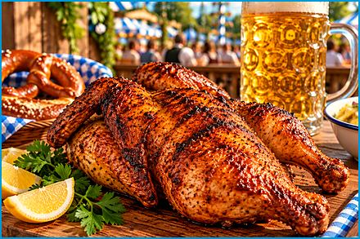
Serves 4
Wiesn-Hendl
The golden, paprika-scented chicken served in the beer tents of the Wiesn, traditionally with a pretzel and a cold beer.
Ingredients

- 1 whole chicken, about 3.3 lbs. (1.5 kg)
- 3 Tbsp. soft butter, divided
- 2 tsp. sweet paprika
- 1½ tsp. salt
- 1 tsp. freshly ground black pepper
- 1 tsp. dried marjoram
- 1 onion, quartered
- 1 small bunch parsley
- 150 ml (½ cup) wheat beer or water, for the pan
- Pretzels and radishes, for serving
Method
Prepare the Chicken:
- Preheat the oven to 200°C (390°F).
- Pat the chicken dry inside and out.
- Mix 2 Tbsp. of the butter with the paprika, 1 tsp. of the salt, the pepper, and the marjoram.
- Loosen the skin over the breast and rub some of the butter under it.
- Rub the rest over the outside of the chicken.
- Sprinkle the remaining salt inside the cavity and fill it with the onion and parsley.
Roast:
- Place the chicken breast side up on a rack in a roasting pan and pour the beer into the pan.
- Roast for about 1 hour 10 minutes, basting with the pan juices every 20 minutes.
- Melt the remaining butter and brush it over the skin for the last 15 minutes, until deep golden and crisp. The chicken is done when the juices run clear and a thermometer reads 75°C (165°F) in the breast and 80°C (176°F) in the thigh.
Serve:
- Let the chicken rest for 10 minutes.
- Cut it into halves or quarters.
- Serve with pretzels, radishes, and the pan juices.

Cheese Spätzle with Crispy Onions
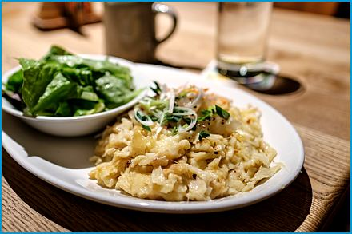
Serves 4
Kässpätzle
Bavaria’s answer to macaroni and cheese: fresh spätzle layered with melting mountain cheese and crowned with golden onions. In our house it is also the answer to most other questions.
Ingredients

For the Spätzle:
- 12 oz. (340 g) all-purpose flour
- 4 large eggs
- 170 ml (¾ cup) water or milk
- 1 tsp. salt
- A pinch of nutmeg
For the Cheese and Onions:
- 7 oz. (200 g) grated Bergkäse, Emmental, or a mix of both
- 3 large onions, cut into thin rings
- 3 Tbsp. butter plus 1 Tbsp. vegetable oil
- Salt and pepper to taste
- 2 Tbsp. chives, chopped
- A green salad, for serving
Method
Make the Dough:
- Whisk the flour, eggs, water, salt, and nutmeg.
- Beat vigorously until the batter is smooth, thick, and full of bubbles.
- Let it rest for 15 minutes.
Fry the Onions:
- Heat the butter and oil in a large skillet over medium-low heat.
- Cook the onion rings for 20-25 minutes, stirring often, until deep golden.
- Season with salt and keep warm.
Cook the Spätzle:
- Bring a large pot of salted water to a boil and preheat the oven to 180°C (350°F).
- Press or scrape the batter in batches into the water. When the spätzle rise to the surface, after 1-2 minutes, lift them out with a slotted spoon.
- Layer them at once in a warm ovenproof dish, scattering a handful of cheese between the layers.
Melt and Serve:
- Place the dish in the oven for 5-10 minutes, until the cheese is melted and stringy.
- Top with the fried onions, sprinkle with chives and pepper, and serve with a green salad.

Creamy Veal Strips with Mushrooms
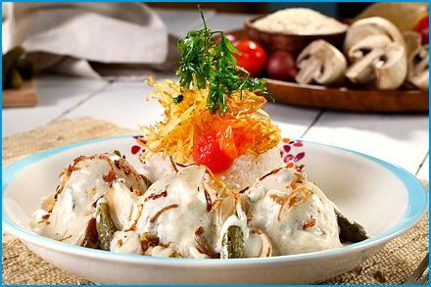
Serves 4
Kalbsrahmgeschnetzeltes
Tender veal strips in a silky mushroom-cream sauce, a Bavarian restaurant classic that is ready in half an hour.
Ingredients

- 18 oz. (500 g) veal cutlet or fillet (or pork or chicken breast), cut into thin strips
- 8 oz. (225 g) mushrooms, sliced
- 1 large onion, finely chopped
- 2 Tbsp. butter plus 1 Tbsp. vegetable oil
- 1 Tbsp. all-purpose flour
- 100 ml (3.5 fl oz.) dry white wine
- 200 ml (¾ cup) veal or chicken broth
- 200 ml (¾ cup) heavy cream
- 1 tsp. lemon juice
- Salt and white pepper to taste
- Fresh parsley, chopped (for garnish)
Method
Sear the Veal:
- Pat the veal strips dry and season them with salt and pepper.
- Heat the oil and 1 Tbsp. of the butter in a large skillet over high heat.
- Sear the veal in two batches for 1-2 minutes, until just browned, and set aside.
Cook the Mushrooms:
- Add the remaining butter to the skillet and cook the onion for 3 minutes, until soft.
- Add the mushrooms and cook for 6-8 minutes, until golden.
- Sprinkle with the flour and stir for 1 minute.
Make the Sauce:
- Pour in the wine, scraping up the browned bits, and let it reduce by half.
- Add the broth and cream and simmer for about 8 minutes, until creamy.
Finish and Serve:
- Return the veal and its juices to the pan and heat gently for 2 minutes.
- Do not let it boil, or the veal will turn tough.
- Season with lemon juice, salt, and pepper, sprinkle with parsley, and serve with spätzle, rösti, or rice.

Sirloin Steak with Fried Onions and Gravy
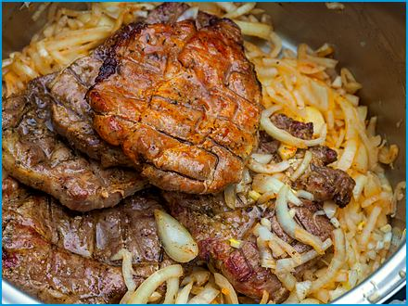
Serves 4
Zwiebelrostbraten
A tender steak crowned with a heap of crisp fried onions and a rich pan gravy, a Bavarian inn favorite.
Ingredients

For the Steaks:
- 4 sirloin or rump steaks (about 6 oz. (170 g) each, 1.5 cm thick)
- Salt and freshly ground pepper
- 2 Tbsp. butter or oil
For the Fried Onions:
- 3 large onions, cut into thin rings
- 3 Tbsp. all-purpose flour
- Vegetable oil for frying (about 1 cm deep)
For the Gravy:
- 100 ml (3.5 fl oz.) dry red wine
- 250 ml (1 cup) beef broth
- 1 tsp. mustard
- A pinch of dried marjoram
- 1 tsp. cornstarch mixed with 1 Tbsp. cold water (optional)
Method
Fry the Onions:
- Toss the onion rings with the flour and a pinch of salt, shaking off any excess.
- Heat the oil to 170°C (340°F) and fry the onions in batches for 2-3 minutes, until golden and crisp.
- Drain on paper towels and keep warm.
Cook the Steaks:
- Make small cuts along the fat edge of each steak so it does not curl, and season with salt and pepper.
- Heat the butter in a heavy skillet over high heat and sear the steaks for 2-3 minutes per side for medium-rare.
- Rest them on a plate for 5 minutes.
Make the Gravy:
- Pour the red wine into the skillet and scrape up the browned bits.
- Add the broth, mustard, and marjoram and simmer for 8-10 minutes, until reduced by about half.
- Thicken with the cornstarch mixture if you like, and season to taste.
Serve:
- Place the steaks on warm plates, pour over the gravy, and top with the fried onions.
- Serve with spätzle or fried potatoes.

Pichelsteiner Meat and Vegetable Stew
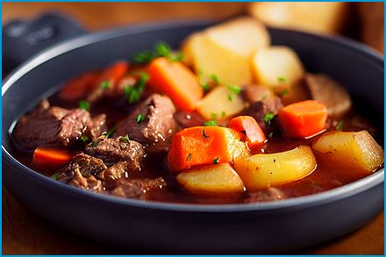
Serves 4
Pichelsteiner Eintopf
The hearty stew of the Bavarian Forest: layers of meat and vegetables slowly cooked in their own juices.
Ingredients

- 18 oz. (500 g) beef (chuck) and pork shoulder, cut into 2 cm cubes
- 1 large onion, sliced
- 1 lb. (450 g) potatoes, peeled and cut into chunks
- 2 carrots, sliced
- 1 leek, sliced
- 1/4 celeriac (or 2 celery stalks), diced
- 7 oz. (200 g) savoy cabbage, shredded
- 2 Tbsp. butter or lard
- 1 tsp. dried marjoram
- About 500 ml (2 cups) hot beef broth
- Salt and pepper to taste
- Fresh parsley, chopped (for garnish)
Method
Prepare the Pot:
- Grease a large heavy pot with the butter.
- Season the meat with salt, pepper, and the marjoram.
Layer the Stew:
- Spread half of the meat in the pot.
- Add half of the onion, carrots, leek, celeriac, and cabbage.
- Repeat with the remaining meat and vegetables and finish with the potatoes on top.
- Season each layer lightly with salt.
Cook:
- Pour in enough hot broth to come about halfway up the layers.
- Cover tightly and simmer over low heat for 1½ hours, without stirring, until the meat is tender.
Serve:
- Stir gently, adjust the seasoning, and serve in deep bowls sprinkled with parsley.

Franconian Roast Pork Shoulder
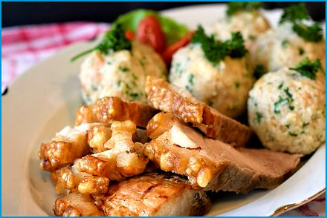
Serves 4
Fränkisches Schäufele
A bone-in pork shoulder with a crackling crust, roasted in beer and served with potato dumplings: the pride of northern Bavaria.
Ingredients

- 2.5 lbs. (1.2 kg) bone-in pork shoulder, with the rind (skin) on
- 1½ tsp. salt
- 1 tsp. caraway seeds, ground
- 1 tsp. freshly ground pepper
- 2 cloves garlic, crushed
- 1 onion, quartered
- 1 carrot, cut into chunks
- 1 celery stalk, cut into chunks
- 250 ml (1 cup) dark beer
- 250 ml (1 cup) water or beef broth
Method
Prepare the Roast:
- Preheat the oven to 180°C (350°F).
- Score the rind in a diamond pattern about 1 cm apart without cutting into the meat.
- Mix the salt, caraway, pepper, and garlic and rub it into the roast, working some into the scores.
Roast:
- Put the onion, carrot, and celery in a roasting pan, add the water, and place the roast on top, rind side up.
- Roast for 45 minutes.
- Pour the beer around the roast and continue roasting for another hour, basting the meat with the pan juices every 30 minutes.
Crisp the Crackling:
- Raise the oven to 220°C (430°F) and roast for 15-20 minutes more, until the rind blisters and turns golden. The meat should pull easily from the bone.
- Let it rest for 15 minutes.
Serve:
- Strain the pan juices and serve them as gravy with the carved roast, potato dumplings, and a green salad.

Sour Sausages in Onion-Vinegar Broth

Serves 4
Saure Zipfel
Small bratwursts poached in a tangy broth of onions and vinegar, a Nuremberg tavern classic served with rye bread.
Ingredients

- 8 small bratwursts (about 1 lb. (450 g) in total)
- 2 onions, cut into rings
- 1 carrot, sliced
- 350 ml (1½ cups) water
- 150 ml (½ cup) white wine vinegar
- 1 bay leaf
- 5 peppercorns, 3 allspice berries, and 1 clove
- 1 tsp. sugar
- 1 tsp. salt
- Rye bread, for serving
Method
Make the Broth:
- Bring the water, vinegar, onions, carrot, spices, sugar, and salt to a boil.
- Simmer for 10 minutes.
Poach the Sausages:
- Reduce the heat until the liquid barely moves, add the sausages, and let them steep for 12-15 minutes.
- Do not let the broth boil.
Serve:
- Serve the sausages in deep plates with the onions and some of the broth, with rye bread on the side.

Boiled Pork with Sauerkraut
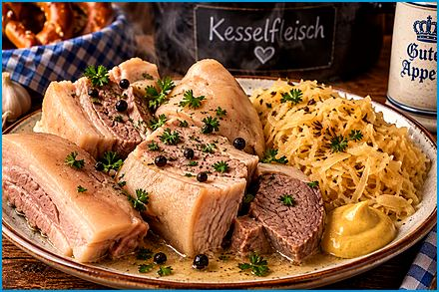
Serves 4
Kesselfleisch
Pork simmered until tender in a spiced broth, then sliced and served hot with sauerkraut, mustard, and horseradish: the traditional butcher’s-shop lunch.
Ingredients

- 1 lb. 10 oz. (750 g) pork belly or shoulder, in one or two pieces
- 1 onion, halved
- 1 bay leaf
- 5 peppercorns
- 2 tsp. salt
- 1 L (4¼ cups) water
- 14 oz. (400 g) sauerkraut
- 1 tsp. caraway seeds
- Mustard and freshly grated horseradish, for serving
- Rye bread, for serving
Method
Simmer the Pork:
- Place the pork, onion, bay leaf, peppercorns, and salt in a pot and cover with the water.
- Bring to a boil, skim off the foam.
- Cover and simmer gently for 1½ hours, until the pork is tender.
Heat the Sauerkraut:
- Shortly before serving, simmer the sauerkraut with the caraway and 100 ml (3.5 fl oz.) of the pork broth for 15 minutes.
Serve:
- Slice the pork, arrange it on plates with the sauerkraut, and spoon over a little broth.
- Serve with mustard, horseradish, and rye bread.

Sides
In Bavaria the side dish is never an afterthought. Plenty of guests have come for the roast and gone home talking about the dumplings.

Potato Noodles
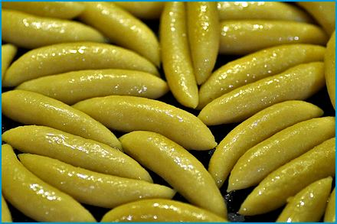
Serves 4
Schupfnudeln
Finger-shaped potato dumplings, boiled and then fried golden in butter.
Ingredients
- 18 oz. (510 g) potatoes, preferably starchy ones
- 4.5 oz. (130 g) all-purpose flour (plus extra for dusting)
- 1 egg
- Salt to taste
- Butter or oil for frying
- Nutmeg, to taste
Method
Prepare the Potatoes:
- Peel the potatoes and cut them into chunks.
- Boil the potatoes in salted water until they are tender, about 15-20 minutes.
- Drain the potatoes and let them cool slightly.
- Mash the potatoes until smooth or press them through a potato ricer for a finer texture.
Make the Dough:
- Combine the mashed potatoes, flour, egg, and a pinch of salt in a large bowl.
- Mix well until a dough forms.
- Add a little more flour if the dough is too sticky.
- Turn the dough out onto a lightly floured surface and knead briefly until smooth.
Shape the Schupfnudeln:
- Divide the dough into small portions.
- Roll each portion into a small log, about the length and thickness of your finger.
- Repeat with the remaining dough.
Cook the Schupfnudeln:
- Bring a large pot of salted water to a boil.
- Add the Schupfnudeln in batches and cook until they float to the surface, about 3-4 minutes.
- Remove them with a slotted spoon and set aside.
Pan-Fry the Schupfnudeln:
- Heat some butter or oil over medium heat in a large skillet.
- Add the cooked Schupfnudeln and pan-fry until they are golden brown and crispy on all sides.

Egg Noodles
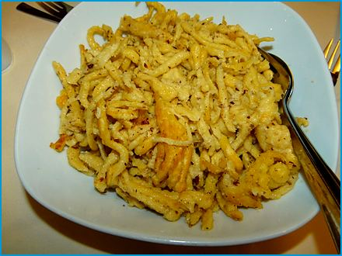
Serves 4
Spätzle
Soft, irregular egg noodles scraped into boiling water: the all-round side dish, or a main course with cheese and fried onions.
Ingredients

- 10.5 oz. (300 g, about 2⅓ cups) all-purpose flour
- 3 large eggs
- 150 ml (⅔ cup) milk or water
- 3/4 tsp. salt
- Butter for frying (optional)
- Freshly ground nutmeg (optional)
- Fresh parsley, chopped (for garnish)
Method
Prepare the Dough:
- Combine the flour and salt in a large mixing bowl.
- Create a well and crack the eggs into it.
- Gradually add the milk or water while mixing the ingredients together until you get a thick batter. The dough should be slightly sticky and elastic.
- Add a little more liquid if it's too thick.
Rest the Dough:
- Let the dough rest for about 10-15 minutes.
Boil Water:
- Bring a large pot of salted water to a boil.
Form the Spätzle:
- Press the dough through the maker into the boiling water if you have a Spätzle maker. Alternatively, you can use a colander with large holes or a cutting board and knife to cut small strips of dough directly into the boiling water.
Cook the Spätzle:
- Let the Spätzle cook in the boiling water until they float to the surface.
- Use a slotted spoon to transfer the Spätzle to a bowl of cold water to stop the cooking process.
- Drain well and set aside.
Serve:
- Garnish with freshly chopped parsley.
- Serve the Spätzle hot, either as a side dish or a main course with your favorite sauce or gravy.

Potato Dumplings

Serves 4
Kartoffelknödel
Soft, fluffy dumplings of boiled potato, made for soaking up gravy. A good one holds together in the pot and falls apart only under gravy, which is exactly where you want it to.
Ingredients

- 2 lbs. (910 g) potatoes (preferably starchy potatoes)
- 2 eggs
- 1/2 cup (120 ml) potato starch or corn starch
- Salt to taste
- Nutmeg, freshly grated (optional)
- 2 Tbsp. butter
- Breadcrumbs for coating (optional)
- Fresh parsley, chopped (for garnish)
Method
Boil Potatoes:
- Wash the potatoes thoroughly and boil them in their skins until they're soft, about 20-25 minutes.
- Drain the potatoes and let them cool slightly.
- Peel them while they are still warm.
Prepare Dough:
- Mash the peeled potatoes in a large bowl until smooth.
- Add the eggs, potato starch (or corn starch), salt, and a pinch of nutmeg (if using).
- Mix well to form a smooth dough.
- Add a bit more starch if the dough is too sticky.
Shape Dumplings:
- Form the dough into balls about the size of a small apple (roughly tennis ball-sized) with wet hands. Optional: Roll the dumplings in breadcrumbs for a crunchy coating.
Cook Dumplings:
- Bring a large pot of salted water to a gentle boil.
- Carefully place the dumplings in the water.
- Reduce the heat to a simmer and cook the dumplings for about 15-20 minutes, or until they float to the surface.
Serve:
- Remove the dumplings with a slotted spoon and let them drain briefly.
- Serve hot, garnished with fresh parsley. They are perfect as a side dish to roasts or with a hearty sauce.
Enjoy your homemade Kartoffelknödel!

Bavarian Cheese Dumplings
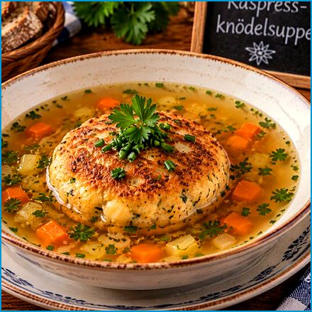
Serves 4
Kapressknödel
Pressed, pan-fried dumplings of stale bread, cheese, and onion. Serve them with a salad or float one in a bowl of hot broth.
Ingredients

- 9 oz. (260 g) dried white bread cubes (hard rolls or baguette), diced into small pieces
- 250 ml (1 cup) whole milk
- 3.5 oz. (100 g) grated cheese (Grey Cheese, Mountain Cheese or Gouda)
- 1 small onion, finely chopped
- 1 garlic clove, minced
- 2 large eggs
- A handful of fresh parsley, finely chopped
- Salt and pepper to taste
- Clarified butter or neutral cooking oil for frying
Method
Prepare the Dough:
- Combine the dried white bread cubes, milk, chopped onion, minced garlic, grated cheese, chopped parsley, and eggs in a large bowl.
- Season with salt and pepper to taste.
- Mix everything together until well combined.
Shape the Dumplings:
- Form the dough into small balls, about the size of a golf ball.
- Flatten each ball slightly to create a disc shape.
Fry the Dumplings:
- Heat clarified butter or neutral cooking oil in a large skillet over medium heat.
- Fry the dumplings in the hot oil until they are golden brown and crispy on both sides, about 2-3 minutes per side.
Serve:
- Serve the Kapressknödel hot, either as a side dish with Sauerkraut or in a soup.
- Garnish with additional parsley if desired.

Bread Dumplings
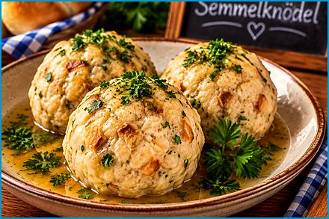
Serves 4
Semmelknödel
The classic Bavarian side dish: tender dumplings made from stale rolls, milk, egg, and parsley. Stale rolls go in; Sunday comes out.
Ingredients

- 5-6 stale hard rolls (Semmeln) or 1 baguette, cut into thin slices or small cubes
- 1 cup (240 ml) milk
- 2 eggs
- 1 onion, finely chopped
- 2 Tbsp. butter
- Salt and pepper to taste
- Fresh parsley, chopped
Method
Soften Bread:
- Place the bread cubes in a large bowl and pour the milk over them.
- Let it soak for about 10 minutes.
Cook Onions:
- Melt the butter and sauté the onions in a pan until they're golden brown.
Mix Ingredients:
- Add the sautéed onions, eggs, salt, pepper, and parsley to the soaked bread.
- Mix everything until well combined.
Form Dumplings:
- Form the mixture into balls about the size of a tennis ball with wet hands.
Cook Dumplings:
- Bring a large pot of salted water to a boil.
- Reduce to a simmer.
- Gently place the dumplings in the water and cook for about 15-20 minutes until they float to the surface.
Serve:
- Remove the dumplings with a slotted spoon and serve hot with your favorite gravy or sauce.
Guten Appetit!

Bavarian Braised Cabbage (Bayrisch Kraut)
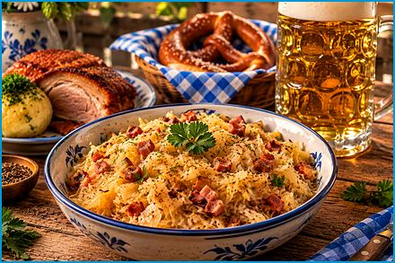
Serves 4
Bayrisch Kraut is the mildly tangy, caraway-scented braised white cabbage served with roasts across Bavaria. It is not fermented like sauerkraut, so it is ready in about an hour.
Ingredients

- 1 small green cabbage, shredded (about 1½ lbs. (680 g))
- 1 large onion, finely chopped
- 1 apple, peeled and grated
- 2 Tbsp. bacon fat (or oil)
- 1 tsp. caraway seeds
- 1/2 cup (120 ml) white wine or apple cider
- 1/2 cup (120 ml) chicken or vegetable broth
- 2 Tbsp. white vinegar
- Salt and pepper to taste
Method
Prepare the Cabbage:
- Shred the cabbage finely and rinse it under cold water.
- Drain well.
Cook the Onions:
- Heat the bacon fat or oil over medium heat in a large pot.
- Add the chopped onions and cook until they are soft and translucent.
Add Cabbage and Apple:
- Add the shredded cabbage and grated apple to the pot.
- Stir well to combine with the onions.
Season and Simmer:
- Add the caraway seeds, white wine or apple cider, broth, and vinegar to the pot.
- Season with salt and pepper.
- Stir everything together and bring to a gentle simmer.
Cook:
- Cover the pot and let the cabbage cook on low heat for about 45 minutes to 1 hour, stirring occasionally. The cabbage should become tender, and the flavors should meld together.
Adjust Seasoning:
- Taste the cabbage and adjust the seasoning with more salt, pepper, or vinegar if needed.
Serve:
- Serve your Bavarian braised cabbage hot as a side dish to sausages, pork dishes, or other Bavarian specialties.

Bavarian Yeast Dumplings

Serves 4 (8-10 dumplings)
Dampfnudeln
Soft yeast dumplings steamed in a covered pan with a golden crust underneath, served with meat sauce or as a sweet dish with vanilla sauce.
Ingredients
For the Dough:
- 18 oz. (510 g) all-purpose flour
- 250 ml (1 cup) milk, lukewarm
- 2 oz. (55 g) sugar
- 1 packet (2 tsp.) active dry yeast
- 2.5 oz. (70 g) butter, melted
- 1 egg
- 1/2 tsp. salt
For Cooking:
- 200 ml (¾ cup) milk
- 1.7 oz. (50 g) butter
- A pinch of salt
- 1 Tbsp. sugar
Method
Prepare the Dough:
- Dissolve the yeast and sugar in lukewarm milk in a small bowl.
- Let it sit for 10 minutes until frothy.
- Combine the flour and salt in a large mixing bowl.
- Add the yeast mixture, melted butter, and egg to the dry ingredients.
- Mix until a smooth dough forms.
- Knead the dough on a floured surface for about 10 minutes until it is smooth and elastic.
- Place it in a greased bowl, cover with a cloth, and let it rise in a warm place until doubled in size.
Shape the Dampfnudeln:
- Once the dough has risen, punch it down and divide it into equal-sized pieces, the size of a small apple.
- Shape each piece into a smooth ball, cover, and let rise for 20-30 minutes.
Cook the Dampfnudeln:
- In a large, deep pan with a tight-fitting lid, combine the milk, butter, 1 Tbsp. sugar, and a pinch of salt.
- Heat until the butter is melted and the mixture is just simmering.
- Place the dough balls in the pan, leaving some space between them. They should not touch each other.
- Cover the pan with the lid and let the dough balls cook over low heat for about 25-30 minutes.
- Do not lift the lid during this time as the steam is essential for cooking.
Finish and Serve:
- Remove them from the pan once the Dampfnudeln are cooked and the liquid has evaporated.
- Serve warm with vanilla sauce, or as a side with meat and gravy.

Blaukraut
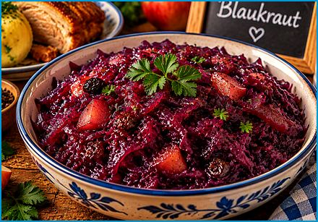
Serves 4
Red cabbage braised with apple, cloves, and vinegar until sweet, sour, and tender: the standard partner of roasts and dumplings. It tastes even better the next day, if you can hide some.
Ingredients

- 1/2 medium red cabbage (about 1½ lbs. (680 g)), finely shredded
- 1 large onion, finely chopped
- 1 apple, peeled and grated
- 2 Tbsp. butter or oil
- 1-2 Tbsp. sugar
- 1/2 cup (120 ml) apple cider vinegar
- 1/2 cup (120 ml) apple juice or water
- 2-3 cloves
- 1-2 bay leaves
- Salt and pepper to taste
Method
Prepare the Cabbage:
- Finely shred the red cabbage and rinse it under cold water.
- Drain well.
Cook the Onions and Apples:
- Melt the butter or heat the oil over medium heat in a large pot.
  - Add the chopped onion and cook until it is soft and translucent.
  - Add the grated apple and cook for another couple of minutes.
Add the Cabbage and Sugar:
- Stir in the shredded cabbage and sprinkle the sugar over it.
- Cook for a few minutes, stirring frequently, until the cabbage begins to wilt.
Add Liquid and Spices:
- Pour in the apple cider vinegar and apple juice (or water).
- Add the cloves and bay leaves.
- Season with salt and pepper to taste.
Simmer:
- Bring the mixture to a boil.
- Reduce the heat to low.
- Cover and simmer for 45 minutes to 1 hour, stirring occasionally, until it is tender and the flavors are well blended.
Adjust Seasoning:
- Taste and adjust the seasoning with more salt, pepper, or a little more sugar if desired.
Serve:
- Remove the cloves and bay leaves before serving. Blaukraut can be served hot as a side dish with roast meats, sausages, or other Bavarian specialties.

Bavarian Warm Potato Salad
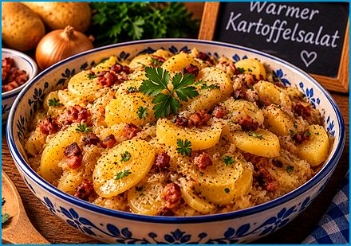
Serves 4
Warmer Kartoffelsalat
Warm sliced potatoes in a sharp dressing of broth, vinegar, and onions, finished with crisp bacon.
Ingredients

- 2 lbs. (910 g) potatoes (waxy potatoes like red or Yukon Gold)
- 6 oz. (170 g) bacon, diced
- 1 medium onion, finely chopped
- 4 Tbsp. apple cider vinegar
- 3/4 cup (180 ml) beef or chicken broth
- 3 Tbsp. sunflower oil
- 1 tsp. sugar
- 1/2 Tbsp. Dijon mustard (optional)
- Salt and pepper to taste
- 2 Tbsp. fresh parsley, chopped
Method
Boil Potatoes:
- Wash the potatoes and place them in a large pot of salted water.
- Bring to a boil and cook until the potatoes are tender, about 15-20 minutes.
- Drain the potatoes and let them cool slightly.
- Peel and slice them into thin (3-5 mm) rounds.
Cook Bacon:
- Cook the diced bacon over medium heat in a large skillet until it is crispy.
- Remove the bacon with a slotted spoon and set it aside, leaving the rendered bacon fat in the skillet.
Cook Onions:
- Add the chopped onion to the skillet with the bacon fat.
- Cook until the onion is soft and translucent.
Make Dressing:
- Add the apple cider vinegar, broth, sugar, and Dijon mustard (if using) to the skillet with the onions.
- Bring the mixture to a simmer and cook for a few minutes until the sugar is dissolved and the dressing is well combined.
- Season with salt and pepper to taste.
Combine and Serve:
- Place the sliced potatoes in a large bowl.
- Pour the warm dressing and the sunflower oil over the potatoes and gently toss to combine, being careful not to break the potato slices.
- Add the crispy bacon and chopped parsley, and toss again.
- Serve the potato salad warm.

Spicy Bavarian Beer Mustard
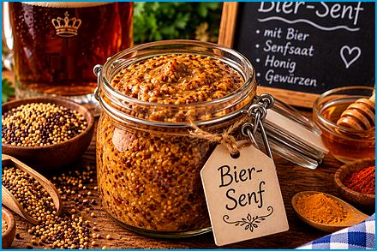
Makes about 2 cups (500 ml)
A coarse homemade mustard from soaked seeds, dark beer, and cider vinegar. Wonderful with sausages and pretzels.
Ingredients

- 1/2 cup (120 ml) yellow mustard seeds
- 1/2 cup (120 ml) brown mustard seeds
- 1 cup (240 ml) dark beer (Dunkel or Stout)
- 1/2 cup (120 ml) apple cider vinegar
- 1/4 cup (60 ml) water
- 2 Tbsp. brown sugar
- 1 Tbsp. honey
- 2 tsp. salt
- 1 tsp. ground turmeric
- 1/4 tsp. cayenne pepper
Method
Soak Mustard Seeds:
- Combine the yellow and brown mustard seeds with the beer, apple cider vinegar, and water in a large bowl.
- Mix well.
- Cover the bowl and let the seeds soak at room temperature for at least 12 hours, or overnight. This will allow the seeds to soften and absorb the liquid.
Blend the Mustard:
- Transfer the mustard seed mixture to a blender or food processor after soaking.
- Add the brown sugar, honey, salt, turmeric, and cayenne pepper (if using).
- Blend until you achieve your desired mustard consistency. For a coarser mustard, blend for a shorter time, then for a smoother mustard, blend longer.
Adjust the Flavor:
- Taste the mustard and adjust the seasoning if needed. You can add more salt, sugar, or vinegar to balance the flavors to your liking.
Store the Mustard:
- Transfer the mustard to clean, airtight jars.
- Let the mustard sit in the refrigerator for at least a few days before using to allow the flavors to meld together. The mustard will continue to develop its flavor over time.
Enjoy your homemade Spicy Bavarian Beer Mustard!

Bavarian Pretzels

Makes 8 pretzels
Brezeln
Chewy pretzels with a shiny brown crust, made by dipping the dough in a baking-soda bath before baking. They are best within the hour, which has never once been a problem.

Ingredients
For the Dough:
- 18 oz. (510 g) all-purpose flour
- 0.7 oz. (20 g) fresh yeast or 1 packet (2¼ tsp.) active dry yeast
- 150 ml (⅔ cup) warm water
- 150 ml (⅔ cup) warm milk
- 1 tsp. sugar
- 1 tsp. salt
- 1.8 oz. (50 g) butter, melted
For the Soda Bath:
- 1 L (4¼ cups) water
- 2 oz. (55 g) baking soda
For Topping:
- Coarse sea salt
Method
Prepare the Dough:
Bavarian Brezeln (Pretzels)
- Dissolve the yeast and sugar in the warm water and milk in a small bowl.
- Let it sit for about 10 minutes until frothy.
- Combine the flour and salt in a large mixing bowl.
- Make a well in the center and add the melted butter and yeast mixture.
- Mix until a dough forms.
- Knead on a floured surface for about 10 minutes until smooth and elastic.
- Place the dough in a greased bowl, cover, and let it rise in a warm place for about 1 hour.
Shape the Brezeln:
- Preheat your oven to 425°F (220°C).
- Divide it into 8 equal pieces once the dough has risen.
- Roll each piece into a long rope (about 20 in. long) and shape it into a pretzel by forming a U-shape, then crossing the ends and pressing them onto the bottom of the U.
Soda Bath:
- Bring the water to a boil and carefully add the baking soda (it will bubble up) in a large pot.
- Gently lower each pretzel into the soda bath using a slotted spoon for about 30 seconds. This step gives pretzels their distinctive texture and flavor.
- Remove the pretzels from the bath and place them on a baking sheet lined with parchment paper.
Bake the Brezeln:
- Sprinkle the pretzels with coarse sea salt.
- Bake in the preheated oven for about 12-15 minutes, or until golden brown.
Serve:
- Let the pretzels cool slightly on a wire rack.
Enjoy your homemade Brezeln fresh from the oven with butter!

Sourdough Bread
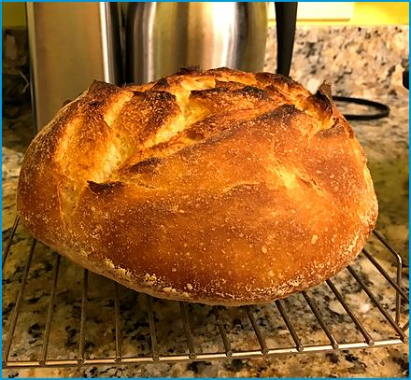
Makes 1 loaf
Sauerteigbrot
A crusty loaf of wheat and rye leavened with sourdough, with a tangy flavor and an open crumb.

Ingredients
For the Sourdough Starter:
- 2 oz. (55 g) whole wheat flour
- 2 oz. (55 g) water
- 1 Tbsp. active sourdough starter (to start the fermentation)
- Or skip this step and use 4 oz. (110 g) ready, active sourdough starter
For the Bread Dough:
- 9 oz. (260 g) wheat flour or whole wheat flour
- 9 oz. (260 g) rye flour
- 350 ml (1½ cups) water
- 2 tsp. salt
- All of the sourdough starter (from above)
Method
Prepare the Sourdough Starter:
- Mix the whole wheat flour, water, and 1 Tbsp. sourdough starter in a bowl.
- Cover with a cloth and let it ferment at room temperature for 12-24 hours, until bubbly and active.
Mix the Dough:
- Combine the wheat flour, rye flour, water, and salt in a large mixing bowl.
- Add the sourdough starter and mix until a rough dough forms.
- Let the dough rest for 30 minutes.
Knead the Dough:
- Knead the dough by hand or using a stand mixer for about 10 minutes, until smooth and elastic.
- Place the dough in a lightly oiled bowl, cover with a cloth, and let it rise for 4-6 hours.
Shape the Dough:
- Turn the dough out onto a lightly floured surface and shape it into a round or oval loaf.
- Cover and let it proof for another 2-4 hours, or until it has risen noticeably.
Preheat the Oven:
- Preheat your oven to 250°C (480°F) with a baking stone or a Dutch oven inside.
Bake the Bread:
- Carefully transfer the dough into the preheated Dutch oven, score the top, and cover with the lid if using a Dutch oven.
- Transfer the dough to a parchment-lined baking sheet, score the top, and place it on the stone if using a baking stone.
- Bake for 20 minutes.
- Reduce the oven temperature to 400°F (205°C) and bake for another 20-30 minutes. The bread is done when it sounds hollow when tapped on the bottom and has a deep brown crust.
Cool and Serve:
- Let the bread cool completely on a wire rack before slicing.

Bavarian Green Bean Salad
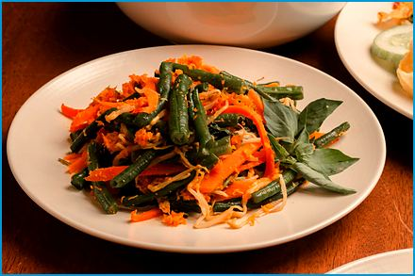
Serves 4
Bayerischer Bohnensalat
Crisp green beans in a mustard vinaigrette with red onion, served chilled.
Ingredients

- 18 oz. (510 g) green beans, trimmed and cut into 2-3 cm pieces
- 1 medium red onion, finely chopped
- 4 oz. (110 g) walnuts (optional)
- 4-5 strips of bacon, cooked and crumbled (optional)
- 2-3 Tbsp. white wine vinegar
- 3-4 Tbsp. vegetable oil (such as sunflower, or canola oil)
- 1 tsp. mustard (preferably Dijon or German mustard)
- 1 tsp. dried savory (Bohnenkraut), optional
- 1/2 tsp. sugar
- Salt and pepper to taste
- Fresh parsley, chopped (for garnish)
Method
Cook the Green Beans:
- Bring a large pot of salted water to a boil.
- Add the green beans and cook for about 5-7 minutes, or until tender but still crisp.
- Drain the beans and plunge them into a bowl of ice water to stop the cooking process and retain their bright green color.
- Drain again and set aside.
Prepare the Dressing:
- Whisk together the white wine vinegar, vegetable oil, mustard, savory (if using), sugar, salt, and pepper in a large bowl.
Combine the Salad:
- Add the cooked green beans and finely chopped red onion to the bowl with the dressing.
- Toss everything together until the beans are well coated with the dressing.
- Add the crumbled bacon and walnuts if using.
- Toss again.
Chill and Serve:
- Let the salad chill in the refrigerator for at least 30 minutes to allow the flavors to meld.
- Garnish with fresh chopped parsley before serving.

Napkin Dumpling
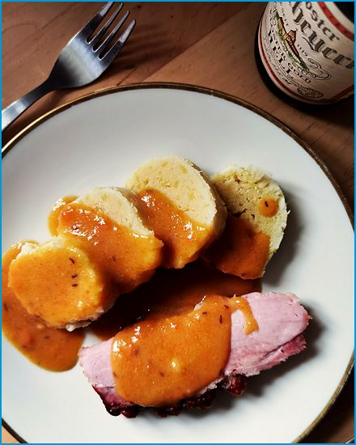
Serves 4
Serviettenknödel
A bread dumpling shaped into a long roll, cooked in a cloth, and cut into thick slices: the elegant partner of any gravy dish.
Ingredients

- 10 oz. (300 g) stale white bread rolls or bread, cut into small cubes
- 250 ml (1 cup) warm milk
- 3 eggs
- 1 small onion, finely diced
- 1 Tbsp. butter
- 2 Tbsp. chopped parsley
- Salt, pepper, and a pinch of nutmeg
- Butter for greasing the cloth
Method
Make the Dough:
- Cook the onion in the butter until soft and let it cool slightly.
- Whisk the warm milk with the eggs, parsley, salt, pepper, and nutmeg and pour it over the bread with the onion.
- Mix gently and let it stand for 20 minutes.
Shape the Roll:
- Shape the dough into a roll about 6 cm thick on a buttered clean kitchen towel (or on cling film wrapped in foil) and wrap it up loosely, tying both ends with kitchen twine.
Cook:
- Lower the roll into a large pot of simmering salted water and cook for 40 minutes, just below the boil.
- Lift it out, let it drain for 2 minutes, unwrap it, and cut it into 2 cm slices.
Serve:
- Serve the slices hot with gravy, roast meat, or creamy mushroom sauce.

Desserts
Bavarians have a sweet tooth and an afternoon coffee hour to prove it. These are the cakes, strudels, and puddings that fill it, plus a few sweet dishes that count as a main course on a Friday.

German Doughnuts

Makes about 12
Krapfen
Fluffy yeast doughnuts filled with jam and dusted with powdered sugar, the Bavarian carnival treat. Someone will always bite into one from the jam side. Have napkins ready.
Ingredients

- 18 oz. (510 g) all-purpose flour
- 200 ml (¾ cup) milk, lukewarm
- 1.8 oz. (50 g) sugar
- 2.5 oz. (70 g) butter, softened
- 0.7 oz. (20 g) fresh yeast (or 2 tsp. active dry yeast)
- 3 large eggs
- A pinch of salt
- Zest of 1 lemon (optional)
- Vegetable oil for frying
- Fruit jam (apricot, raspberry, or your favorite), for filling
- Powdered sugar for dusting
Method
Prepare the Dough:
- Dissolve the yeast in lukewarm milk with 1 tsp. of the sugar in a small bowl.
- Let it sit for 10 minutes until frothy.
- Combine the flour, remaining sugar, salt, and lemon zest (if using) in a large mixing bowl.
- Add the yeast mixture, eggs, and softened butter.
- Mix until a smooth dough forms.
- Knead the dough on a floured surface for about 10 minutes until it is smooth and elastic.
- Place the dough in a greased bowl, cover with a cloth, and let it rise in a warm place for about 1½ hours.
Shape the Krapfen:
- Once the dough has risen, punch it down to release the air.
- Roll out the dough on a floured surface to about 1 cm thickness.
- Use a round cookie cutter or a glass to cut out circles of dough (about 7-8 cm in diameter).
- Place the dough circles on a floured baking sheet and cover with a cloth.
- Let them rise for 30 minutes.
Fry the Krapfen:
- Heat the vegetable oil in a deep fryer or a large pot to 175°C (350°F).
- Fry the dough circles in batches until they are golden brown on both sides, 2-3 minutes per side.
- Remove the Krapfen from the oil with a slotted spoon and drain on paper towels.
Fill and Dust:
- Use a pastry bag fitted with a long, thin nozzle to fill each one with jam once the Krapfen are cool enough to handle.
- Dust the filled Krapfen generously with powdered sugar.

Bayerischer Scheiterhaufen
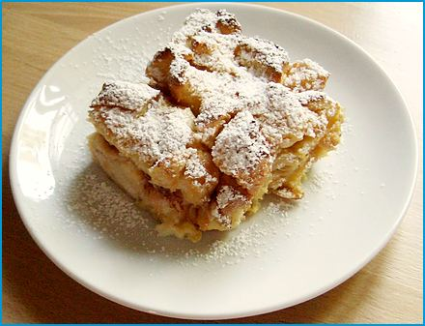
Serves 4
A baked pudding of old bread, apples, and raisins in a sweet custard, a clever way to rescue leftover bread.
Ingredients
- 8 slices of stale bread (about 1 lb. (450 g))
- 750 ml (3 cups) milk (250 ml for soaking the bread, 500 ml (2 cups) for the custard)
- 1 pinch of salt
- Zest of half a lemon
- 2 oz. (55 g) sugar
- 3 eggs
- 1.5 lbs. (680 g) juicy apples (e.g., Boskoop, Jonagold, or Braeburn)
- 2 oz. (55 g) raisins
- 2 Tbsp. butter for baking
- Powdered sugar for dusting
Method
Prepare the Bread:
- Cut the old bread into thin slices and place them in a bowl.
- Pour 250 ml (1 cup) of the milk over the bread slices and let them soak for about 10-15 minutes.
Prepare the Filling:
- Peel, core, and thinly slice the apples while the bread is soaking.
- Wash the raisins under cold water and soak them in hot water for a few minutes.
Preheat the Oven:
- Preheat your oven to 180°C (350°F).
Mix the Custard:
- Mix together the remaining 500 ml (2 cups) milk, salt, lemon zest, sugar, and eggs in a bowl.
- Whisk until well combined.
Assemble the Scheiterhaufen:
- Grease a baking dish with butter.
- Layer the soaked bread slices, apple slices, and raisins alternately in the dish.
Bake:
- Pour the custard over the layers.
- Dot with small pieces of butter.
- Bake in the preheated oven for about 30-45 minutes, or until the top is golden brown and a toothpick inserted into the center comes out clean.
Serve:
- Let the Scheiterhaufen cool slightly before dusting with powdered sugar.
- Serve warm with a dollop of whipped cream or vanilla sauce.

Marble Bundt Cake
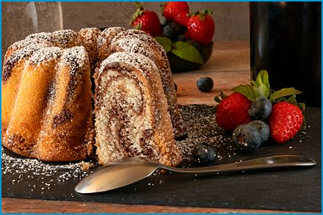
Serves 10-12
Marmor Gugelhupf
A buttery Bundt cake with a marbled swirl of vanilla and chocolate, perfect with coffee.

Ingredients
- 10 oz. (280 g) unsalted butter, softened
- 8 oz. (230 g) sugar
- 1 packet vanilla sugar (or 1 tsp. vanilla extract)
- 5 eggs
- 1 lb. (450 g) all-purpose flour
- 250 ml (1 cup) milk
- 2 Tbsp. cocoa powder
- 2 Tbsp. powdered sugar
- A pinch of salt
- Butter and flour for the pan
- 3 tsp. baking powder (or 3/4 tsp. baking soda and 1½ tsp. lemon juice)
Method
Preheat the Oven:
- Preheat your oven to 180°C (350°F).
- Grease a Bundt cake pan with butter and dust it with flour to prevent sticking.
Prepare the Batter:
- Cream the softened butter with the sugar and vanilla sugar (or vanilla extract) in a large mixing bowl until light and fluffy.
- Add the eggs one at a time, beating well after each addition.
- Mix together the flour, baking powder, and a pinch of salt in a separate bowl.
- Gradually add the dry ingredients to the butter mixture, alternating with the milk, beginning and ending with the dry ingredients.
- Mix until just combined.
Create the Marble Effect:
- Divide the batter into two equal parts. To one part, add the cocoa powder and mix until well incorporated.
- Spoon the vanilla and chocolate batters alternately into the prepared Bundt pan.
- Gently swirl the batters together to create a marble effect using a knife or a skewer.
- Do not overmix.
Bake the Cake:
- Bake in the preheated oven for about 50-60 minutes, or until a toothpick inserted into the center of the cake comes out clean.
- Remove the cake from the oven and let it cool in the pan for about 10 minutes.
- Turn the cake out onto a wire rack to cool completely.
Finish and Serve:
- Dust it with powdered sugar once the cake is completely cool.
- Slice and serve with a cup of coffee or tea.

Bavarian Plum Cake
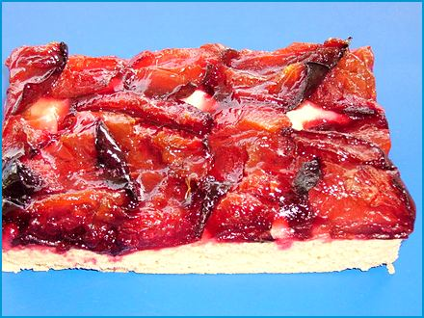
Serves 10-12
Zwetschgendatschi
A yeast-dough cake covered in juicy plums, baked until the fruit turns jammy. A late-summer favorite. When the plums are ripe, the whole street seems to bake one on the same Saturday.
Ingredients

For the Dough:
- 14 oz. (400 g) all-purpose flour
- 1/2 tsp. salt
- 2.5 oz. (70 g) sugar
- 1 egg
- 1 package (2 tsp.) active dry yeast
- 200 ml (¾ cup) warm milk
- 2.5 oz. (70 g) butter, melted
For the Topping:
- 2 lbs. (910 g) plums (Zwetschgen), pitted and quartered
- 1.7 oz. (50 g) sugar
- 1 tsp. ground cinnamon
- 1.7 oz. (50 g) sliced almonds (optional)
For the Streusel (Optional Sprinkle):
- 3.5 oz. (100 g) all-purpose flour
- 2 oz. (55 g) sugar
- 2.5 oz. (70 g) butter, cold and cut into small pieces
Method
Prepare the Dough:
- Dissolve the yeast in the warm milk and let it sit in a small bowl for about 10 minutes until frothy.
- Mix the flour, salt, sugar, yeast mixture, melted butter, and egg in a large bowl until a smooth dough forms.
- Knead the dough on a floured surface for about 10 minutes until it is smooth and elastic.
- Place the dough in a greased bowl, cover with a cloth, and let it rise in a warm place for 2 hours.
Prepare the Topping:
- Wash, pit, and quarter the plums.
- Mix the sugar and ground cinnamon in a small bowl.
Prepare the Streusel (Optional):
- Combine the flour, sugar, and cold butter pieces in a bowl.
- Use your fingers to rub the butter into the flour and sugar until the mixture resembles coarse crumbs.
Assemble the Zwetschgendatschi:
- Preheat your oven to 180°C (350°F).
- Roll out the dough on a floured surface and place it on a greased baking sheet or in a baking pan.
- Arrange the plum quarters closely on top of the dough in rows.
- Sprinkle the cinnamon sugar mixture evenly over the plums.
- Sprinkle the streusel and sliced almonds on top if using.
Bake:
- Bake for about 30-40 minutes, or until the dough is golden brown and the plums are tender.
Serve:
- Let the Zwetschgendatschi cool before slicing.
- Serve at room temperature.

Moist Apple Cake
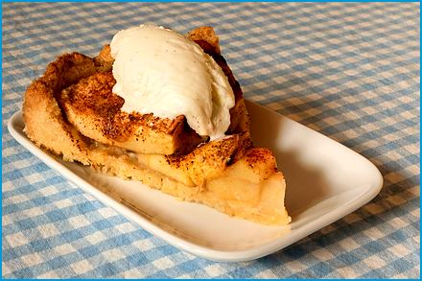
Serves 10-12
Saftiger Apfelkuchen
A tender, juicy cake layered with fresh apple slices and a little cinnamon.
Ingredients

- 4 large apples (such as Granny Smith or Braeburn), peeled, cored, and sliced
- 7 oz. (200 g) all-purpose flour
- 7 oz. (200 g) sugar
- 7 oz. (200 g) unsalted butter, softened
- 1 packet vanilla sugar (or 1 tsp. vanilla extract)
- 1 tsp. ground cinnamon
- 3 large eggs
- 2 tsp. baking powder (or 1/2 tsp. baking soda and 1 tsp. lemon juice)
- 100 ml (3.5 fl oz.) milk
- A pinch of salt
- Powdered sugar for dusting (optional)
Method
Preheat the Oven:
- Preheat your oven to 180°C (350°F).
- Grease a 24 cm (9 inch) springform pan and line the bottom with parchment paper.
Prepare the Apples:
- Peel, core, and slice the apples.
- Set aside.
Make the Batter:
- Cream the butter with sugar and vanilla sugar (or vanilla extract) in a large bowl until light and fluffy.
- Add the eggs one at a time, beating well after each addition.
- Mix together the flour, baking powder, ground cinnamon, and a pinch of salt in a separate bowl.
- Gradually add the dry ingredients to the butter mixture, alternating with the milk, beginning and ending with the dry ingredients.
- Mix until just combined.
Assemble the Cake:
- Pour half of the batter into the prepared springform pan and spread it evenly.
- Arrange half of the apples over the batter.
- Pour the remaining batter over it and spread evenly.
- Arrange the remaining apple slices on top of the batter in a decorative pattern.
Bake the Cake:
- Bake in the preheated oven for about 50-60 minutes, or until a toothpick inserted into the center of the cake comes out clean.
- Remove the cake from the oven and let it cool in the pan for about 10 minutes.
- Remove the cake from the pan and let it cool completely on a wire rack.
Serve:
- Dust it with powdered sugar if desired once the cake is completely cool.
- Slice and serve with a cup of coffee or tea.

Yeast Dumplings with Vanilla Sauce
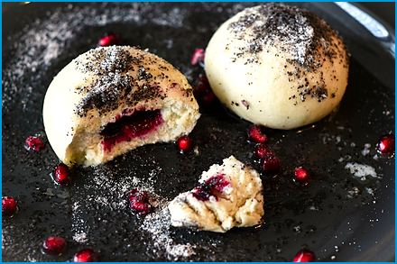
Serves 4 (8-10 dumplings)
Germknödel mit Vanillesauce
Steamed yeast dumplings filled with plum jam, covered in vanilla sauce, and scattered with poppy seeds and sugar.
Ingredients

For the Germknödel (Yeast Dumplings):
- 18 oz. (510 g) all-purpose flour
- 250 ml (1 cup) milk, lukewarm
- 1 packet dry yeast (2 tsp.)
- 2 oz. (55 g) sugar
- 1 tsp. vanilla extract
- 2 large eggs
- 2.5 oz. (70 g) unsalted butter, melted
- A pinch of salt
- Plum jam (Powidl), about 8-10 Tbsp., for filling
For the Vanilla Sauce:
- 500 ml (2 cups) milk
- 1 tsp. vanilla extract
- 3 egg yolks
- 1.7 oz. (50 g) sugar
- 1 Tbsp. cornstarch
For Topping:
- 1.7 oz. (50 g) poppy seeds, ground, mixed with 1.7 oz. (50 g) powdered sugar
- 1.7 oz. (50 g) unsalted butter, melted
Method
Prepare the Dough:
- Mix the lukewarm milk with the yeast and 1 tsp. of the sugar in a small bowl.
- Let it sit for about 10 minutes until it becomes frothy.
- Combine the flour, remaining sugar, vanilla extract, melted butter, eggs, and salt in a large mixing bowl.
- Add the yeast mixture to the bowl and knead everything into a smooth dough.
- Add a little more flour if the dough is too sticky.
- Add a bit more milk if it's too dry.
- Cover the bowl with a clean kitchen towel and let the dough rise in a warm place for 1 hour, or until it has doubled in size.
Shape the Dumplings:
- Once the dough has risen, punch it down and knead it briefly.
- Divide the dough into equal portions (about 8-10 pieces).
- Flatten each piece and place 1 Tbsp. of plum jam in the center.
- Fold the dough over the jam and shape it into a smooth ball, sealing the edges well.
- Place the filled dumplings on a floured surface, cover with a towel, and let them rise for another 30 minutes.
Cook the Dumplings:
- Bring a couple of inches of water to a boil in a large pot.
- Reduce the heat to a gentle simmer.
- Place a steaming rack or insert in the pot.
- Place the dumplings on the rack (making sure they don't touch each other), cover, and steam for about 20-25 minutes, or until the dumplings are cooked through.
Prepare the Vanilla Sauce:
- Heat the milk with the vanilla extract in a saucepan until it begins to simmer.
- Whisk together the egg yolks, sugar, and cornstarch in a bowl until smooth.
- Slowly pour the hot milk into the egg mixture, whisking constantly.
- Return the mixture to the saucepan and cook over low heat, stirring constantly, until the sauce thickens.
- Do not let it boil.
Serve:
- Place the steamed Germknödel on plates.
- Pour the warm vanilla sauce over the dumplings.
- Drizzle with melted butter and sprinkle with ground poppy seeds.

Apple Fritters
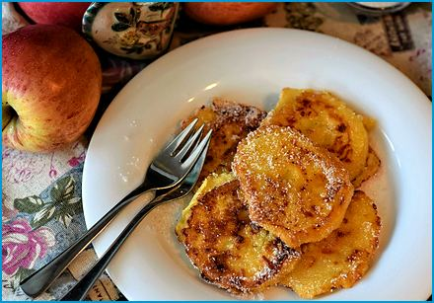
Serves 4
Apfelkücherl
Apple rings dipped in batter and fried until crisp, dusted with cinnamon sugar.

Ingredients
- 4 large apples (such as Granny Smith or Braeburn)
- 7 oz. (200 g) all-purpose flour
- 2 Tbsp. sugar
- 1 packet vanilla sugar (or 1 tsp. vanilla extract)
- 1 tsp. ground cinnamon
- 2 large eggs
- 200 ml (¾ cup) milk
- A pinch of salt
- Vegetable oil for frying
- Powdered sugar or cinnamon sugar for dusting
Method
Prepare the Apples:
- Peel, core, and slice the apples into rings about 1 cm thick.
- Set the apple rings aside.
Make the Batter:
- Combine the flour, sugar, vanilla sugar (or vanilla extract), ground cinnamon, and a pinch of salt in a mixing bowl.
- Add the eggs and milk, and whisk until you have a smooth batter.
Heat the Oil:
- Heat the vegetable oil to about 175°C (350°F) in a deep frying pan or pot. The oil should be deep enough to submerge the apple rings.
Fry the Apple Rings:
- Dip each apple ring into the batter, ensuring it is fully coated.
- Carefully place the battered apple rings into the hot oil.
- Fry in batches to avoid overcrowding the pan.
- Fry the apple rings until they are golden brown on both sides, about 2-3 minutes per side.
- Use a slotted spoon to remove the apple rings from the oil and place them on a paper-towel-lined plate to drain excess oil.
Serve:
- Dust the warm Apfelkücherl with powdered sugar or cinnamon sugar.
- Serve immediately and enjoy them warm.

Bavarian Cream
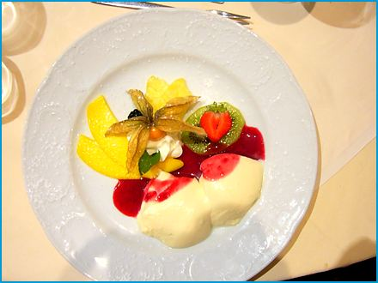
Serves 4
Bayerische Crème
A chilled, vanilla-scented custard lightened with whipped cream and served with fresh berries.
Ingredients

- 500 ml (2 cups) milk
- 1 vanilla bean or 1 tsp. vanilla extract
- 4 egg yolks
- 3.5 oz. (100 g) sugar
- 1 Tbsp. (about 10 g (0.5 oz.)) powdered gelatin
- 200 ml (¾ cup) heavy cream, whipped
- Fresh berries or fruit sauce for serving
Method
Prepare the Vanilla Milk:
- Heat the milk with the vanilla bean (split and seeds scraped) or vanilla extract in a saucepan until it begins to simmer.
- Do not let it boil.
- Remove from heat and let it steep for 10-15 minutes to infuse the vanilla flavor.
Make the Egg Mixture:
- Whisk together the egg yolks and sugar in a bowl until pale and creamy.
- Gradually add the vanilla milk to the egg mix, whisking constantly to prevent the eggs from curdling.
Cook the Cream:
- Return the mixture to the saucepan and cook over low heat, stirring constantly, until it thickens slightly and coats the back of a spoon.
- Do not let it boil.
- Remove from heat.
Dissolve the Gelatin:
- Dissolve the gelatin in a few Tbsp. of cold water in a small bowl.
- Let it sit for a few min until it blooms.
- Stir the dissolved gelatin into the warm custard mixture until completely dissolved.
Cool and Fold in Whipped Cream:
- Let the custard mixture cool to room temperature.
- Gently fold in the whipped cream until well combined once cooled.
Chill and Serve:
- Pour the mixture into individual serving dishes or a large bowl.
- Refrigerate for at least 4 hours, or until set.
- Serve with fresh berries or fruit sauce.

Almond-filled Stollen
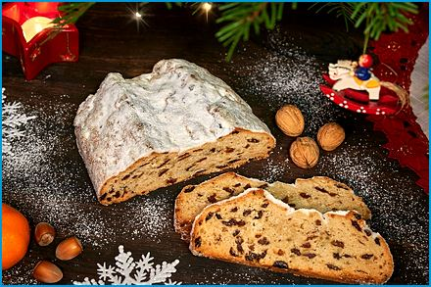
Makes 1 loaf, about 12 slices
Christmas bread with an almond-paste center, candied citrus peel, and a snowy coat of powdered sugar.
Ingredients

For the Dough:
- 18 oz. (510 g) all-purpose flour
- 3.5 oz. (100 g) sugar
- 200 ml (¾ cup) warm milk
- 1 tsp. ground cinnamon
- 1 package (2 tsp.) active dry yeast
- 6 oz. (170 g) butter, softened
- 2 eggs
- 1/2 tsp. salt
- 1 tsp. vanilla extract
- 1/2 tsp. ground cardamom
- 3.5 oz. (100 g) raisins (optional)
- 1.7 oz. (50 g) candied orange peel
- 1.7 oz. (50 g) candied lemon peel
- 4 oz. (110 g) chopped almonds
For the Almond Filling:
- 7 oz. (200 g) ground almonds
- 3.5 oz. (100 g) powdered sugar
- 1 egg white
- 1 tsp. almond extract
For Finishing:
- 1.7 oz. (50 g) melted butter
- Powdered sugar for dusting
Method
Prepare the Dough:
- Dissolve the yeast in the warm milk and let it sit in a small bowl for about 10 minutes until frothy.
- Combine the flour, sugar, salt, cinnamon, and cardamom in a large bowl.
- Add the yeast mixture, softened butter, eggs, and vanilla extract.
- Mix until a dough forms.
- Knead the dough on a floured surface for about 10 minutes until smooth and elastic.
- Place the dough in a greased bowl, cover with a cloth, and let it rise in a warm place for about 2 hours.
Prepare the Almond Filling:
- Mix the ground almonds, powdered sugar, egg white, and almond extract in a bowl until it forms a smooth paste.
Shape the Stollen:
- Preheat your oven to 180°C (350°F).
- Roll it out into a large rectangle on a floured surface once the dough has risen.
- Spread the almond filling evenly over the dough.
- Sprinkle the raisins, candied orange peel, candied lemon peel, and almonds over the almond filling.
- Fold the dough in half lengthwise and shape it into a loaf, making sure to seal the edges well.
Bake the Stollen:
- Place the Stollen on a baking sheet lined with parchment paper.
- Bake in the preheated oven for about 40-50 minutes, or until golden brown and cooked through.
Finish the Stollen:
- Brush the hot Stollen with melted butter once baked.
- Let it cool completely.
- Dust generously with powdered sugar.
- Enjoy your festive Almond-Filled Stollen!

All Saints' Braid
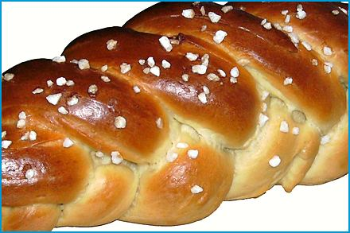
Makes 1 braid, about 10 slices
Allerheiligen Striezel
A sweet braided yeast bread, traditionally baked and gifted around All Saints' Day.
Ingredients

18 oz. (510 g) all-purpose flour
250 ml (1 cup) milk, lukewarm
1 packet dry yeast (2 tsp.)
2.5 oz. (70 g) sugar
1 packet vanilla sugar (or 1 tsp. vanilla extract)
2.5 oz. (70 g) unsalted butter, melted
1 large egg
A pinch of salt
3.5 oz. (100 g) raisins (optional)
1 egg yolk (for brushing)
1 Tbsp. milk (for brushing)
Powdered sugar for dusting (optional)
Method
Prepare the Dough:
- Mix the lukewarm milk with the dry yeast and 1 tsp. of the sugar in a small bowl.
- Let it sit for about 10 minutes until it becomes frothy.
- Combine the flour, remaining sugar, vanilla sugar (or vanilla extract), melted butter, egg, and a pinch of salt in a large mixing bowl.
- Add the yeast mixture to the bowl and knead everything into a smooth dough.
- Add a little more flour if the dough is too sticky.
- Add a bit more milk if it's too dry.
- Fold them into the dough during the kneading process if using raisins.
- Cover the bowl with a kitchen towel and let the dough rise in a warm place until it has doubled in size.
Shape the Striezel:
- Once the dough has risen, punch it down and knead it briefly.
- Divide the dough into three equal portions.
- Roll each portion into a long rope, about 14 in. in length.
- Braid the three ropes together and tuck the ends under to secure.
Second Rise:
- Place the braided dough on a baking sheet lined with parchment paper.
- Cover with a towel and let it rise for another 30 minutes.
Prepare for Baking:
- Preheat your oven to 180°C (350°F).
- Whisk together the egg yolk and milk in a small bowl.
- Brush it over the braided dough to give it a nice glaze.
Bake the Striezel:
- Bake in the preheated oven for about 25-30 minutes, or until the bread is golden brown and sounds hollow when tapped on the bottom.
- Remove from the oven and let it cool on a wire rack.
Serve:
- Dust it with powdered sugar if desired once the bread is cool.
- Slice and serve as a festive treat.

Almnussen

Makes about 20
Small, soft quark-dough puffs fried until golden and dusted with sugar: a treat from the alpine pastures.
Ingredients

9 oz. (250 g) all-purpose flour
1 tsp. baking powder
2 Tbsp. sugar
9 oz. (250 g) quark (20% fat)
2 large eggs
2.5 oz. (70 g) clarified butter or neutral oil (for frying)
Powdered sugar for dusting
Method
Prepare the Dough:
- Mix the flour, baking powder, sugar, quark, and eggs in a bowl until a smooth dough forms. The dough will be soft and sticky.
- Do not roll it out.
- Shape the Almnussen:.
- Use a spoon to scoop small portions of dough and shape them into walnut-sized balls.
Fry the Almnussen:
- Heat the clarified butter (or about 1 cm of neutral oil) in a large skillet over medium heat.
- Fry the dough balls in batches, turning them until they are golden brown on all sides.
- Remove the fried Almnussen from the skillet and let them drain on a paper-towel-lined plate.
Serve:
- Dust the Almnussen with powdered sugar while still warm.
- Serve immediately and enjoy!

Apfel-Schneemus-Torte
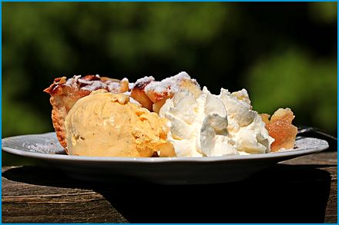
Serves 10-12
A light sponge cake layered with spiced apple filling and whipped cream.

Ingredients
For the Crust:
- 150 g (5.5 oz.) butter, softened
- 150 g (5.5 oz.) sugar
- 1 tsp. vanilla sugar
- 2 eggs
- 200 g (7 oz.) flour
- 2 tsp. baking powder (or 1/2 tsp. baking soda and 1 tsp. lemon juice)
- 75-100 ml (⅓-½ cup) milk
- A pinch of salt
- 3 Tbsp. almond flakes
For the Filling:
- 700 g (1.5 lbs.) apples, peeled, cored, and diced
- 300 ml (1¼ cups) apple juice
- 2 Tbsp. sugar
- 1 tsp. vanilla sugar
- 1 packet vanilla pudding powder
- 400 ml (1⅔ cups) heavy cream
- 1 Tbsp. gelatin (for stabilizing the whipped cream)
Method
Prepare the Crust:
- Preheat your oven to 180°C (350°F).
- Cream together the butter, sugar, and vanilla sugar in a mixing bowl until light and fluffy.
- Add eggs one at a time, mixing well after each addition.
- Mix the flour, baking powder, and salt in a separate bowl.
- Gradually add the dry ingredients to the butter mixture, alternating with the milk, until a smooth dough forms.
- Spread the dough evenly in a greased springform pan (28 cm).
- Sprinkle the almond flakes on top.
- Bake for 30-40 minutes, or until golden brown.
- Let it cool.
Prepare the Filling:
- Combine the diced apples, the apple juice (keep back 4 Tbsp.), sugar, and vanilla sugar in a saucepan.
- Cook over medium heat until the apples are soft but still hold their shape, about 5 minutes.
- Stir the vanilla pudding powder into the reserved apple juice until smooth, stir it into the apples, and simmer for 1 minute until thickened.
- Let the filling cool completely.
Assemble the Torte:
- Slice it horizontally into two layers once the crust is cool.
- Spread the apple filling evenly over the bottom layer of the crust.
- Dissolve the gelatin in 3 Tbsp. of hot water and let it cool slightly.
- Whip the cream, drizzling in the gelatin once soft peaks form, until stiff.
- Spread the whipped cream over the apple filling.
- Place the top layer of the crust over the whipped cream.
Chill and Serve:
- Refrigerate the torte for at least 2 hours before serving.
- Dust with powdered sugar before serving, if desired.

Apfel-Zimt-Griessbrei
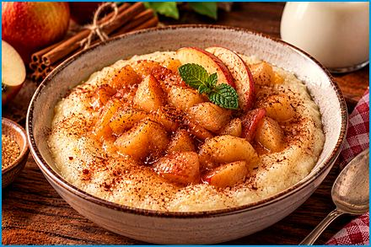
Serves 4
Warm semolina porridge with cinnamon apples: comfort food for breakfast or dessert.
Ingredients
- 750 ml (3 cups) milk
- 3 oz. (85 g) semolina (Grieß)
- 3 Tbsp. sugar
- 1 tsp. vanilla extract (or 1 packet vanilla sugar)
- 1 tsp. ground cinnamon, 3 apples, peeled, cored, and diced
- 1 Tbsp. butter
- A pinch of salt
- Ground cinnamon and sugar for sprinkling (optional)
Method
Cook the Apples:
- Melt the butter over medium heat in a small saucepan.
- Add the diced apples and cook until they are soft and slightly caramelized, about 5-7 minutes.
- Sprinkle with ground cinnamon and cook for another minute.
- Set aside.
Make the Semolina Porridge:
- Bring the milk to a gentle boil in a medium saucepan.
- Gradually whisk in the semolina, stirring constantly to prevent lumps.
- Add the sugar, vanilla extract (or vanilla sugar), and a pinch of salt.
- Continue to cook the mixture over low heat, stirring constantly, until it thickens and the semolina is fully cooked, about 5-7 minutes.
Combine and Serve:
- Stir the cooked apples into the semolina porridge.
- Spoon the Apfel-Zimt-Griessbrei into bowls.
- Sprinkle with a little more ground cinnamon and sugar, if desired.

Hoiber Datschi
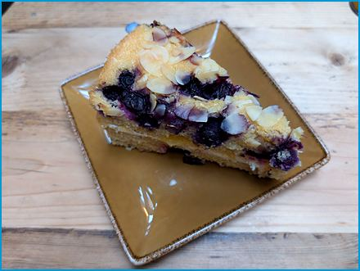
Serves 4
A puffy baked pancake studded with blueberries and dusted with sugar, a Bavarian Forest favorite.
Ingredients
- 10 oz. (280 g) flour
- 5 eggs (separate yolks and whites)
- 500 ml (2 cups) milk
- 1.7 oz. (50 g) butter
- A pinch of salt
- 1.7 oz. (50 g) sugar (some for the batter, some for sprinkling)
- 18 oz. (510 g) blueberries (Heidelbeeren)
- 1 tsp. vanilla extract (optional)
Method
Prepare the Batter:
- Preheat your oven to 180°C (350°F).
- Beat the egg whites in a bowl until stiff peaks form.
- Whisk together the egg yolks, flour, 2 Tbsp. of the sugar, and a pinch of salt in another bowl.
- Gradually add the milk to the egg yolk mixture, stirring constantly to avoid lumps.
- Gently fold the beaten egg whites into the batter until well combined.
Prepare the Filling:
- Melt the butter over medium heat in a saucepan.
- Add the blueberries and cook until they soften slightly, about 5-7 minutes.
- Sprinkle with sugar and vanilla extract (if using), and cook for another minute.
Assemble and Bake:
- Grease a baking dish and pour the batter into it.
- Spread the blueberry mixture evenly over the batter.
- Bake in the preheated oven for about 40-45 minutes, or until the top is golden brown and a toothpick inserted into the center comes out clean.
- Allow the Hoiber Datschi to cool slightly before serving.
- Dust with additional sugar if desired.

Apple Cinnamon Rolls
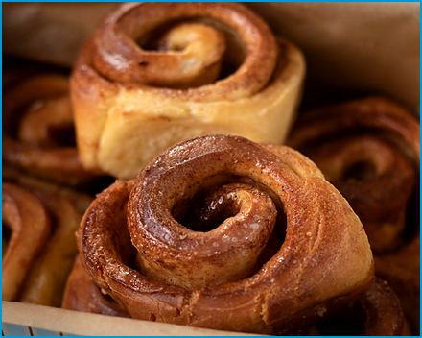
Makes 12 rolls
Apfelschnecken
Soft yeast rolls rolled up with cinnamon apples and finished with a lemon glaze.
Ingredients
For the Dough:
- 18 oz. (510 g) all-purpose flour
- 250 ml (1 cup) milk, lukewarm
- 1.7 oz. (50 g) sugar
- 1 packet dry yeast (2 tsp.)
- 2.5 oz. (70 g) unsalted butter, melted
- 1 large egg
- A pinch of salt
For the Filling:
- 3-4 large apples, peeled, cored, and diced
- 3.5 oz. (100 g) sugar
- 2 tsp. ground cinnamon
- 1 packet vanilla sugar (or 1 tsp. vanilla extract)
- 1.7 oz. (50 g) unsalted butter, melted
For the Glaze:
- 6 oz. (170 g) powdered sugar
- 2-3 Tbsp. lemon juice
Method
Prepare the Dough:
- Mix the lukewarm milk with the dry yeast and 1 tsp. of the sugar in a small bowl.
- Let it sit for about 10 minutes, until frothy.
- Combine the flour, remaining sugar, and a pinch of salt in a large mixing bowl.
- Add the yeast mixture, melted butter, and egg to the dry ingredients.
- Mix until a smooth dough forms.
- Knead the dough on a lightly floured surface for about 5-10 minutes, until it is smooth and elastic.
- Place in a greased bowl, cover with a kitchen towel, and let it rise in a warm place until it has doubled in size.
Prepare the Filling:
- Mix the diced apples with the sugar, ground cinnamon, and vanilla sugar (or vanilla extract) in a bowl.
Assemble the Rolls:
- Once the dough has risen, punch it down and roll it out on a floured surface into a large rectangle about 1/4 in. (6 mm) thick.
- Spread the melted butter and the apple and cinnamon mix over the rolled-out dough. Starting from one of the long sides, roll the dough tightly into a log.
- Cut the log into 1 in. slices and place them in a greased baking dish, leaving some space in-between.
Second Rise:
- Cover the baking dish with a kitchen towel and let the rolls rise for another 30 minutes.
Bake the Rolls:
- Preheat your oven to 180°C (350°F).
- Bake the rolls for about 25-30 minutes, or until they are golden brown and cooked through.
- Remove from the oven and let them cool slightly.
Prepare the Glaze:
- Mix the powdered sugar with lemon juice in a small bowl until smooth.
- Drizzle over the warm rolls.

Lemon Sorbet and Tonic Dream

Serves 4
Zitronensorbet-Tonic-Traum
Lemon sorbet topped with ice-cold tonic water and fresh mint: a sparkling palate cleanser.
Ingredients

For the Lemon Sorbet:
- 7 oz. (200 g) sugar
- 250 ml (1 cup) water
- 200 ml (¾ cup) freshly squeezed lemon juice (about 4-5 lemons)
- 1 Tbsp. lemon zest
- 1 Tbsp. vodka
For the Tonic Dream:
- 1 L (4¼ cups) tonic water, chilled
- Fresh mint leaves (for garnish)
- Lemon slices or zest (for garnish)
Method
Make the Lemon Sorbet:
- Combine the sugar and water in a medium saucepan.
- Heat over medium heat, stirring until the sugar is completely dissolved.
- Remove from heat and let the syrup cool to room temperature.
- Stir in the freshly squeezed lemon juice, lemon zest, and vodka.
- Pour the mixture into an ice cream maker and churn according to the manufacturer’s instructions until the sorbet is firm and smooth.
- Transfer the sorbet to a container and freeze for at least 2 hours or until firm.
Prepare the Tonic Dream:
- Just before serving, scoop the lemon sorbet into chilled glasses.
- Pour the chilled tonic water over the sorbet.
Garnish and Serve:
- Garnish with fresh mint leaves and lemon slices or zest.
- Serve immediately and enjoy!

Oktoberfest Apple Strudel
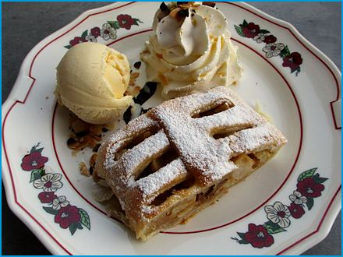
Serves 6
Paper-thin strudel dough rolled around spiced apples, raisins, and nuts, baked crisp and golden. The dough should be thin enough to read a newspaper through. A recipe will do.
Ingredients

For the Dough:
- 9 oz. (260 g) all-purpose flour
- 1/4 tsp. salt
- 1 egg
- 125 ml (½ cup) lukewarm water
- 2 Tbsp. vegetable oil
- 1 tsp. white vinegar
For the Filling:
- 2 lbs. (910 g) apples, peeled, cored, and thinly sliced
- 3.5 oz. (100 g) sugar
- 1 tsp. ground cinnamon
- 1.7 oz. (50 g) raisins (optional)
- 1.7 oz. (50 g) chopped nuts (optional)
- Zest of 1 lemon
- 1.7 oz. (50 g) breadcrumbs
- 1.7 oz. (50 g) melted butter
For Brushing and Finishing:
- 1.7 oz. (50 g) melted butter
- Powdered sugar for dusting
Method
Prepare the Dough:
- Combine the flour and salt in a large bowl.
- Make a well in the center and add the egg, lukewarm water, vegetable oil, and vinegar.
- Mix until a dough forms.
- Knead the dough on a floured surface for about 10 minutes until smooth and elastic.
- Place the dough in a greased bowl, cover, and let it rest for about 1 hour.
Prepare the Filling:
- Combine the sliced apples, sugar, ground cinnamon, raisins, chopped nuts, and lemon zest in a large bowl.
- Heat a small pan over medium heat and toast the bread crumbs in a bit of melted butter until golden brown.
- Let them cool.
- Mix them into the apple filling.
Roll Out the Dough:
- Preheat your oven to 190°C (375°F).
- Place a clean kitchen towel on your work surface and lightly flour it.
- Roll out the dough as thin as possible on the towel, then gently stretch it out using the backs of your hands until it is very thin and almost transparent.
Assemble the Strudel:
- Brush the dough with melted butter.
- Spread the apple filling over the dough, leaving a small border all around.
- Use the kitchen towel to help roll the dough up tightly into a log shape, starting from one end.
- Place the strudel seam-side down on a baking sheet lined with parchment paper.
Bake the Strudel:
- Brush the top of the strudel with more melted butter.
- Bake in the preheated oven for about 35 minutes until golden brown and crispy.
Serve:
- Let the strudel cool slightly before dusting with powdered sugar.
- Slice and serve warm, optionally with a dollop of whipped cream or vanilla ice cream.

Bavarian Gingerbread
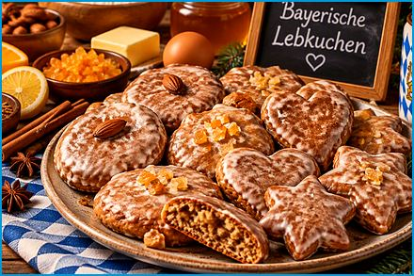
Makes about 30
Honiglebkuchen mit Zuckerguss
Honey-sweet gingerbread cookies cut into shapes and brushed with a thin white sugar glaze.
Ingredients

- 9 oz. (260 g) honey
- 7 oz. (200 g) brown sugar
- 2.5 oz. (70 g) butter
- 18 oz. (500 g) all-purpose flour
- 1 tsp. baking powder
- 1 tsp. baking soda
- 1 tsp. ground cinnamon
- 1 tsp. ground cloves
- 1 tsp. ground allspice
- 1 tsp. ground nutmeg
- 1/4 tsp. ground cardamom (optional)
- Zest of 1 lemon
- 1/2 tsp. ground ginger
- 1 large egg
- 6 oz. (170 g) ground almonds
- 3.5 oz. (100 g) chopped candied orange peel
- 3.5 oz. (100 g) chopped candied lemon peel
- Edible wafer paper (optional, for the base)
For the Glaze:
- 7 oz. (200 g) powdered sugar
- 3 Tbsp. water or lemon juice
Method
Prepare the Dough:
- Combine honey, brown sugar, and butter in a medium saucepan.
- Heat over medium heat, stirring until the sugar is dissolved and the mixture is smooth.
- Remove from heat and let it cool slightly.
Mix Dry Ingredients:
- Whisk together flour, baking powder, baking soda, cinnamon, cloves, allspice, nutmeg, ginger, and cardamom (if using) in a large bowl.
Combine Ingredients:
- Add the cooled honey mixture, egg, and lemon zest to the dry ingredients.
- Mix until well combined.
- Stir in the ground almonds, candied orange peel, and candied lemon peel.
Chill the Dough:
- Cover the dough and refrigerate for at least 2 hours, or overnight for better flavor development.
Shape and Bake:
- Preheat your oven to 180°C (350°F).
- Roll out the dough on a lightly floured surface to about 5 mm (1/4 in.) thick.
- Cut into shapes using cookie cutters or form small rounds.
- Cut the paper to the size of the cookies and place it on the baking sheet before adding the dough if using edible wafer paper.
- Arrange the cookies on a baking sheet lined with parchment paper.
- Bake for 10-15 minutes, or until the edges are lightly browned.
Glaze the Cookies:
- Mix powdered sugar with water or lemon juice to make a smooth glaze in a small bowl.
- Brush the glaze over the warm cookies and let them cool on a wire rack until the glaze is set.

Rhubarb Sour Cream Cake
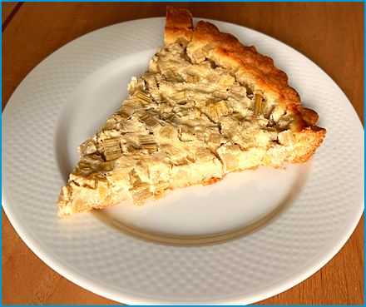
Serves 10-12
Rhabarber-Schmandkuchen
A shortbread base topped with tart rhubarb and a creamy sour-cream custard that sets as it bakes.
Ingredients
For the Base:
- 7 oz. (200 g) all-purpose flour
- 1 tsp. baking powder
- 2.5 oz. (70 g) sugar
- 1 packet vanilla sugar (or 1 tsp. vanilla extract)
- 3.5 oz. (100 g) unsalted butter, softened
- 1 large egg
For the Filling:
- 18 oz. (510 g) rhubarb, trimmed and cut into small pieces
- 7 oz. (200 g) sugar
- 7 oz. (200 g) sour cream (Schmand)
- 200 ml (¾ cup) heavy cream
- 1 packet vanilla pudding powder (or 2 Tbsp. cornstarch)
- 3 large eggs
Method
Prepare the Base:
- Preheat your oven to 180°C (350°F).
- Combine the flour, baking powder, sugar, and vanilla sugar in a mixing bowl.
- Add the softened butter and egg, and mix until a smooth dough forms.
- Press the dough into the bottom of a greased springform pan (26 cm) to form an even base.
- Set aside.
Prepare the Filling:
- Toss the rhubarb pieces with 3.5 oz. (100 g) of sugar in a large bowl.
- Let it sit for about 10 minutes to macerate.
- Whisk together the sour cream, heavy cream, remaining 3.5 oz. (100 g) of sugar, vanilla pudding powder (or cornstarch), and eggs in a separate mixing bowl until smooth.
Assemble the Cake:
- Spread the rhubarb pieces evenly over the dough base.
- Pour the sour cream mixture over the rhubarb.
Bake the Cake:
- Bake in the preheated oven for about 50-60 minutes, or until the filling is set and the top is golden brown.
- Remove the cake from the oven and let it cool in the pan.
Serve:
- Remove it from the springform pan once the cake is completely cool.
- Slice and serve.

Elisen Lebkuchen
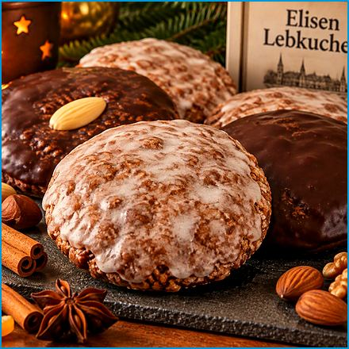
Makes about 12
Nuremberg's finest gingerbread: soft rounds of ground nuts and candied peel with almost no flour, baked on a wafer base. Bake them in November and they are at their best by Advent, if anyone lets them last that long.
Ingredients
For the Cookies:
- 7 oz. (200 g) ground hazelnuts
- 7 oz. (200 g) ground almonds
- 3.5 oz. (100 g) candied orange peel, finely chopped
- 3.5 oz. (100 g) candied lemon peel, finely chopped
- 3 large eggs
- 7 oz. (200 g) sugar
- 1 tsp. vanilla extract
- 1 tsp. ground cinnamon
- 1/2 tsp. ground cloves
- 1/2 tsp. ground allspice
- 1/4 tsp. ground nutmeg
- 1/4 tsp. ground ginger
- 1 pinch of salt
- Oblaten (wafer papers), 2-3 in. (5-7 cm) across (optional)
For Glaze or Chocolate Coating:
- 6 oz. (170 g) powdered sugar and about 3 Tbsp. lemon juice, for the glaze
- Or, for a chocolate coating, 7 oz. (200 g) dark chocolate, melted
Method
Prepare the Dough:
- Combine the ground hazelnuts, ground almonds, candied orange peel, and candied lemon peel in a large mixing bowl.
- Beat the eggs and sugar together in a separate bowl until light and fluffy.
- Add the vanilla extract, cinnamon, cloves, allspice, nutmeg, ginger, and salt to the egg mixture.
- Mix well.
- Gradually fold in the nut and candied fruit mixture until well combined. The dough will be sticky.
Shape the Cookies:
- Preheat your oven to 150°C (300°F).
- Place them on a baking sheet lined with parchment paper if using Oblaten.
- Scoop about 2 Tbsp. of dough and shape it into a round, flat disc using a spoon or your hands.
- Place the disc on an Oblate or directly on the parchment paper.
- Repeat with the remaining dough.
Bake the Cookies:
- Bake the Elisenlebkuchen in the preheated oven for about 20-25 minutes, until firm on the outside but not browned, then they should still be slightly soft in the center.
- Remove from the oven and let them cool on the baking sheet.
Prepare the Glaze:
- Mix the powdered sugar with enough lemon juice to create a smooth, thick glaze in a small bowl.
- Brush the glaze over the cooled cookies. Alternatively, you can dip the cookies in melted dark chocolate for a chocolate coating.
Serve:
- Let the glaze or chocolate coating set before serving.
- Store the Elisenlebkuchen in an airtight container to keep them fresh.

Vanille Kipferl
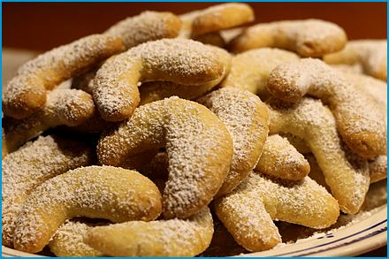
Makes about 40
Buttery crescent-shaped cookies with ground almonds, rolled in vanilla sugar while still warm.
Ingredients
- 9 oz. (260 g) all-purpose flour
- 7 oz. (200 g) unsalted butter, cold and cut into small pieces
- 3.5 oz. (100 g) ground almonds or hazelnuts
- 2 oz. (55 g) powdered sugar
- 1 packet vanilla sugar (or 1 tsp. vanilla extract)
- A pinch of salt
For Coating:
- 3.5 oz. (100 g) powdered sugar
- 2 packets vanilla sugar (or 2 tsp. vanilla extract)
Method
Prepare the Dough:
- Combine the flour, ground almonds or hazelnuts, powdered sugar, vanilla sugar, and salt in a large mixing bowl.
- Add the cold butter pieces and quickly work them into the dry ingredients with your hands or a pastry cutter until the mixture resembles coarse crumbs.
- Knead the mixture gently until a smooth dough forms.
- Be careful not to overwork the dough.
- Form the dough into a disc, wrap it in plastic wrap, and refrigerate for at least 1 hour.
Shape the Cookies:
- Preheat your oven to 175°C (350°F) and line a baking sheet with parchment paper.
- Take small portions of the dough and roll them into small logs, about 5 cm long.
- Shape each log into a crescent or "kipferl" shape and place them on the prepared baking sheet.
Bake the Cookies:
- Bake the Vanillekipferl in the preheated oven for about 10-15 minutes, or until they are lightly golden around the edges.
- Be careful not to overbake them as they should remain pale in color.
Coat the Cookies:
- Mix the powdered sugar and vanilla sugar for the coating in a shallow bowl while the cookies are baking.
- Remove the cookies from the oven and let them cool slightly on the baking sheet for a few minutes.
- Gently roll them in the powdered sugar mixture until they are fully coated while the cookies are still warm.
Serve:
- Let the coated cookies cool completely on a wire rack.
- Store the Vanillekipferl in an airtight container to keep them fresh.

Kirchweih Nudeln
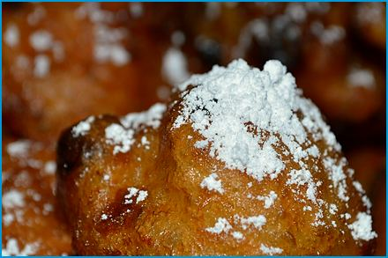
Makes about 12
Fried yeast pastries stretched thin in the middle, a traditional fair and church-festival treat.
Ingredients
- 18 oz. (510 g) all-purpose flour
- 0.7 oz. (20 g) fresh yeast (or 2 tsp. active dry yeast)
- 250 ml (1 cup) warm milk
- 2 oz. (55 g) sugar
- 1 packet vanilla sugar (or
1 tsp. vanilla extract)
- 2 large eggs
- 2.5 oz. (70 g) unsalted butter, melted
- 1/2 tsp. salt
- Zest of 1 lemon
- Vegetable oil for frying
- Powdered sugar for dusting
Method
Prepare the Dough:
- Dissolve the fresh yeast in warm milk along with 1 tsp. of the sugar in a small bowl.
- Let it sit for about 10 minutes until it becomes frothy. If using active dry yeast, follow the same process.
- Combine the flour, sugar, vanilla sugar, salt, and lemon zest in a large mixing bowl.
- Add the yeast mixture, eggs, and melted butter to the dry ingredients.
- Mix until a smooth dough forms.
- Knead the dough on a lightly floured surface for about 5-10 minutes until it is smooth and elastic.
- Place the dough in a greased bowl, cover with a clean kitchen towel, and let it rise in a warm place for about 1-2 hours, or until it has doubled in size.
Shape the Pastries:
- Once the dough has risen, punch it down and divide it into small portions (about the size of a golf ball).
- Roll each portion into a ball.
- Use your fingers to stretch and flatten the center of each ball while keeping the edges slightly thicker. The dough should be thin in the middle and thicker around the edges.
Fry the Pastries:
- In a large, heavy-bottomed pot, heat the vegetable oil to about 175°C (350°F).
- Carefully place the stretched dough pieces into the hot oil, one or two at a time, depending on the size of your pot.
- Fry until golden brown on both sides, about 2-3 minutes per side.
- Use a slotted spoon to remove the pastries from the oil and place them on a plate lined with paper towels to drain excess oil.
Serve:
- Dust the warm Kirchweihnudeln with powdered sugar before serving.

Blackcurrant Ice Cream
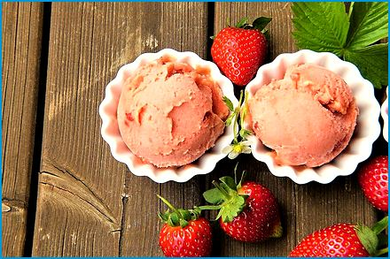
Serves 4
Johannisbeer Eis
Homemade custard ice cream swirled with tangy blackcurrant purée.
Ingredients
- 10 oz. (280 g) blackcurrants (fresh or frozen)
- 6 oz. (170 g) sugar
- 1 Tbsp. lemon juice
- 300 ml (1¼ cups) heavy cream
- 200 ml (¾ cup) whole milk
- 2 large egg yolks
- 1 tsp. vanilla extract
Method
Prepare the Blackcurrants:
- Rinse them and remove any stems if using fresh blackcurrants.
- Combine the blackcurrants, 3 oz. (85 g) of the sugar, and lemon juice in a saucepan.
- Cook over medium heat until the blackcurrants break down and release their juices, about 10 minutes.
- Remove from heat and let it cool slightly.
- Puree the mixture using a blender or immersion blender.
- Strain through a fine-mesh sieve to remove the seeds.
- Set the puree aside to cool completely.
Make the Custard Base:
- Heat the milk and heavy cream over medium heat in a saucepan until it starts to simmer.
- Do not let it boil.
- Whisk together the egg yolks and 3 oz. (85 g) of the sugar in a separate bowl until pale and thick.
- Gradually pour the hot milk mixture into the egg yolk mixture, whisking constantly to prevent curdling.
- Return the mixture to the saucepan and cook over low heat, stirring constantly, until the custard thickens enough to coat the back of a spoon (about 5-7 minutes).
- Remove from heat and stir in the vanilla extract.
- Let the custard cool to room temperature.
Combine and Churn:
- Mix them together until well combined once the custard and blackcurrant puree are cool.
- Pour the mixture into an ice cream maker and churn according to the manufacturer's instructions until it reaches a soft-serve consistency.
- Pour the mixture into a shallow dish and freeze, stirring every 30 minutes until it reaches the desired consistency if you don't have an ice cream maker.
Freeze and Serve:
- Transfer the churned ice cream to a lidded container and freeze until firm, about 2-4 hours.
- Serve your Johannisbeereis in bowls or cones, and enjoy!

Bavarian Lemon Sorbet

Serves 4
Zitronensorbet
A refreshing, sharp lemon sorbet that works as a dessert or between courses.
Ingredients
- 1 cup (240 ml) water
- 3/4 cup (150 g) sugar
- 1 cup (240 ml) squeezed lemon juice (4-5 lemons)
- 1 Tbsp. lemon zest
- Optional: 2 Tbsp. vodka or lemon liqueur (to keep the sorbet softer)
Method
Make the Simple Syrup:
- Combine the water and sugar in a medium saucepan.
- Heat over medium heat, stirring occasionally, until the sugar is completely dissolved.
- Remove the syrup from heat and let it cool to room temperature.
Prepare the Lemon Mixture:
- Combine the freshly squeezed lemon juice and lemon zest in a large bowl.
- Add it to the lemon mixture once the simple syrup has cooled.
- Stir in the vodka or lemon liqueur to help keep the sorbet from freezing too hard if using.
Chill the Mixture:
- Cover the bowl and refrigerate the mixture for at least 1 hour, or until it is thoroughly chilled.
Churn the Sorbet:
- Pour the chilled mixture into an ice cream maker and churn according to the manufacturer's instructions until it reaches a soft-serve consistency.
- Pour the mixture into a shallow dish and freeze, stirring every 30 minutes until it reaches the desired consistency if you don't have an ice cream maker.
Freeze and Serve:
- Transfer the churned sorbet to a lidded container and freeze until firm, about 2-4 hours.
- Serve your lemon sorbet in bowls or scooped into cones.

Bavarian Pancakes
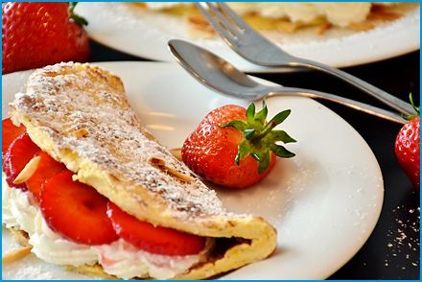
Serves 4 (about 6 pancakes)
Bayerische Pfannkuchen
Thin, tender pancakes served with jam, applesauce, or fruit.
Ingredients
- 1½ cups (190 g) all-purpose flour
- ½ tsp. salt
- ½ to 1 Tbsp. sugar
- 1 cup (240 ml) milk
- 3 eggs
- 1 Tbsp. melted butter
- ½ tsp. vanilla extract (optional)
- Butter or sunflower oil for frying
- Powdered sugar for garnish (optional)
- Fruit, applesauce, nuts or jam for serving
Method
Prepare the Batter:
- Whisk together the flour, salt, and sugar in a large mixing bowl.
- Combine the milk, eggs, melted butter, and vanilla extract in a separate bowl.
- Mix well.
- Gradually add the wet ingredients to the dry ingredients, whisking until smooth.
- Let the batter rest for about 10 minutes.
Cook the Pancakes:
- Heat a non-stick skillet or frying pan over medium heat and add a small amount of butter.
- Pour a ladleful of batter into the pan, spreading it out evenly to form a thin pancake.
- Cook until bubbles form on the surface and the edges start to lift.
- Flip and cook the other side until golden brown.
- Repeat with the remaining batter, adding more butter to the pan as needed.
Serve:
- Serve the pancakes hot, garnished with powdered sugar if desired.
- Top with fresh fruit, jam, or syrup for a delicious treat.

Rice Pudding Cake with Cherry Compote
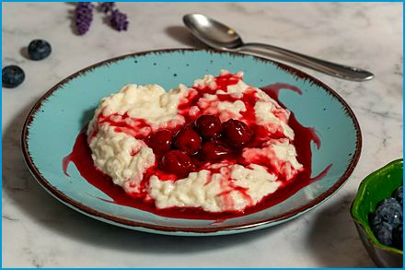
Serves 4
Milchreiskuchen mit Kirschkompott
Creamy rice pudding lightened with whipped egg whites and baked into a cake, served with warm cherry compote.
Ingredients
For the Rice Pudding Cake:
- 7 oz. (200 g) short-grain rice (such as pudding rice or Arborio)
- 1 L (4¼ cups) milk
- 2.5 oz. (70 g) sugar
- 1 packet vanilla sugar (or 1 tsp. vanilla extract)
- 1 pinch of salt
- 3 large eggs, separated
- 1.5 oz. (45 g) melted butter
- Zest of 1 lemon
- 3.5 oz. (100 g) ground almonds (optional, for added texture)
For the Cherry Compote:
- 18 oz. (510 g) fresh or frozen cherries
- 3.5 oz. (100 g) sugar
- 1 Tbsp. lemon juice
- 1 Tbsp. cornstarch (mixed with 2 Tbsp. water)
- 1 tsp. vanilla extract
Method
Prepare the Rice Pudding:
- Combine the rice, milk, sugar, vanilla sugar, and salt in a large saucepan.
- Bring to a boil.
- Reduce the heat and simmer, stirring occasionally, until the rice is tender and the mixture is thick and creamy, about 30-40 minutes.
- Remove from heat and let it cool slightly.
Make the Cake Batter:
- Preheat your oven to 180°C (350°F).
- Grease a springform pan or a baking dish.
- Mix the cooled rice pudding with the egg yolks, melted butter, lemon zest, and ground almonds (if using) in a large bowl. In a separate bowl, beat the egg whites until stiff peaks form, then gently fold them into the rice pudding mixture.
Bake the Cake:
- Pour the mixture into the prepared pan and smooth the top.
- Bake in the preheated oven for about 40-45 minutes, or until the top is golden and a toothpick inserted into the center comes out clean.
- Let the cake cool completely before removing from the pan.
Prepare the Cherry Compote:
- Combine the cherries, sugar, and lemon juice in a medium saucepan.
- Cook over medium heat until the cherries release their juices and start to soften, about 10 minutes.
- Stir in the cornstarch mixture and continue to cook until the compote thickens, about 2-3 minutes.
- Remove from heat and stir in the vanilla extract.
- Let it cool slightly.
Serve:
- Serve slices of Milchreiskuchen with a generous spoonful of cherry compote on top.

Apple Strudel

Serves 6
Apfelstrudel
A quick apple strudel in crisp phyllo pastry with raisins and nuts.
Ingredients
- 6-7 apples, peeled and thinly sliced
- 3.5 oz. (100 g) sugar
- 1 tsp. cinnamon
- 1.7 oz. (50 g) raisins
- 1.7 oz. (50 g) chopped nuts (walnuts or almonds)
- 7 oz. (200 g) phyllo dough
- 1.7 oz. (50 g) melted butter
- Powdered sugar for dusting
Method
- Preheat the oven to 180°C (350°F).
- Mix the sliced apples, sugar, cinnamon, raisins, and nuts in a bowl.
- Lay out a sheet of phyllo dough and brush with melted butter.
- Layer with more sheets, brushing each with butter.
- Spread the apple mixture over the dough, leaving a border.
- Roll up the dough with the filling and place it on a baking sheet.
- Brush the top with butter and bake for 30-40 minutes until golden brown.
- Dust with powdered sugar before serving.

Shredded Pancake with Plum Compote
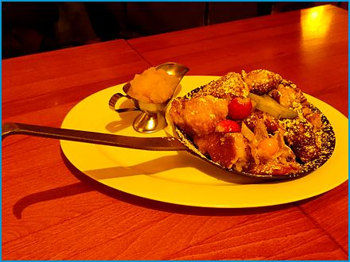
Serves 4
Kaiserschmarrn
The emperor’s pancake: fluffy, caramelized, torn into pieces and dusted with sugar, a favorite in Alpine huts and Bavarian beer gardens. It is said to have begun as a pancake that went wrong. Tearing it up on purpose is much more satisfying.
Ingredients

For the Pancake:
- 6 eggs, separated
- 9 oz. (250 g) all-purpose flour
- 400 ml (1¾ cups) milk
- 2 oz. (60 g) sugar, plus 2 Tbsp. for caramelizing
- 1 packet vanilla sugar (or 1 tsp. vanilla extract)
- A pinch of salt
- 1.7 oz. (50 g) raisins, soaked in 2 Tbsp. rum or warm water
- 3 Tbsp. butter, plus 1 Tbsp. for caramelizing
- Powdered sugar for dusting
To Serve:
- Plum compote (Zwetschgenröster) or applesauce
Method
Make the Batter:
- Whisk the egg yolks, milk, flour, vanilla sugar, and salt until smooth and let the batter rest for 10 minutes.
- Beat the egg whites with the 2 oz. (60 g) of sugar until stiff peaks form.
- Fold them gently into the batter.
Cook the Pancake:
- Preheat the oven to 200°C (390°F).
- Melt 1½ Tbsp. of the butter in a 28 cm ovenproof skillet over medium heat.
- Pour in half of the batter and scatter over half of the raisins.
- Cook for about 3 minutes, until golden underneath.
- Transfer the skillet to the oven for 5-6 minutes, until puffed and set.
Tear and Caramelize:
- Tear the pancake into bite-sized pieces in the pan with two forks.
- Add ½ Tbsp. of butter and 1 Tbsp. of sugar and toss over medium heat for 1-2 minutes, until lightly caramelized.
- Repeat with the remaining batter, raisins, and butter.
Serve:
- Dust generously with powdered sugar and serve at once with plum compote.

Quark Strudel
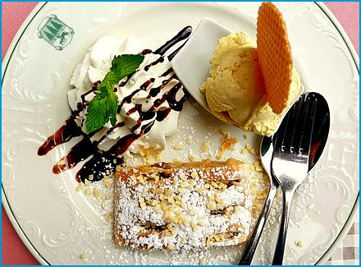
Serves 6
Topfenstrudel
A tender strudel filled with lemony quark (Topfen), best served warm with vanilla sauce.
Ingredients

For the Dough:
- 9 oz. (250 g) all-purpose flour
- 1/4 tsp. salt
- 1 egg
- 125 ml (½ cup) lukewarm water
- 2 Tbsp. vegetable oil
- 1 tsp. white vinegar
For the Filling:
- 18 oz. (500 g) quark (20% fat), well drained
- 2.5 oz. (70 g) soft butter
- 2.5 oz. (70 g) sugar
- 3 egg yolks and 2 egg whites
- Zest of 1 lemon
- 1 packet vanilla sugar
- 1 oz. (30 g) semolina or fine breadcrumbs
- 1.7 oz. (50 g) raisins (optional)
For Brushing and Finishing:
- 2 oz. (60 g) melted butter
- Powdered sugar for dusting
- Vanilla sauce, for serving (optional)
Method
Make the Dough:
- Combine the flour and salt in a bowl, make a well, and add the egg, water, oil, and vinegar.
- Mix to a dough.
- Knead on a floured surface for about 10 minutes, until smooth and elastic.
- Cover with a warm bowl and let it rest for 1 hour.
Make the Filling:
- Cream the butter with the sugar, vanilla sugar, and lemon zest.
- Beat in the egg yolks one at a time.
- Stir in the quark, semolina, and raisins.
- Beat the egg whites to stiff peaks and fold them in gently.
Assemble:
- Preheat the oven to 190°C (375°F).
- Roll out the dough on a floured kitchen towel and stretch it with the backs of your hands until paper thin.
- Brush it with melted butter and spread the filling over two thirds of the dough, leaving a border.
- Use the towel to roll up the strudel.
- Place it seam side down on a baking sheet lined with parchment and brush it with butter.
Bake and Serve:
- Bake for 35-40 minutes, brushing with butter once halfway, until golden.
- Dust with powdered sugar and serve warm, with vanilla sauce if you like.

Prince Regent’s Torte
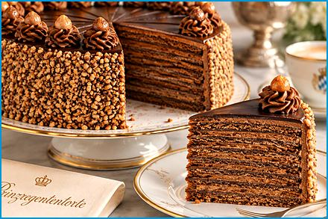
Serves 12 (one 24 cm torte)
Prinzregententorte
Bavaria’s most famous cake, named after Prince Regent Luitpold: thin sponge layers filled with chocolate buttercream under a dark chocolate glaze. Tradition calls for eight layers; six are easier at home. Nobody at my table has ever counted the layers; they are too busy eating them.
Ingredients

For the Sponge Layers:
- 7 oz. (200 g) soft butter
- 7 oz. (200 g) sugar
- 1 packet vanilla sugar
- A pinch of salt
- 6 eggs
- 7 oz. (200 g) all-purpose flour
- 1 tsp. baking powder
- 3 Tbsp. milk
For the Chocolate Buttercream:
- 9 oz. (250 g) soft butter
- 3.5 oz. (100 g) powdered sugar
- 3 egg yolks
- 7 oz. (200 g) dark chocolate (at least 50% cocoa), melted and cooled
For the Glaze:
- 7 oz. (200 g) dark chocolate
- 1 Tbsp. butter or coconut oil
- 2 Tbsp. apricot jam (optional, to seal the top)
Method
Bake the Layers:
- Preheat the oven to 200°C (390°F).
- Line the base of a 24 cm springform pan with parchment.
- Cream the butter, sugar, vanilla sugar, and salt until fluffy.
- Beat in the eggs one at a time.
- Mix in the flour and baking powder, then the milk.
- Spread about one sixth of the batter thinly and evenly in the pan and bake for 8-10 minutes, until golden.
- Turn out and repeat to make six layers, re-lining the pan each time.
- Let the layers cool completely.
Make the Buttercream:
- Beat the butter and powdered sugar until pale and fluffy.
- Beat in the egg yolks one at a time.
- Stir in the cooled melted chocolate until smooth.
Assemble:
- Stack the layers, spreading buttercream between each one, and keep the best-looking layer for the top.
- Coat the sides of the cake thinly with the remaining buttercream and chill for 1 hour.
Glaze and Serve:
- Warm the apricot jam and brush it over the top.
- Melt the chocolate with the butter, let it cool slightly, and pour it over the cake, smoothing it over the top and sides.
- Chill for 2-3 hours and take the torte out of the refrigerator 30 minutes before serving.

Poppy Seed Potato Noodles
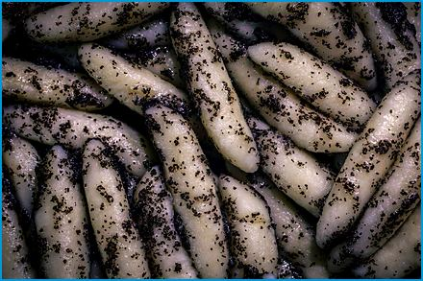
Serves 4
Mohnnudeln
Finger-shaped potato noodles tossed in buttery poppy seeds and sugar, a sweet main course from Bavaria and Austria.
Ingredients

For the Noodles:
- 18 oz. (500 g) starchy potatoes
- 4.5 oz. (125 g) all-purpose flour, plus extra for dusting
- 1 egg yolk
- 1 oz. (30 g) semolina
- A pinch of salt
- A pinch of nutmeg
For the Poppy Seed Topping:
- 3.5 oz. (100 g) ground poppy seeds
- 2 oz. (60 g) sugar
- 2.5 oz. (70 g) butter
- Powdered sugar for dusting
- Plum compote or applesauce, for serving (optional)
Method
Make the Dough:
- Boil the potatoes in their skins until tender, about 25 minutes.
- Peel them while hot and press them through a ricer.
- Let cool.
- Mix the potatoes with the flour, egg yolk, semolina, salt, and nutmeg and knead quickly to a smooth dough.
Shape and Cook:
- Roll the dough into ropes the thickness of a finger and cut them into 3 cm pieces.
- Roll each piece between your palms into a noodle with tapered ends.
- Cook the noodles in simmering salted water in batches for 3-4 minutes, until they float.
- Lift them out and drain.
Toss and Serve:
- Melt the butter in a large skillet, stir in the poppy seeds and sugar, and heat for 1 minute.
- Add the noodles and toss for 2 minutes.
- Dust with powdered sugar and serve with plum compote.

Baked Apples with Almonds and Vanilla Sauce

Serves 4
Bratapfel
A winter classic: tart apples filled with raisins, almonds, and honey, baked until soft and fragrant.
Ingredients

- 4 firm, tart apples (Boskoop or Granny Smith)
- 1.7 oz. (50 g) raisins
- 2 Tbsp. rum or apple juice
- 1 oz. (30 g) chopped almonds
- 2 Tbsp. honey
- 1/2 tsp. ground cinnamon
- 1.5 oz. (40 g) butter, diced
- 100 ml (3.5 fl oz.) apple juice (for the baking dish)
- Vanilla sauce or cream, for serving
Method
Prepare the Filling:
- Preheat the oven to 180°C (350°F).
- Soak the raisins in the rum or apple juice for 15 minutes.
- Mix the raisins with the almonds, honey, and cinnamon.
Fill the Apples:
- Wash the apples and cut out the cores with an apple corer, leaving the base closed.
- Fill the apples with the mixture and top each with a few pieces of butter.
Bake:
- Stand the apples in a baking dish and pour the apple juice around them.
- Bake for 30-35 minutes, until the apples are soft and the skin begins to wrinkle.
Serve:
- Serve warm with vanilla sauce and spoon the pan juices over the top.

Bee Sting Cake

Serves 10-12 (one 24 cm cake)
Bienenstich
A soft yeast cake with a caramelized almond-honey topping and a vanilla cream filling.
Ingredients

For the Dough:
- 9 oz. (250 g) all-purpose flour
- 2 tsp. active dry yeast
- 2 oz. (60 g) sugar
- 125 ml (½ cup) lukewarm milk
- 2 oz. (60 g) soft butter
- 1 egg
- A pinch of salt
For the Almond Topping:
- 3.5 oz. (100 g) butter
- 3.5 oz. (100 g) sugar
- 3 Tbsp. heavy cream
- 1 Tbsp. honey
- 5 oz. (150 g) sliced almonds
For the Vanilla Cream:
- 400 ml (1¾ cups) milk
- 1 packet (about 40 g (1.5 oz.)) vanilla pudding powder
- 2 Tbsp. sugar
- 200 ml (¾ cup) heavy cream, whipped to stiff peaks
Method
Make the Dough:
- Stir the yeast and 1 tsp. of the sugar into the lukewarm milk and let it stand for 10 minutes until frothy.
- Mix in the flour, remaining sugar, butter, egg, and salt and knead for 10 minutes until smooth.
- Cover and let rise for 1 hour.
Make the Topping:
- Melt the butter with the sugar, cream, and honey and simmer for 2 minutes.
- Stir in the almonds and let the mixture cool slightly.
Bake:
- Preheat the oven to 180°C (350°F).
- Roll the dough out to fit a greased 24 cm springform pan, spread the topping on top, and let it rise for 20 minutes.
- Bake for 25-30 minutes, until golden.
- Let it cool completely.
- Cut it in half horizontally.
Make the Cream and Assemble:
- Cook the milk with the pudding powder and sugar until thick, cover the surface with cling film, and let it cool completely.
- Whisk the pudding until smooth, fold in the whipped cream, and spread it over the bottom half of the cake.
- Cover with the almond-topped half and chill for 2 hours.

Drinks
Three warm drinks for cold evenings, for the grown-ups only. The children get hot chocolate and the satisfaction of having been sent to bed last.

Grogg

Makes 1 glass (multiply for 4)
Hot water with dark rum and sugar: a simple winter warmer.
Ingredients
- 50 ml (3.5 Tbsp.) dark rum
- 1 Tbsp. sugar
- 200 ml (¾ cup) hot water
- Optional: a dash of cinnamon or nutmeg for extra warmth
Method
- Heat the Water: In a saucepan, heat the water until it's hot but not boiling.
- Combine Ingredients: In a mug, add the sugar and pour the hot water over it, stirring until the sugar is dissolved.
- Add Rum: Pour the dark rum into the mug and stir to combine. Optional Spices: If you like, add a dash of cinnamon or nutmeg for extra warmth and flavor. Serve: Enjoy your hot grogg while it's warm!

Mulled Wine
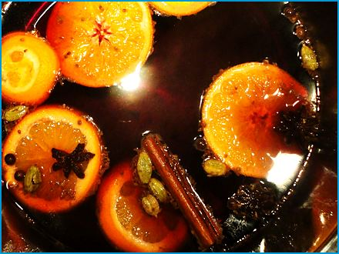
Serves 5
Glühwein
Red wine heated gently with orange, lemon, cinnamon, cloves, and star anise: the scent of every Christmas market. It warms the hands first and the rest of you shortly after.
Ingredients
- 1 bottle of red wine (750 ml, preferably a fruity red wine like Merlot or Pinot Noir)
- 1 orange, sliced
- 1 lemon, sliced
- 2-3 cinnamon sticks
- 4-5 whole cloves
- 2-3 star anise
- 3-4 Tbsp. honey or sugar (to taste)
- 1/4 cup (60 ml) brandy (optional)
Method
Prepare the Ingredients:
- Wash and slice the orange and lemon.
Combine Ingredients:
- Combine the red wine, sliced orange, sliced lemon, cinnamon sticks, cloves, and star anise in a large pot.
Heat the Wine:
- Slowly heat the mixture over low heat.
- Do not let it boil, as boiling will evaporate the alcohol and affect the flavor.
- Heat gently until it is hot and the flavors have melded, about 20-30 minutes.
Sweeten and Add Brandy:
- Taste the mulled wine and add honey or sugar to sweeten it to your liking.
- Stir in the brandy for an extra kick if using.
Serve:
- Remove the spices and citrus slices with a slotted spoon or strain the mixture if desired.
  - Serve the mulled wine hot in mugs or heatproof glasses.
Enjoy your homemade mulled wine!

Jägertee

Serves 6
A strong black tea mixed with red wine, rum, and fruit schnapps: the mountain-hut drink for cold evenings. Hunter's tea, it is called, although very little of it is tea.
Ingredients

- 500 ml (2 cups) strong black tea
- 500 ml (2 cups) dry red wine
- 80 ml (2.5 fl oz.) dark rum
- 80 ml (2.5 fl oz.) fruit schnapps (such as plum or apricot)
- 4 tsp. brown sugar (to taste)
- 1 cinnamon stick
- 2-3 cloves
- Lemon slices (for garnish)
Method
Prepare the Tea:
- Brew a strong black tea in 500 ml (2 cups) of water.
- Let it steep for about 5-7 minutes.
- Remove the tea leaves or tea bags.
Combine Ingredients:
- Combine the brewed tea, red wine, sugar, cinnamon stick, and cloves in a large pot.
Heat the Mixture:
- Heat the mixture over medium heat, but do not let it boil.
- Stir occasionally until the sugar is dissolved and the drink is hot.
Serve:
- Remove the cinnamon stick and cloves.
- Stir in the rum and fruit schnapps just before serving so the alcohol is not boiled off.
- Pour the Jägertee into mugs or heatproof glasses.
- Garnish with lemon slices.

Photo Credits
Picture credits, recipe by recipe. Images marked as AI-generated were made with Microsoft Copilot. The cover combines a Copilot-generated view of Neuschwanstein with a photograph of roast pork knuckle by Vinícius Caricatte (Pexels License). All other photographs are public domain or CC0 images from Wikimedia Commons, or free images used under the Pexels, Pixabay, or Unsplash licenses. Recipe photos were cropped and gently colour-corrected for this edition.
All Saints' Braid: IEDAFHBG, Wikimedia Commons (Public domain)
Allgäuer Cordon Bleu: ReinhardThrainer, Pixabay (Pixabay Content License)
Almnussen: AI-generated image (Microsoft Copilot)
Almond-filled Stollen: JZ68, Pixabay (Pixabay Content License)
Apfel-Schneemus-Torte: NoName_13, Pixabay (Pixabay Content License)
Apfel-Zimt-Griessbrei: AI-generated image (Microsoft Copilot)
Apple Cinnamon Rolls: Federica Gioia, Pexels (Pexels License)
Apple Fritters: RitaE, Pixabay (Pixabay Content License)
Apple Strudel: Brücke-Osteuropa, Wikimedia Commons (CC0)
Baked Apples with Almonds and Vanilla Sauce: neelam279, Pixabay (Pixabay Content License)
Barley Risotto with Vegetables: katiklinski, Pixabay (Pixabay Content License)
Bavarian Beer Goulash: 4666192, Pixabay (Pixabay Content License)
Bavarian Braised Beef: Thiago Rebouças, Pexels (Pexels License)
Bavarian Braised Cabbage (Bayrisch Kraut): AI-generated image (Microsoft Copilot)
Bavarian Bread Soup: Daderot, Wikimedia Commons (CC0)
Bavarian Burger: Thiago Fior de Castro, Wikimedia Commons (Public domain)
Bavarian Cheese Dumplings: AI-generated image (Microsoft Copilot)
Bavarian Cheese Spread: RitaE, Pixabay (Pixabay Content License)
Bavarian Cream: User:Mattes, Wikimedia Commons (Public domain)
Bavarian Creamy Potato Soup: Andy Li, Wikimedia Commons (CC0)
Bavarian Gingerbread: AI-generated image (Microsoft Copilot)
Bavarian Goulash Soup: kirpiklipencere, Pexels (Pexels License)
Bavarian Green Bean Salad: Teguh S, Pexels (Pexels License)
Bavarian Lemon Sorbet: silviarita, Pixabay (Pixabay Content License)
Bavarian Lentil Stew: Openverse (CC0)
Bavarian Liver Dumpling Soup: hpl1961, Pixabay (Pixabay Content License)
Bavarian Meatballs: AI-generated image (Microsoft Copilot)
Bavarian Pancakes: RitaE, Pixabay (Pixabay Content License)
Bavarian Plum Cake: Garitzko, Wikimedia Commons (Public domain)
Bavarian Potato Pancakes: HolgersFotografie, Pixabay (Pixabay Content License)
Bavarian Pretzels: Anton Maienfeldt, Wikimedia Commons (CC0)
Bavarian Robber's Meat: changupn, Pixabay (Pixabay Content License)
Bavarian Sausage Salad: AI-generated image (Microsoft Copilot)
Bavarian Savoy Cabbage Lasagna: AI-generated image (Microsoft Copilot)
Bavarian Snack Platter: AI-generated image (Microsoft Copilot)
Bavarian Turkey Döner Kebab: Patrick, Pexels (Pexels License)
Bavarian Warm Potato Salad: AI-generated image (Microsoft Copilot)
Bavarian Wedding Soup: AI-generated image (Microsoft Copilot)
Bavarian Yeast Dumplings: Openverse (Public domain)
Bavarian-style Skewers: zizitop101, Pixabay (Pixabay Content License)
Bayerischer Scheiterhaufen: User:Panzi, Wikimedia Commons (Public domain)
Bee Sting Cake: Ralphs_Fotos, Pixabay (Pixabay Content License)
Beef Broth with Semolina Dumplings: RitaE, Pixabay (Pixabay Content License)
Beef Fillet with Potato-Celery Puree: Taha Samet Arslan, Pexels (Pexels License)
Beef Tartare with Garlic Baguette: AI-generated image (Microsoft Copilot)
Beer Soup: Openverse (CC0)
Blackcurrant Ice Cream: silviarita, Pixabay (Pixabay Content License)
Boiled Beef with Salted Potatoes and Horseradish: MariaGutebring, Pixabay (Pixabay Content License)
Boiled Pork with Sauerkraut: AI-generated image (Microsoft Copilot)
Bratwurst Supper: AI-generated image (Microsoft Copilot)
Bread Dumplings: AI-generated image (Microsoft Copilot)
Char on a Bed of Vegetables: AI-generated image (Microsoft Copilot)
Cheese Spätzle with Crispy Onions: Dktue, Wikimedia Commons (CC0)
Colorful Fish Skewers: Javier Balseiro, Pexels (Pexels License)
Creamy Mushroom Dish: AI-generated image (Microsoft Copilot)
Creamy Veal Strips with Mushrooms: Mahmoud Salem, Pexels (Pexels License)
Crispy Chicken Schnitzel with Fried Potatoes: Andy Li, Wikimedia Commons (CC0)
Crispy Duck with Red Cabbage, Walnut Crumble, and Dumpling Slices: Valeria Boltneva, Pexels (Pexels License)
Deviled Eggs: pepperlola, Pixabay (Pixabay Content License)
Egg Noodles (Spätzle): Brücke-Osteuropa, Wikimedia Commons (CC0)
Elisen Lebkuchen: AI-generated image (Microsoft Copilot)
Fish Grilled on a Stick: schauhi, Pixabay (Pixabay Content License)
Franconian Roast Pork Shoulder: RitaE, Pixabay (Pixabay Content License)
German Doughnuts: Anh Nguyen, Pexels (Pexels License)
German Lentil Soup: AI-generated image (Microsoft Copilot)
German Split Pea Soup: Mx, Wikimedia Commons (CC0)
Goat Cheese with Beetroot and Pistachio Brittle: MariaGutebring, Pixabay (Pixabay Content License)
Gourmet Fish Fillets: eatde, Pixabay (Pixabay Content License)
Grilled and Braised Asparagus: Openverse (CC0)
Grogg: Garitzko, Wikimedia Commons (Public domain)
Hoiber Datschi: Andy Li, Wikimedia Commons (CC0)
Hunter's Schnitzel: pcs34560, Wikimedia Commons (Public domain)
Jägertee: Masuma Rahaman, Pexels (Pexels License)
Kirchweih Nudeln: Eliens, Pixabay (Pixabay Content License)
Leberkäse: Gerda Arendt, Wikimedia Commons (CC0)
Lemon Sorbet and Tonic Dream: Andy Li, Wikimedia Commons (CC0)
Liver Spätzle Soup: AI-generated image (Microsoft Copilot)
Marble Bundt Cake: Gundula Vogel, Pexels (Pexels License)
Moist Apple Cake: W.carter, Wikimedia Commons (CC0)
Mulled Wine: Angela Huster, Wikimedia Commons (CC0)
Napkin Dumpling: Vero Lova, Pexels (Pexels License)
Oktoberfest Apple Strudel: Arnaud 25, Wikimedia Commons (CC0)
Oktoberfest Roast Chicken: AI-generated image (Microsoft Copilot)
Onion Soup with Bread and Cheese: Lisa Kostina, Pexels (Pexels License)
Pancake Soup: Brücke-Osteuropa, Wikimedia Commons (CC0)
Paprika-Chicken with Shrimp: AI-generated image (Microsoft Copilot)
Pichelsteiner Meat and Vegetable Stew: Hansuan_Fabregas, Pixabay (Pixabay Content License)
Poppy Seed Potato Noodles: Patrick, Pexels (Pexels License)
Pork Chops with Saltimbocca: Cristian Mihaila, Pexels (Pexels License)
Pork Liver with Apple and Caramelized Onions: Riki1979, Wikimedia Commons (Public domain)
Potato Dumplings: RitaE, Pixabay (Pixabay Content License)
Potato Noodles: ivabalk, Pixabay (Pixabay Content License)
Prince Regent’s Torte: AI-generated image (Microsoft Copilot)
Quark Strudel: cocoparisienne, Pixabay (Pixabay Content License)
Radishes Salad: Daderot, Wikimedia Commons (CC0)
Red and White Head Cheese: AI-generated image (Microsoft Copilot)
Red Cabbage (Blaukraut): AI-generated image (Microsoft Copilot)
Rhubarb Sour Cream Cake: Bdx, Wikimedia Commons (CC0)
Rice Pudding Cake with Cherry Compote: Gundula Vogel, Pexels (Pexels License)
Roast Pork with Crackling and Dark Beer Gravy: sharonang, Pixabay (Pixabay Content License)
Roasted Duck (Ente) Stuffed with Apples: Nadin Sh, Pexels (Pexels License)
Roasted Pork Knuckle: cegoh, Pixabay (Pixabay Content License)
Rouladen: Brücke-Osteuropa, Wikimedia Commons (CC0)
Sauerkraut and Mashed Potatoes: AI-generated image (Microsoft Copilot)
Sausage Sauerkraut Soup: kalhh, Pixabay (Pixabay Content License)
Shredded Pancake with Plum Compote: Gerda Arendt, Wikimedia Commons (CC0)
Sirloin Steak with Fried Onions and Gravy: Sergej, Pexels (Pexels License)
Sour Pot Roast: Jameres, Wikimedia Commons (Public domain)
Sour Sausages in Onion-Vinegar Broth: tommao wang, Unsplash (Unsplash License)
Sourdough Bread: Nutrition, Food Safety & Health, Wikimedia Commons (CC0)
Spaghetti with Beef Steak Strips and Parsnips: Arel Yigiter, Pexels (Pexels License)
Spare Ribs with Potato Wedges: Wikimedia Commons (Public domain)
Spicy Bavarian Beer Mustard: AI-generated image (Microsoft Copilot)
Stuffed Grilled Chicken: Andy Li, Wikimedia Commons (CC0)
Tarte Flambée: planet_fox, Pixabay (Pixabay Content License)
Turkey Drumstick: phuonghoangthuy, Pixabay (Pixabay Content License)
Vanille Kipferl: Blueeyes, Pixabay (Pixabay Content License)
Weißwurst with Sweet Mustard and Pretzel: AI-generated image (Microsoft Copilot)
Wine Soup: Kotivalo, Wikimedia Commons (CC0)
Yeast Dumplings with Vanilla Sauce: RitaE, Pixabay (Pixabay Content License)

About the Author
Anneliese Tauber is a Bavarian mother of four. Bavarian Cooking Made Simple collects the dishes she cooks at home, from Sunday roasts and dumplings to beer-garden snacks and Christmas baking, written so that any cook can bring a taste of Bavaria to the table.
If you enjoyed these recipes, a few words on Amazon would mean a great deal. It's how other cooks find their way here, and I read every one.

About This Book
Taste Bavaria at your own table.
From crackling roast pork and creamy Kässpätzle to golden Kaiserschmarrn and a proper Weißwurst breakfast, Bavarian Cooking Made Simple brings 120 southern German classics into your kitchen. These are the dishes of the beer garden, the Alpine hut and the Sunday table, not only the Oktoberfest.
Most recipes serve four, and every one comes with a photo and its German name. Ingredients are listed in US and metric units, and the clear, step-by-step instructions work for beginners and confident cooks alike. Soups, main courses, sides, bakes, desserts and winter drinks fill the pages.
Cook it, share it, enjoy it.
Guten Appetit!

